Year 6

Art – Photography

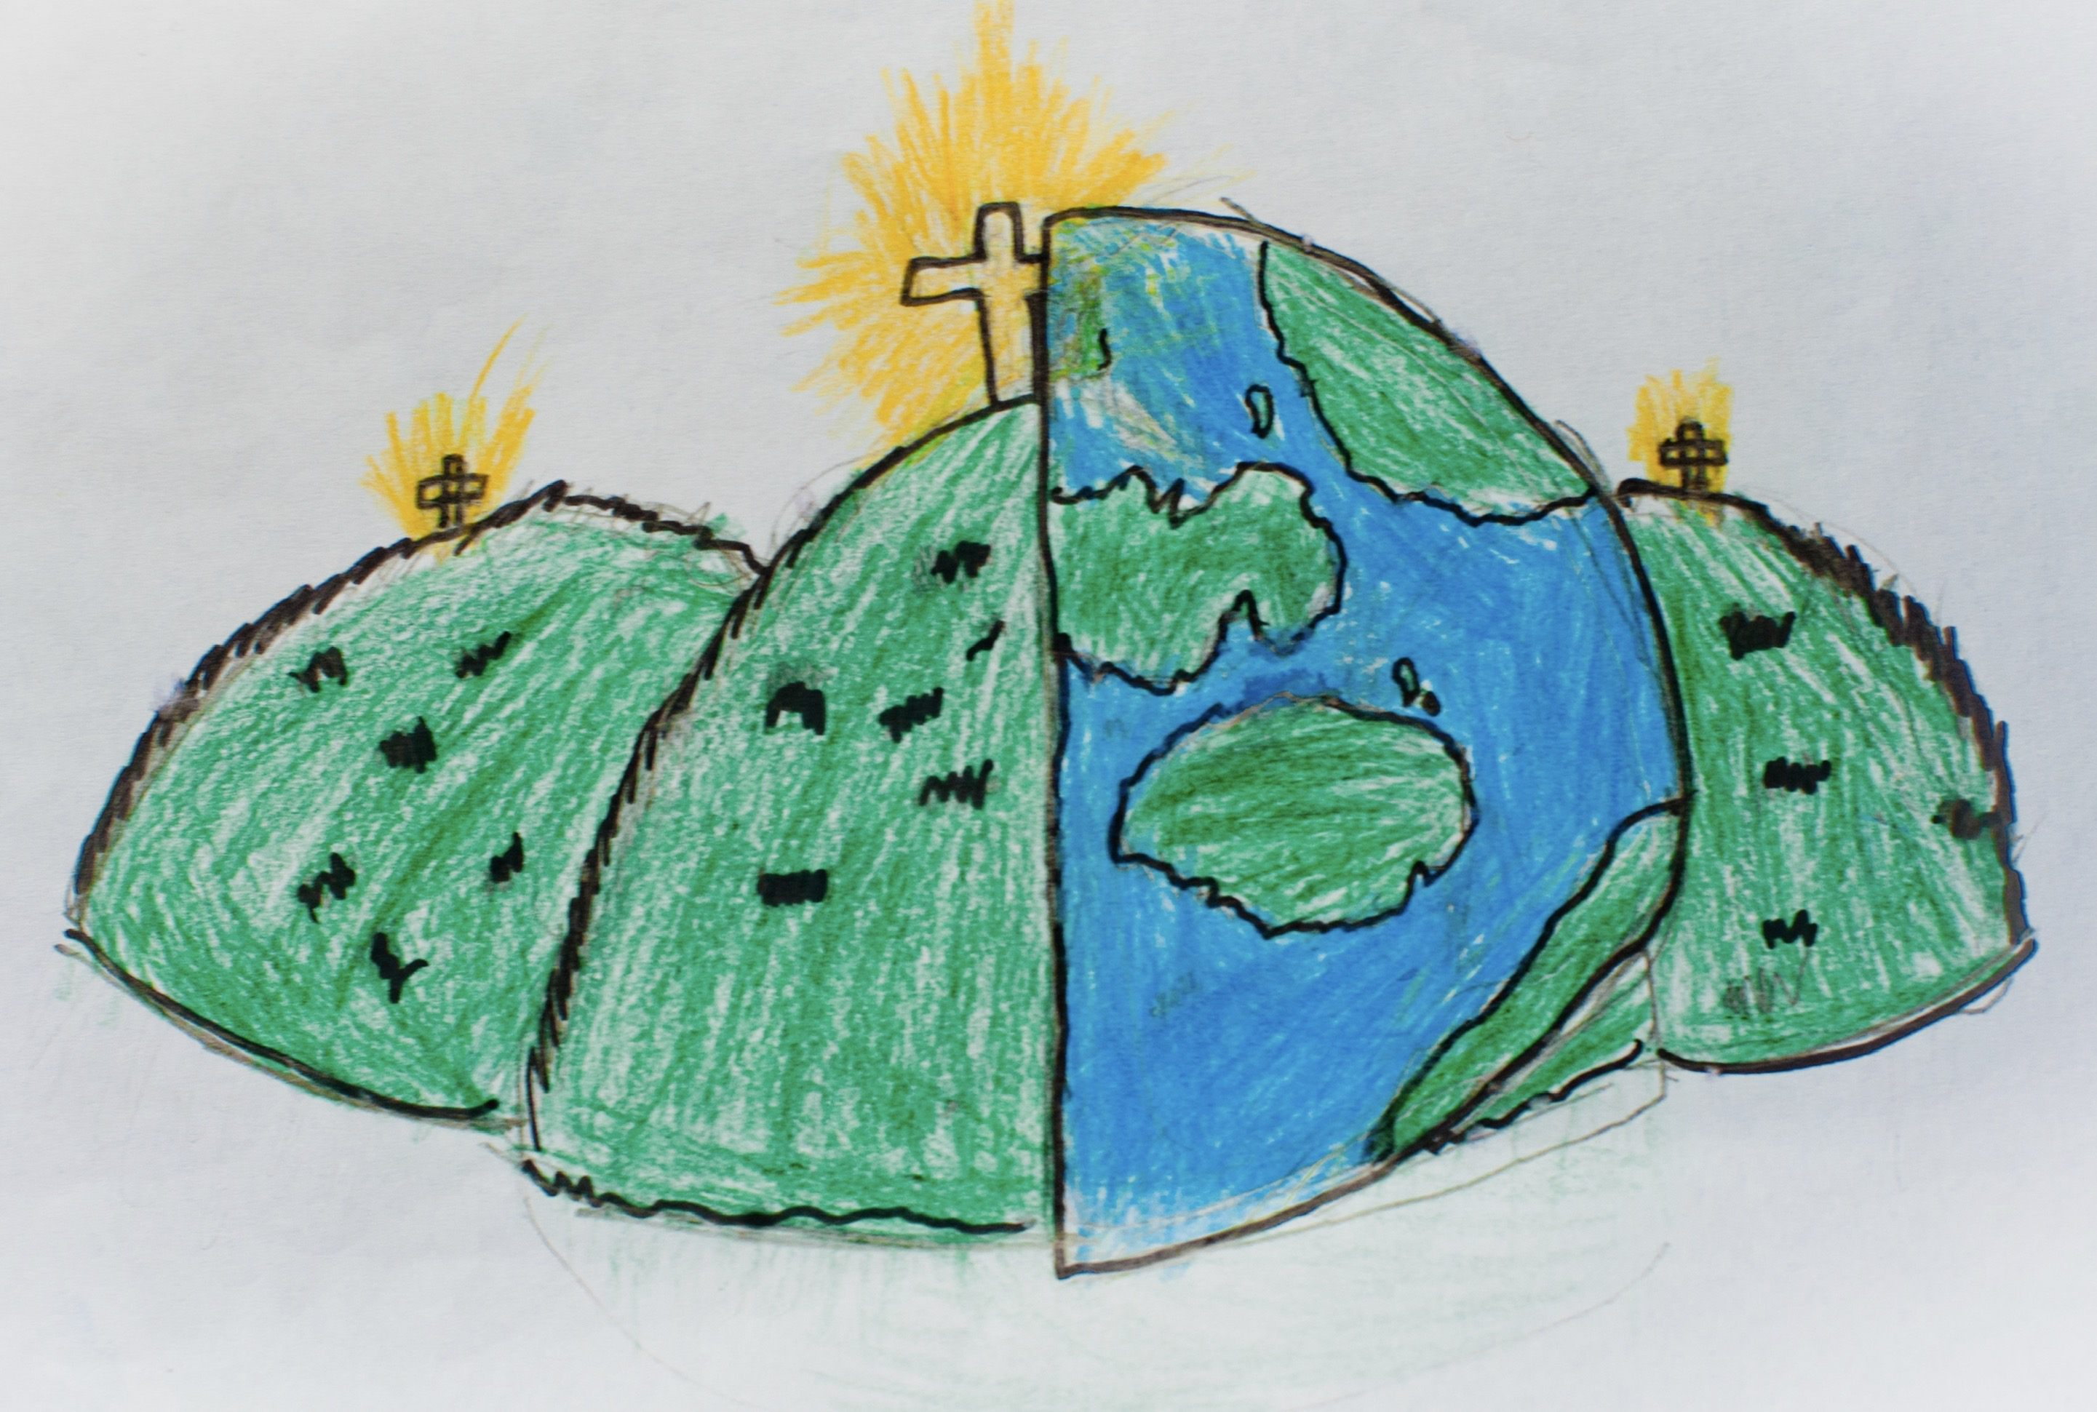

|  |  |  |
| --- | --- | --- |
| arrangement – the composition of visual elements. | digital – art made using electronic devices and computers. | layout – the arrangement of different elements within a given space. |
| macro – very close-up photography, usually of very small subjects that are hard to dear without using a magnifying tool. | monochrome – the use of one colour. | photography – the process of producing an image using a device that captures light. |
| photomontage – a collage of photographs that are arranged or modified. | photorealism – a drawing or painting so detailed it looks like a photo. | objects that re in photographs to enhance a scene. |
| saturation – the intensity or strength of a colour. |  |  |