Year 6 D.T.–

Structures - Playgrounds

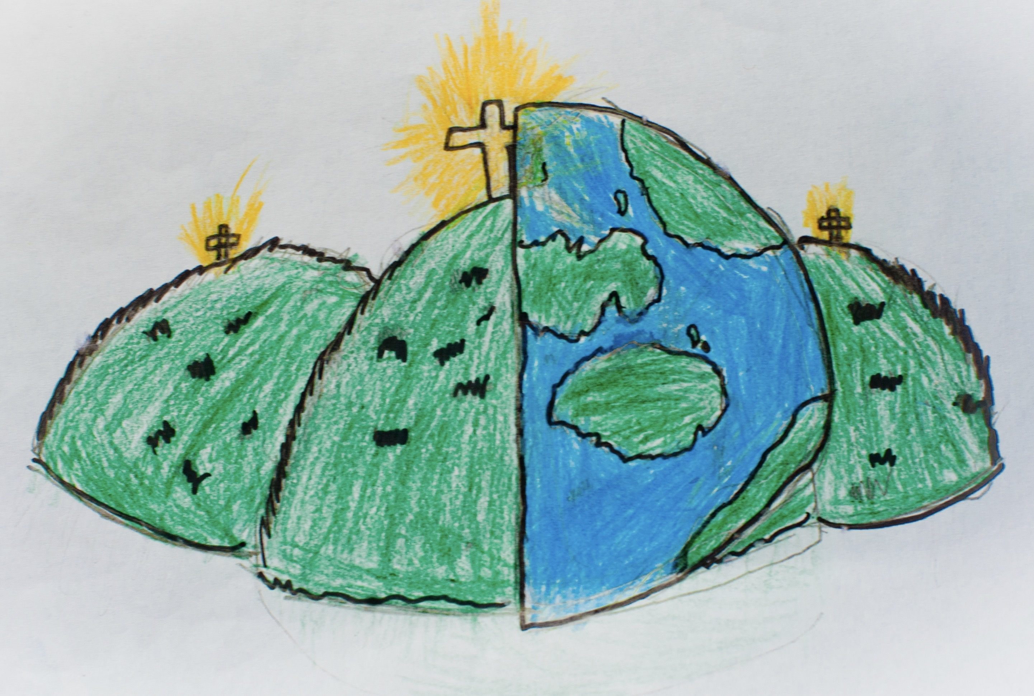

|  |  |  |
| --- | --- | --- |
| apparatus– equipment designed for recreation and play, such as seesaws and swings. | bench hook – a tool which hooks onto the edge of the workbench, it’s used to hold woodwork still when sawing. | coping saw – A saw with a narrow D-shaped metal blade, used for cutting curves in wood. |
| dowel – wood in the shape of a cylinder. Dowels come in all different sizes and thicknesses. | jelutong – a type of softwood, it is lightweight, easy to cut and shape. | mark out – to measure and mark where a piece of material needs to be cut or shaped. |
| modify – to change something, to improve or fix it. | natural materials – materials which come from nature (e.g. wood comes from trees) | plan view – a two-dimensional diagram used to describe a place or object from above with annotations and other details such as measurements. |
| playground – an outdoor area for children to play in. They usually have different apparatus to play on such as climbing frames and slides. | prototype – a simple model that lets you test out our idea and how it will look and work. | reinforce – to make a structure or material stronger, especially by adding another material or element to it. |
| structure – something which stands, usually on its own. | tenon saw – a saw with a flat blade, used for cutting wood in straight lines or angles. | user – a person that uses something. |
| vice – a piece of equipment used to hold an object still while you work on it. |  |  |