Year 6 Science – Evolution and Inheritance

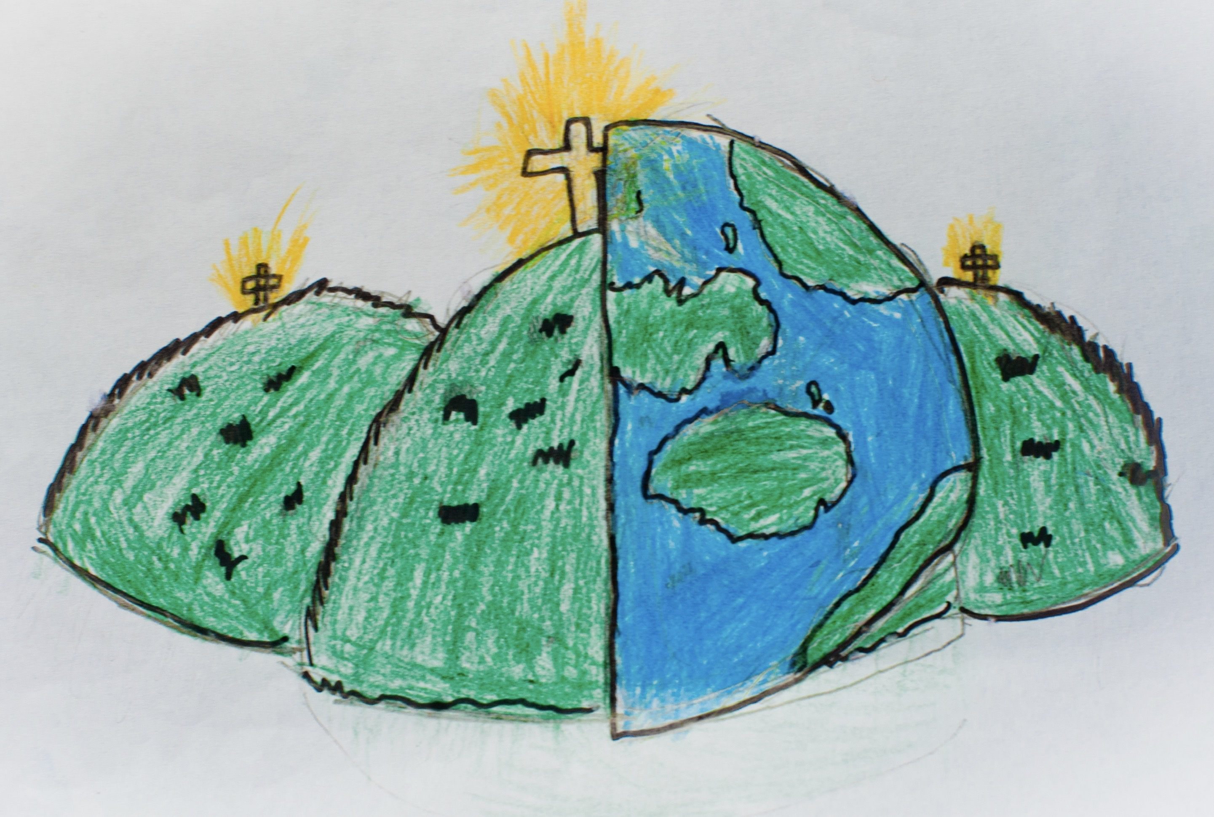

|  |  |  |
| --- | --- | --- |
| adapted – become adjusted to new conditions. | characteristics – a feature or quality belonging to a person, place or thing. | environment – the surroundings or condition in which a person, animal or plant lives. |
| fossils – the remains or impression of a prehistoric plant or animal. | inherited – a quality or characteristic derived genetically from parents or ancestors. | offspring – a persons child or children. |
| reproduction – the production of offspring. | species – a group of living organisms which have the same or similar characteristics. | suited – right or appropriate for a particular person, purpose or situation. |
| vary – differ in size, amount, degrees or nature. |  |  |