Year 6 Science – Oceans - Habitats

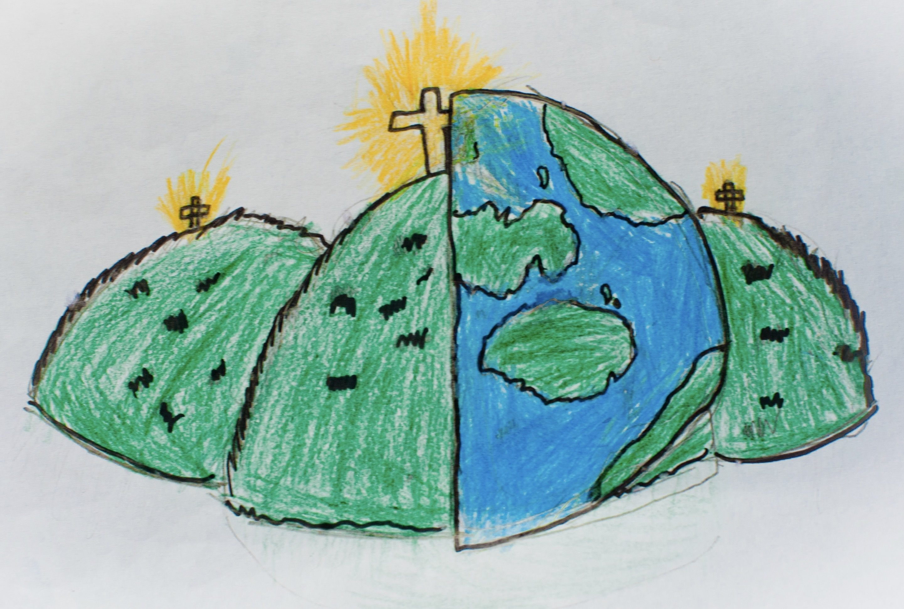

|  |  |  |
| --- | --- | --- |
| amphibians - Their skin is permeable (air can pass through) many  amphibians breathe through their skin. | birds - A group of animals which has feathers. | fish - Fish have a combination of gills, fins and they live only in  the water. |
| habitats – the natural home or environment of an animal, plant or other organism. | insects - creatures that have bodies with three segments that are  protected by a hard shell. | invertebrates - Animals which do not have a back bone. |
| mammals - an animal that breathes air, has a backbone, and grows hair  at some point during its life. | marine species – the plants, animal and other organisms that live in the salt water of seas and oceans. | reptiles - An air-breathing animal that has scales. |
| ecosystem – a biological community of interacting organisms and their physical environment. | pollution – the presence or introduction of a substance which has harmful or poisonous effects. | vertebrates - Animals which have a back bone. |
|  |  |  |