Year 1

Art

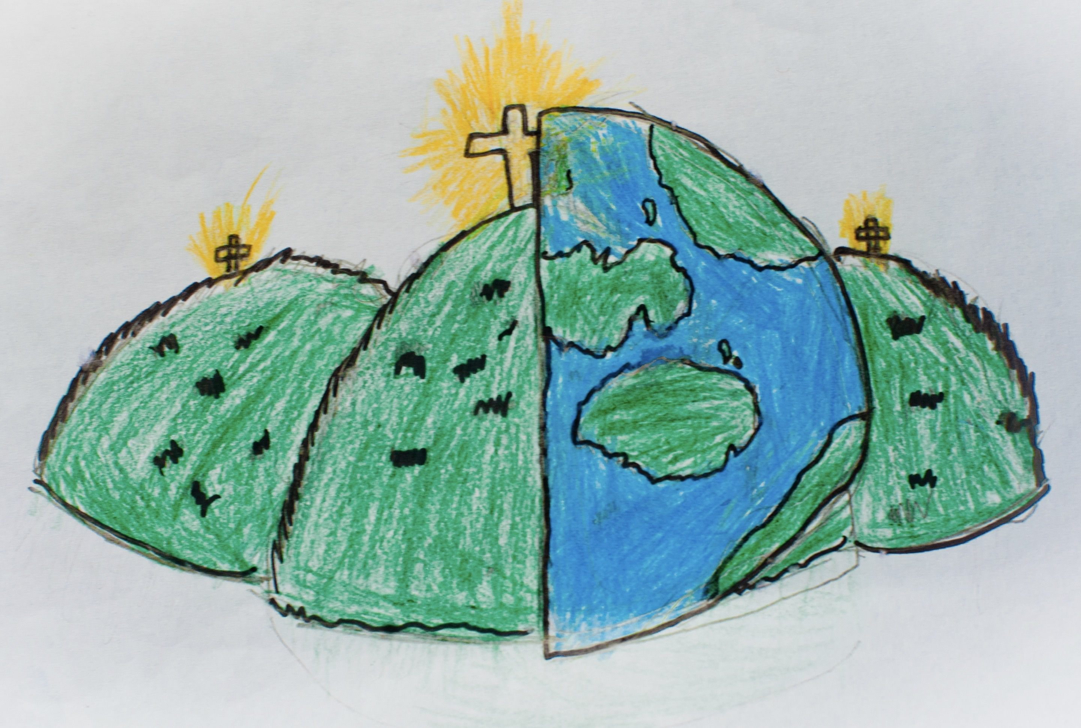

|  |  |  |
| --- | --- | --- |
| geometric  Mathematical shapes with straight lines, angles and  point. | horizontal  Flat or level with the ground and not at an angle to it. | irregular  When shapes or lines are not formed of the same sizes. |
| line  A mark on a surface can be different lengths, widths  and create shapes. | vertical  Pointing straight up at a 90 degree angle from a  horizontal base. | regular  A consistent size or pattern. |
| texture  A surface quality that is not flat. | mark-making  The creation of different lines, patterns and shapes. | observation  To look at something carefully. |