Year 1

DT- Structures

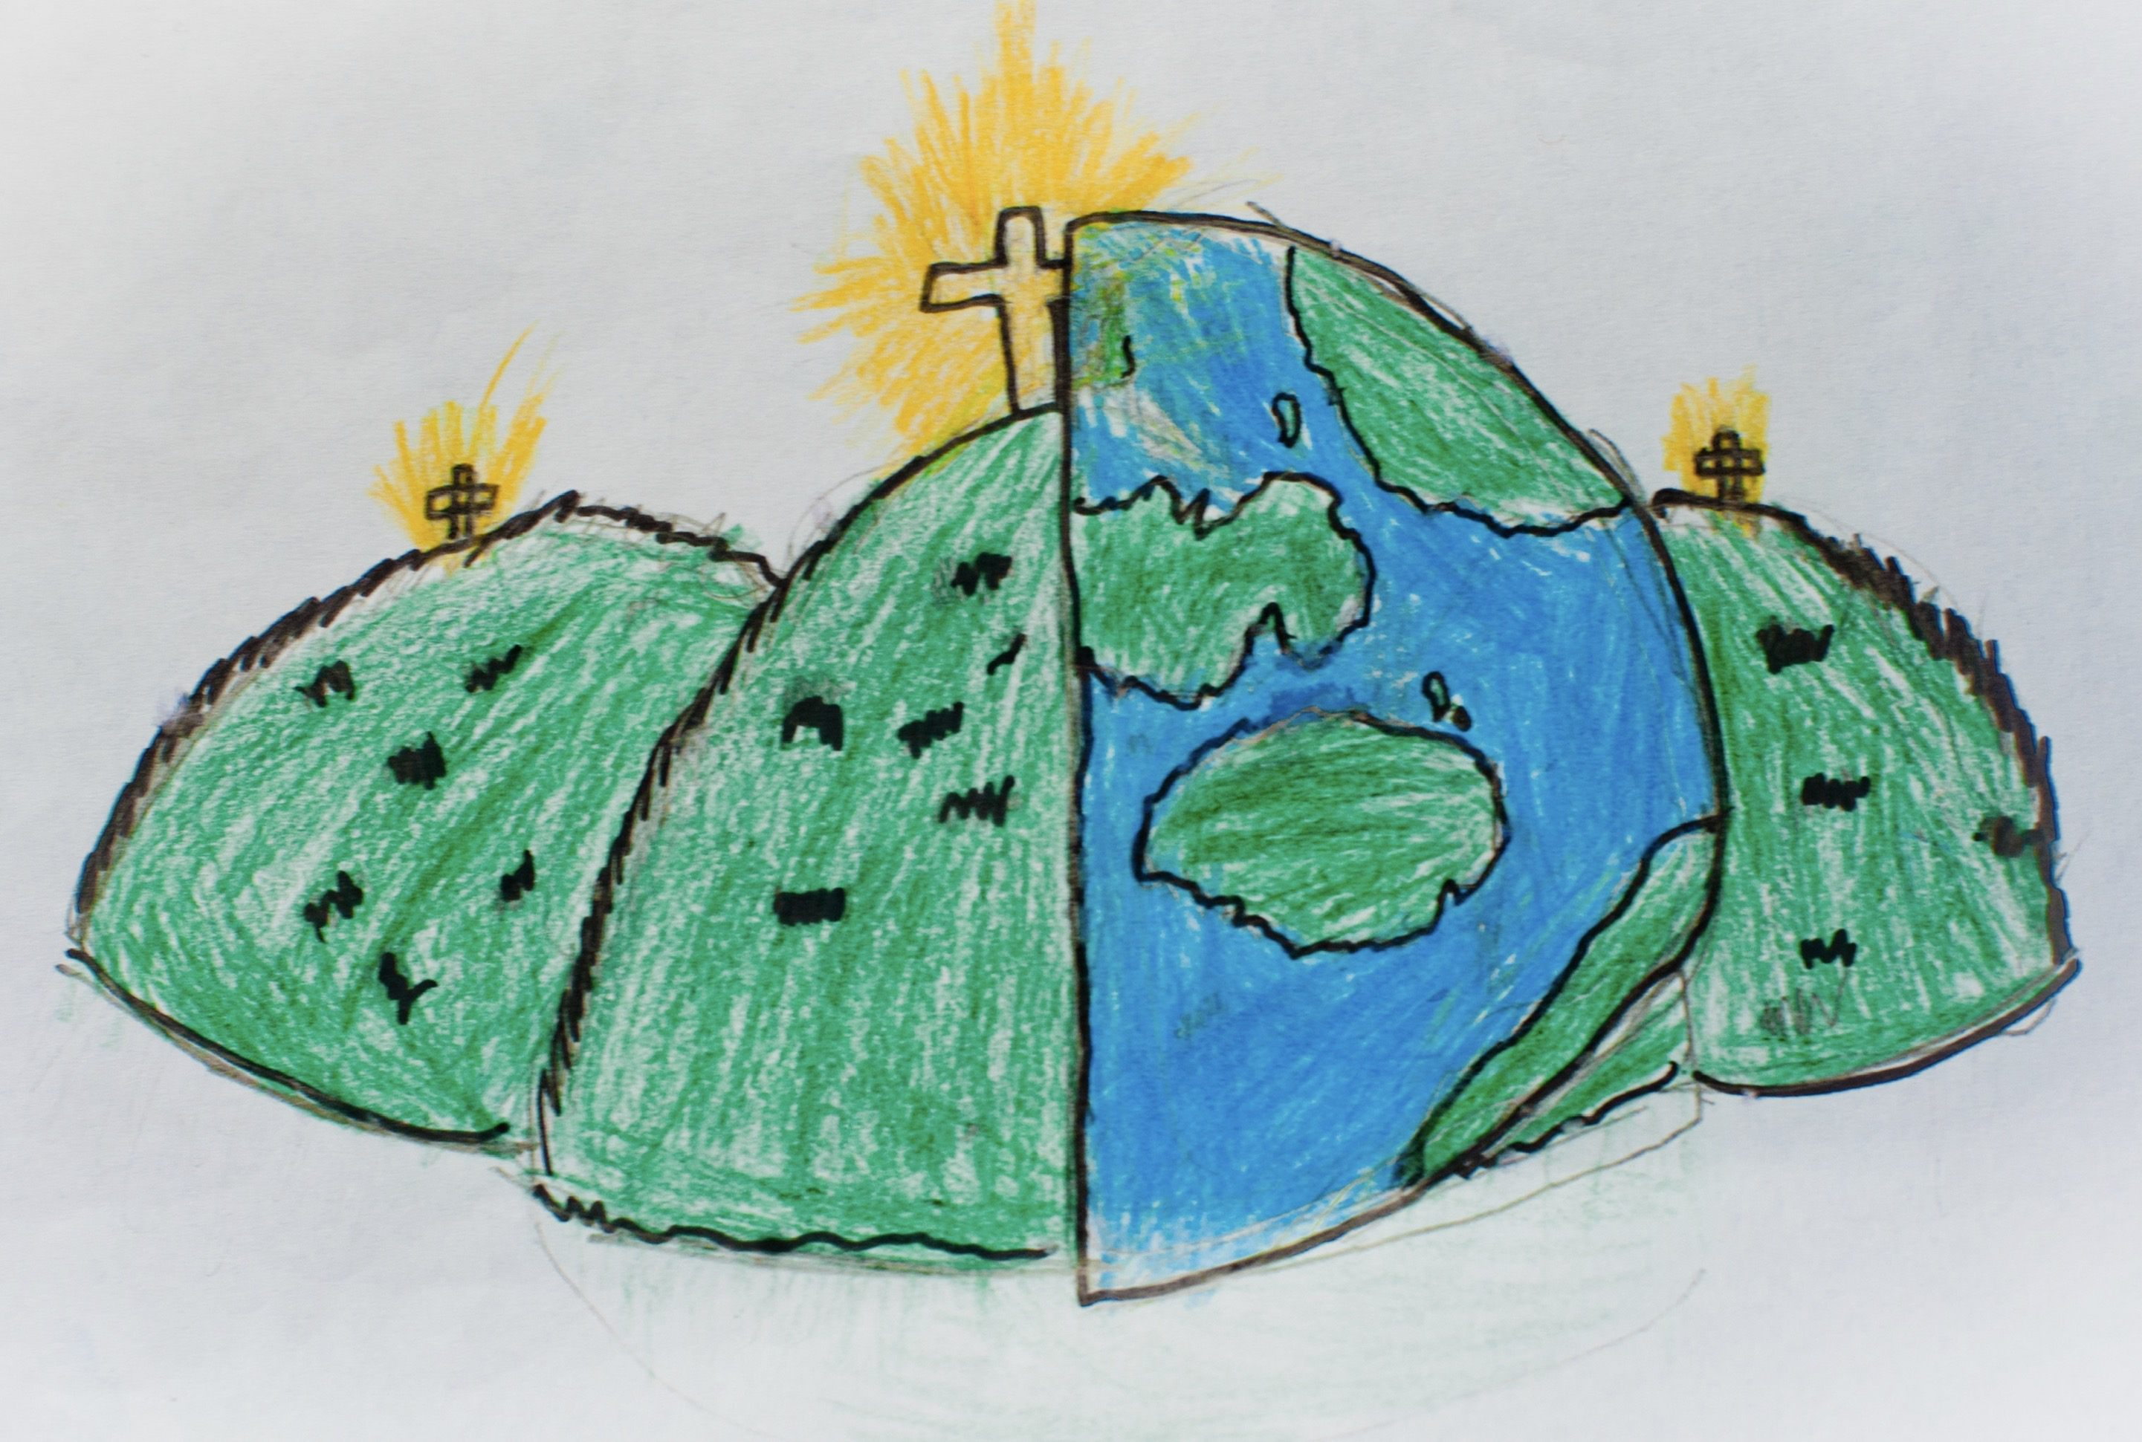

|  |  |  |
| --- | --- | --- |
| windmill | sail or turbine | axle |
| net | design | structure |
| assemble  Put it together. | DT  Design and Technology. |  |