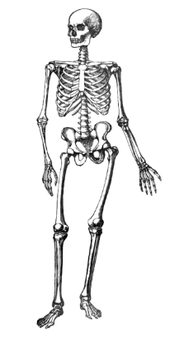

Year 1

Science

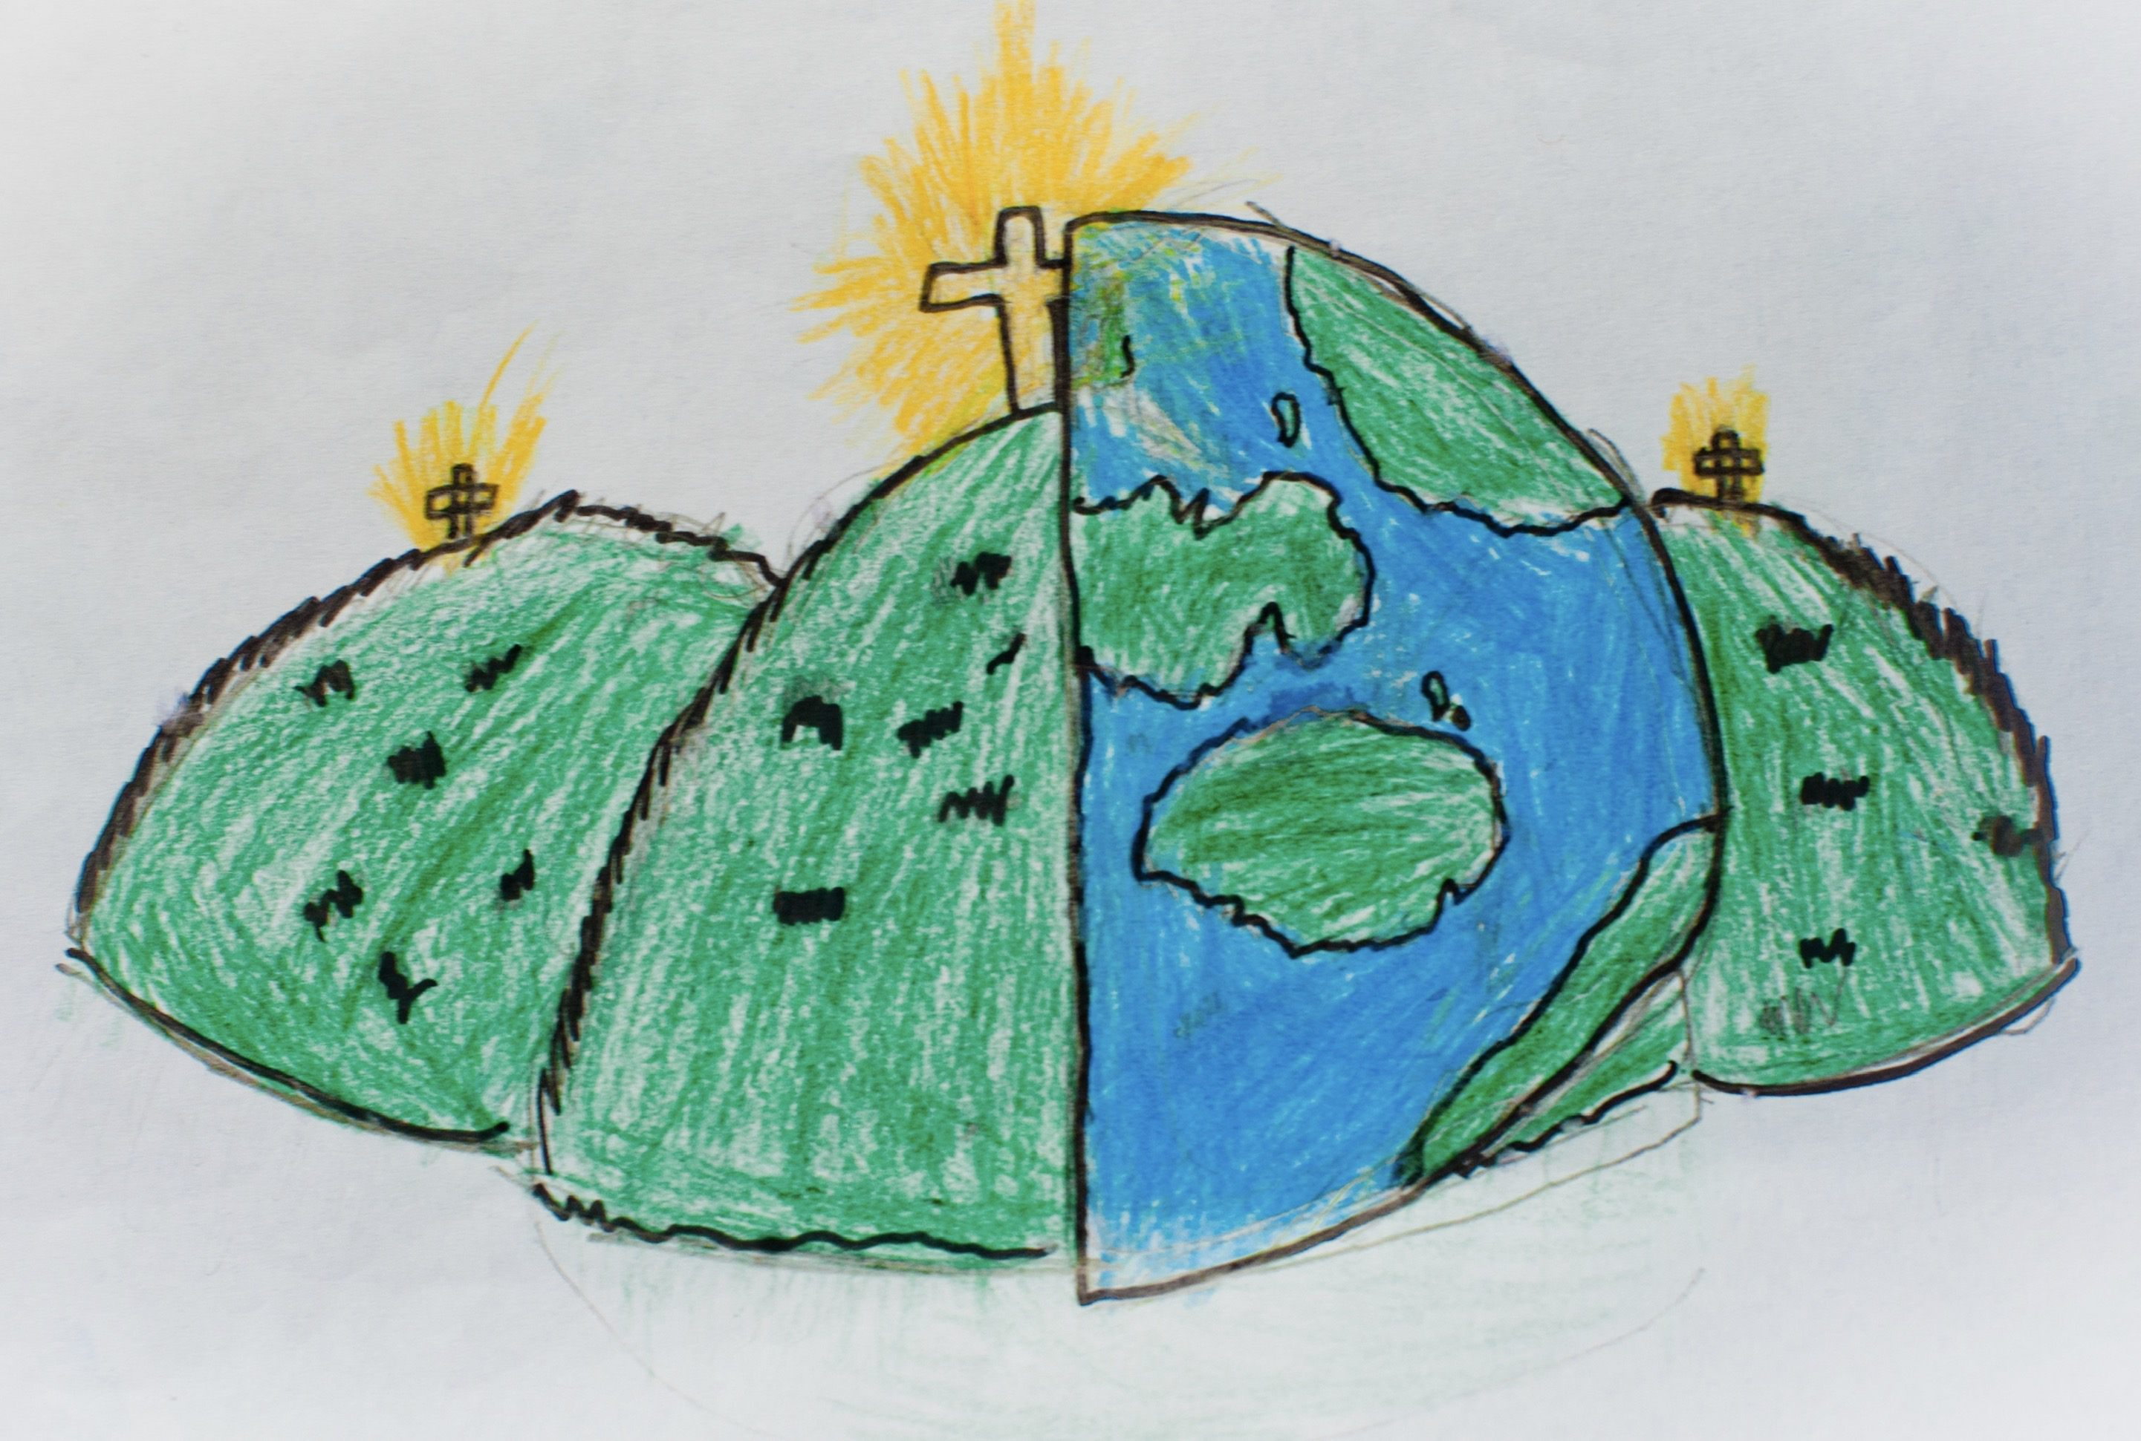

|  |  |  |
| --- | --- | --- |
| body | beak | claws |
| feathers | fur | hooves |
| paws | scales | tail |
| wings | fin | senses |