Year 1

Science- materials.

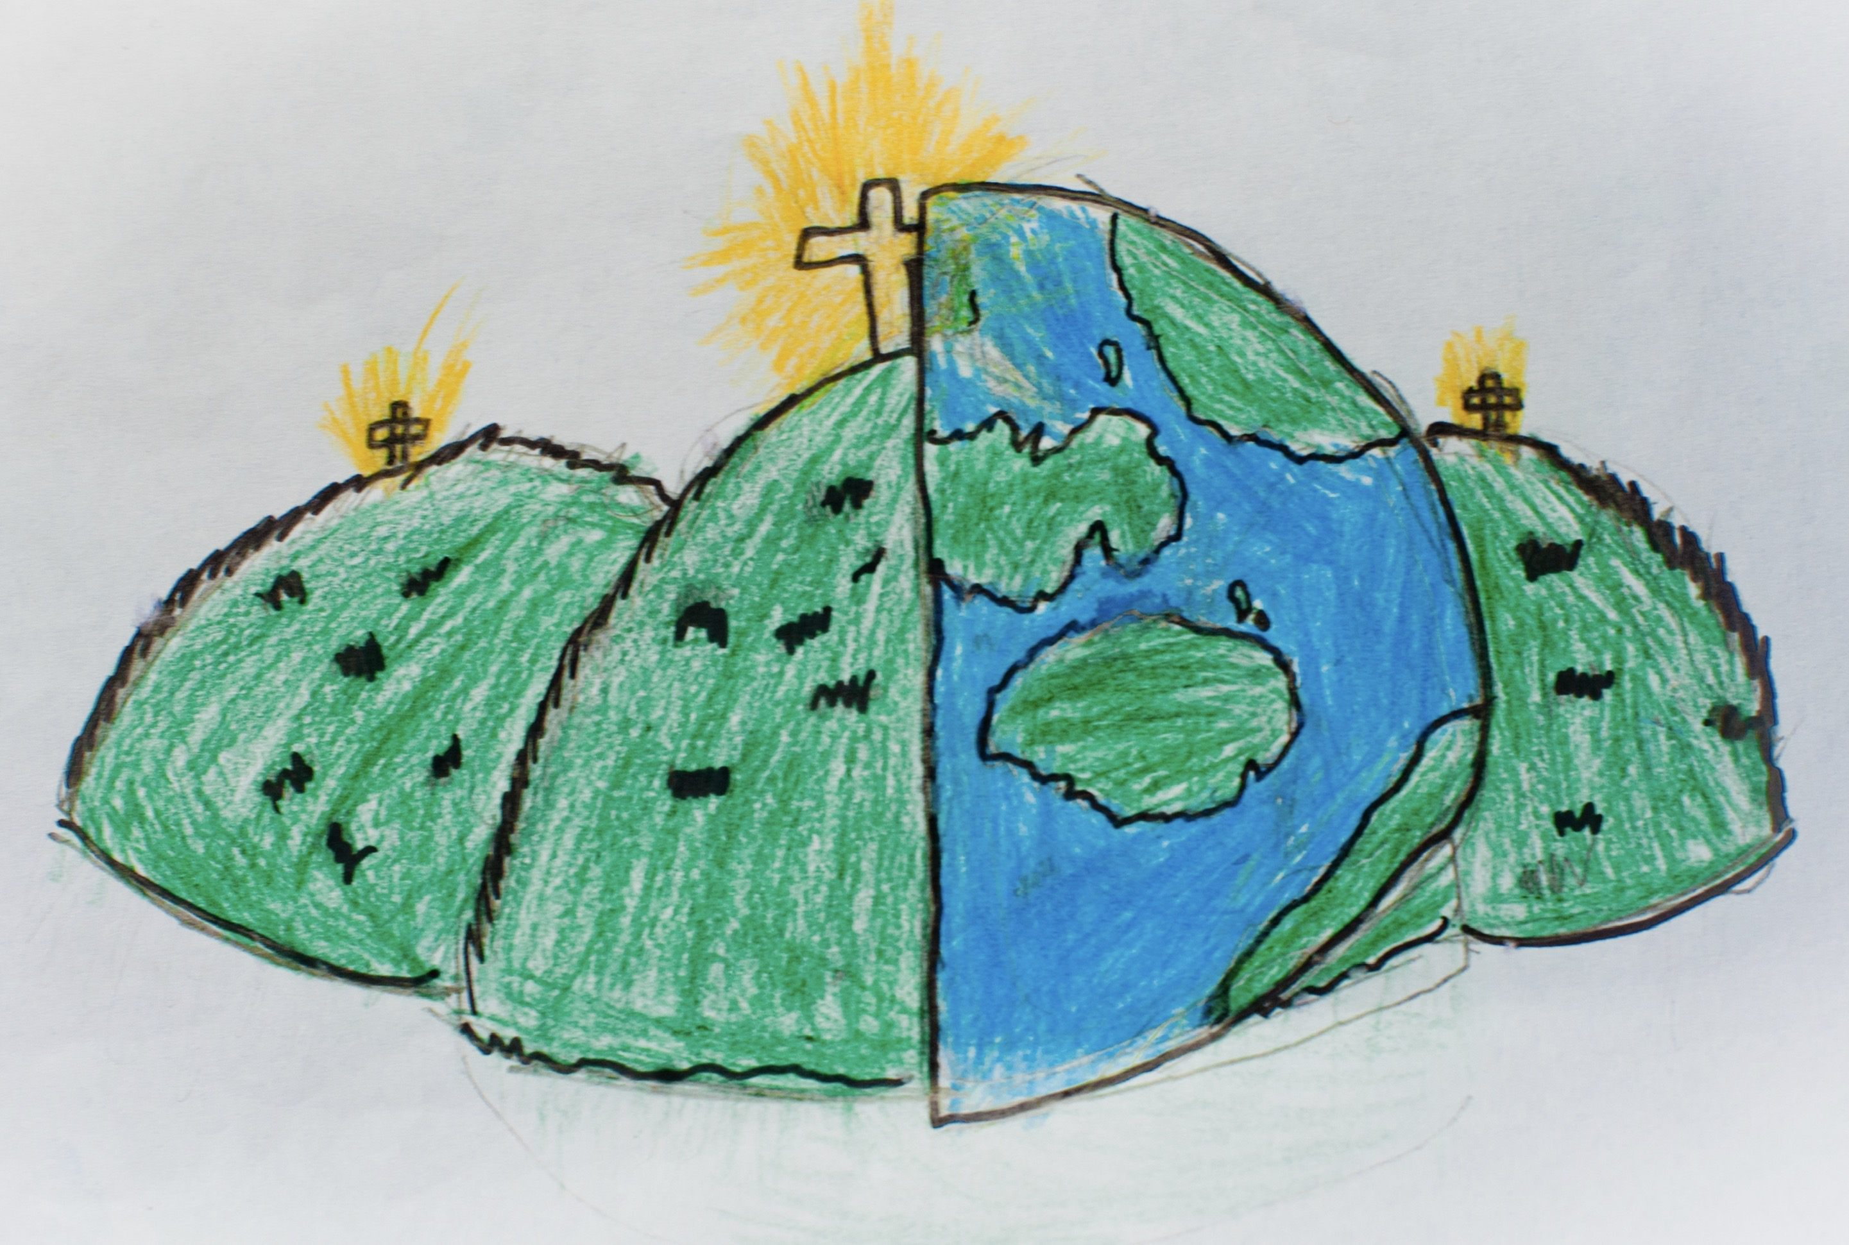

|  |  |  |
| --- | --- | --- |
| observe  To look closely. | compare  To estimate, measure and look for similarities and differences. | material |
| absorbent  Something that soaks up liquid, like water. | fabric  A soft material. | foil  A shiny material which is bendy. |
| elastic  Stretchy and bendy. | floppy  Not strong. | clay  A soft material which can be changed. |
| stretchy  A material which can be pulled. | rough  Uneven and bumpy. | shiny  A bright material. |