Year 2

Computing

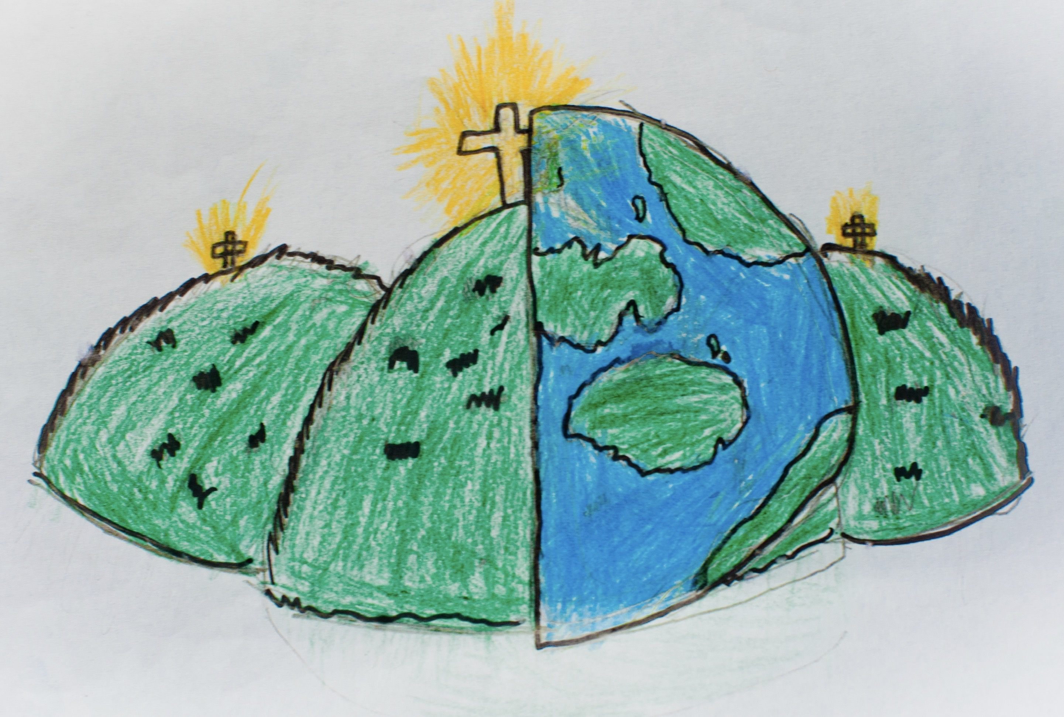

|  |  |  |
| --- | --- | --- |
| background | eraser | fill |
| open | palette | redo |
| save | style | undo |
| zoom |  |  |