Year 2

DT

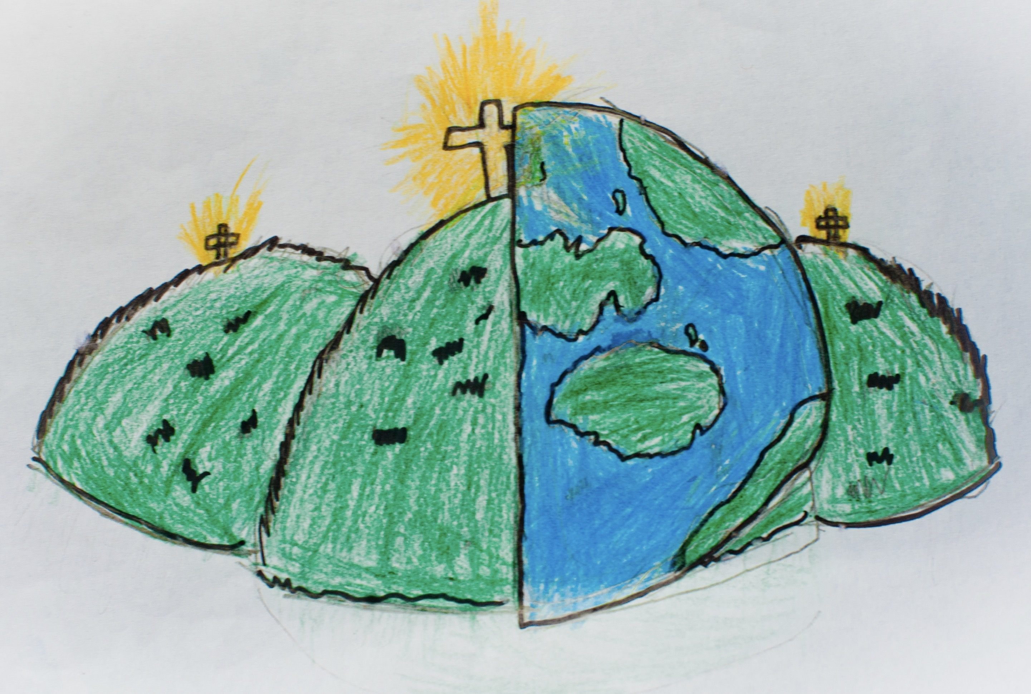

|  |  |  |
| --- | --- | --- |
| accurate | fabric | knot |
| pouch | running stitch | sew |
| shape | stencil | template |
| thimble |  |  |