Year 2

DT

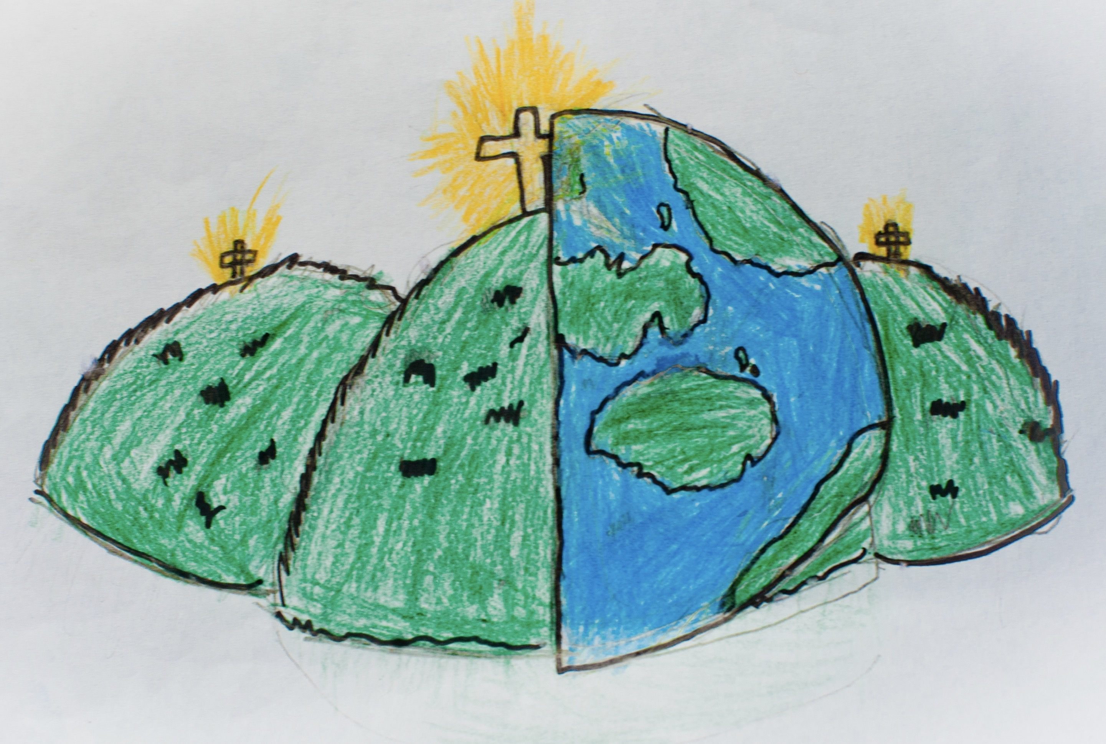

|  |  |  |
| --- | --- | --- |
| function  How/why something works. | man-made | mould  Form different shapes out of soft, squishy materials. |
| natural | stable  Object does not easily topple over. | stiff  Material that does not bend easily. |
| strong  Material that is not easily broken. | structure  Something that has been made and put together, it can usually stand on its own. | test  Find out whether something works as it should. |
| weak  Opposite of strong – something that can easily break. |  |  |