

Year 2

History

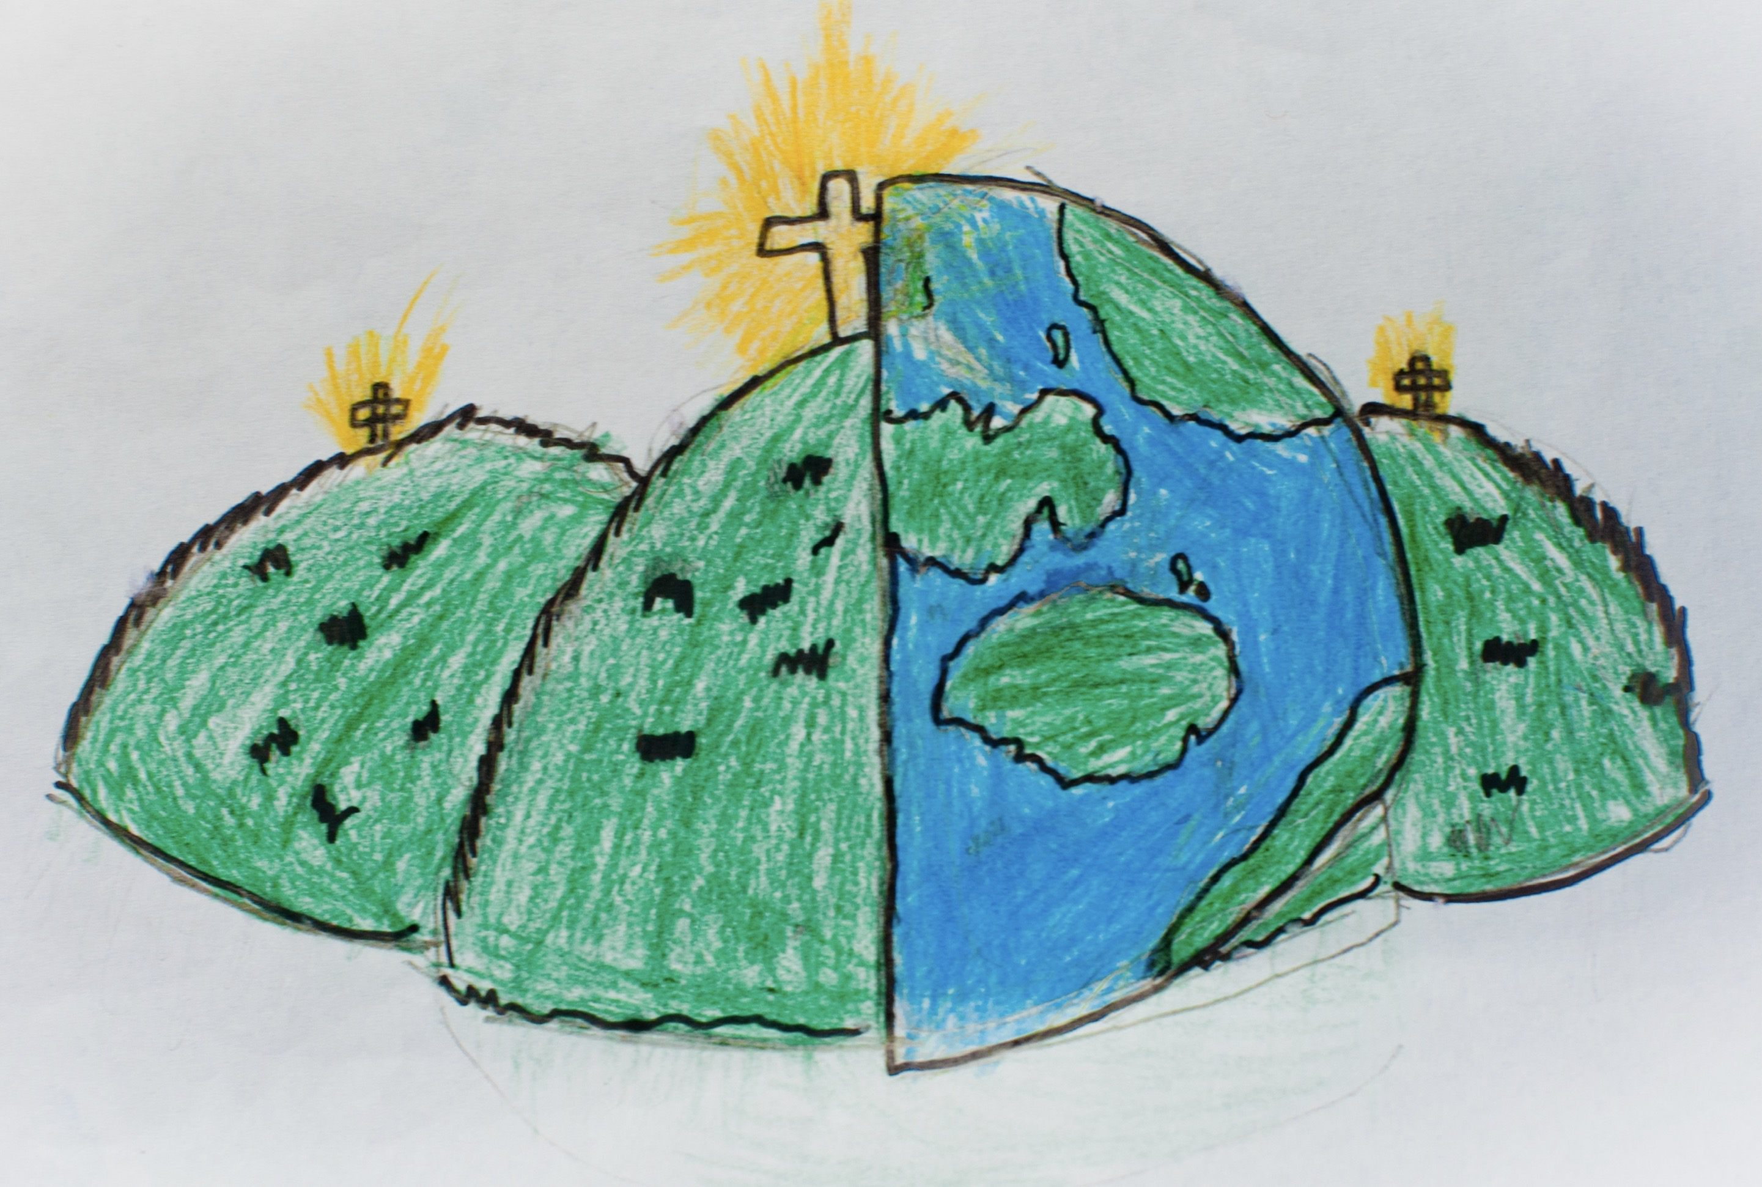

Disciplinary Concept Substantive Concept

Change Family and National History

|  |  |  |
| --- | --- | --- |
| air raid | blackouts | Blitz |
| British Government | cenotaph | citizens |
| evacuation | evacuee | rations |
| World War 2 |  |  |