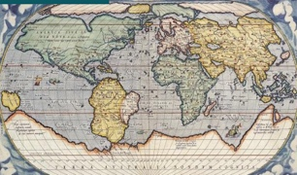Disciplinary Substantive

Year 2

History



Concept Concept

Historical Significance International History

|  |  |  |
| --- | --- | --- |
| astronaut | Buzz Aldrin | chronology |
| century | decade | famous |
| Michael Colins | moon | Neil Armstrong |
| space | timeline |  |