Year 2

PSHE

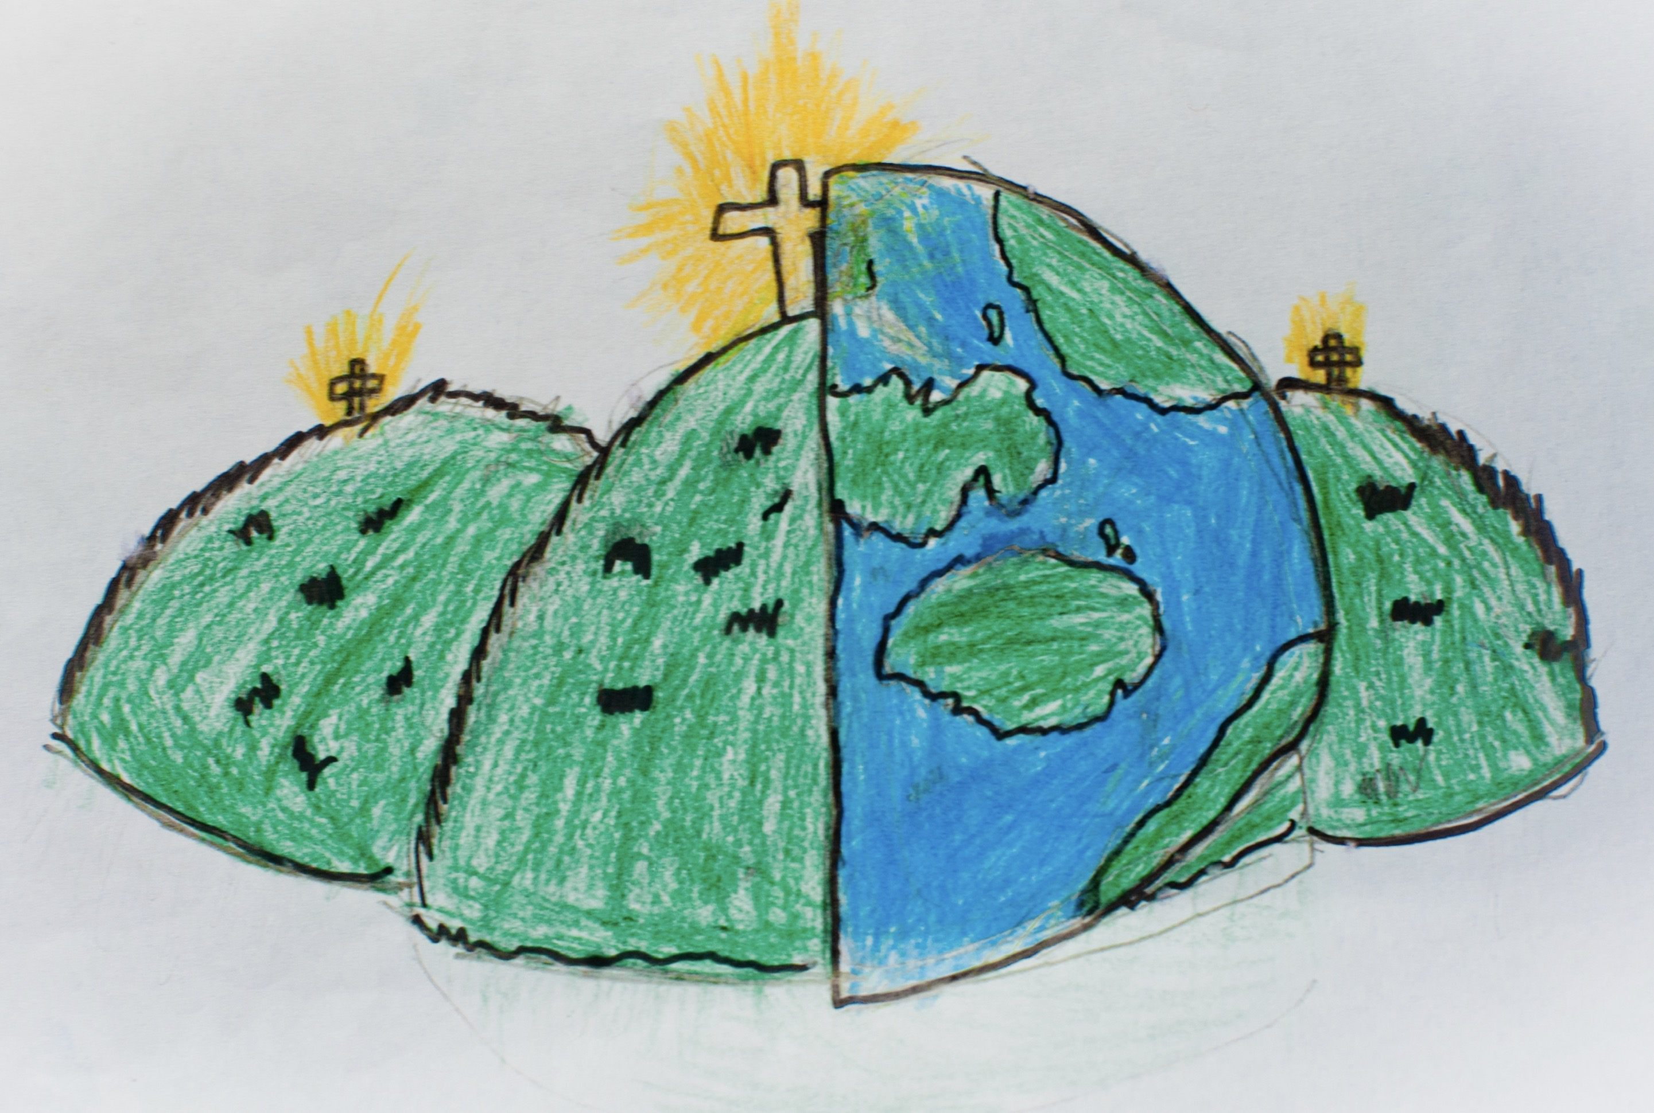

|  |  |  |
| --- | --- | --- |
| active  Moving and getting sweaty. | change | confident |
| confused | emotions  Someone’s inner feelings. | exercise |
| feelings | frustrated | healthy |
| loss | peaceful | physical activity  Movement that causes a person to use energy. |
| relaxed | sugar |  |