Year 3

French – Bonjour!

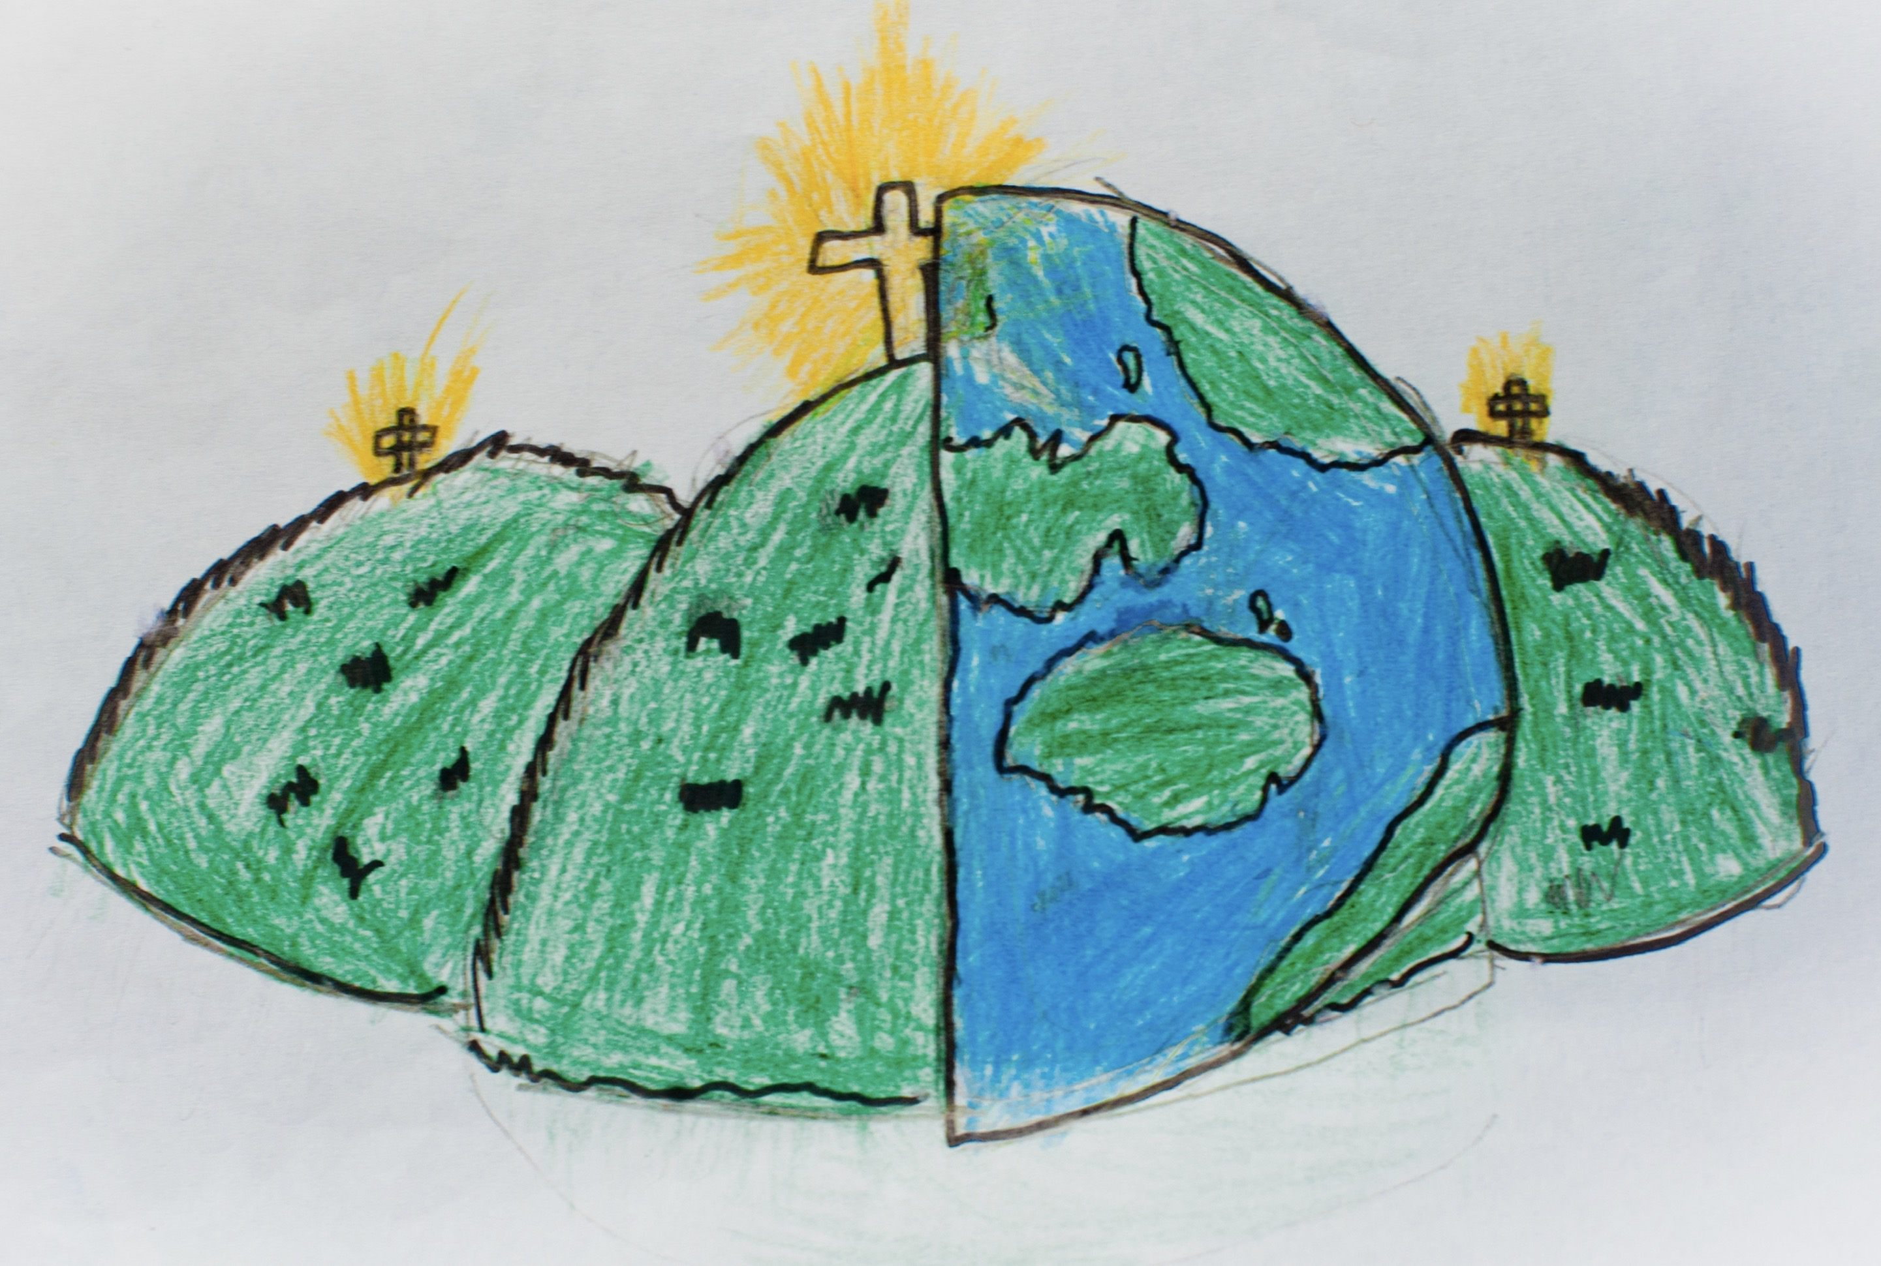

|  |  |  |  |
| --- | --- | --- | --- |
| **Greetings** | | | |
| **bonjour/salut**  hello/hi | | **au revoir**  goodbye | **Madame/Monsieur/**  **Madamoiselle**  Mrs/Mr/Miss |
| **Say and ask names** | | | |
| **Commen t’appelles-tu?**  What is your name? | | **Je m’appelle…**  My name is… | |
| **Say and ask how you are** | | | |
| **Ça va?**  How are you? | | **Ça va bien/Ça ne va pas**  I am fine/I am not fine | **Comme çi comme ça**  I am okay |
| **Numbers** | | **Musical instruments** |  |
| **1 un**  **2 deux**  **3 trois**  **4 quatre**  **5 cin** | **6 six**  **7 sept**  **8 huit**  **9 neuf**  **10 dix** | **Une trompette –** a trumpet  **Une guitare –** a guitar  **Une flûte à bec** – a recorder  **Un piano –** a piano  **Un tambour –** a drum | **Une fille –** a girl  **Un garçon –** a boy  **Un dragon –** a dragon |