Year 3

French – En classe

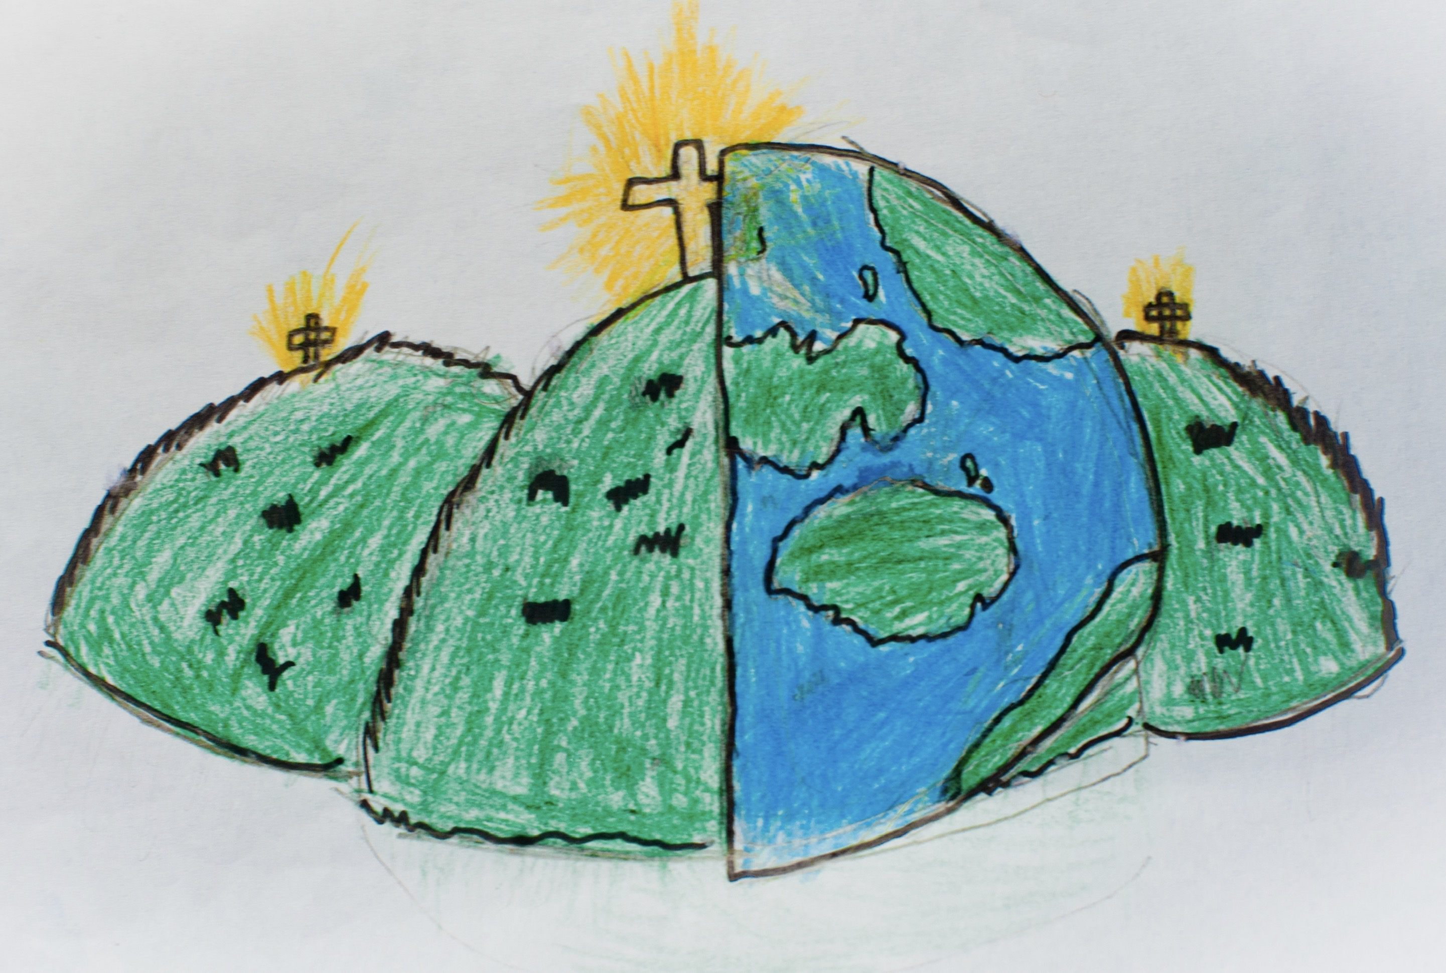

|  |  |  |  |
| --- | --- | --- | --- |
| **Classroom objects** | | | |
| **Une trousse** – pencil case  **Un stylo –** pen  **Une règle –** ruler | | **Un crayon –** pencil  **Un cahier –** exercise book  **Un livre –** text book | **Un sac –** bag  **Une gomme –** rubber |
| **Saying how old you are** | | | |
| **Quel âge as-tu?**  How old are you? | | **J’ai …… ans**  I am …….. years old | **J’ai sept ans.**  **J’ai hui ans.** |
| **Colours** | | **Classroom instructions** | |
| **rouge –** red  **rose –** pink  **bleu –** blue  **jaune** - yellow | **marron –** brown  **orange –** orange  **vert** – green | **écoutez** – listen  **regardez –** look  **lisez –** read  **asseyez-vous –** sit down | **levez-vous –** stand up  **écrivez -**  write  **chantez -** sing |