Year 3

French – Mon corps

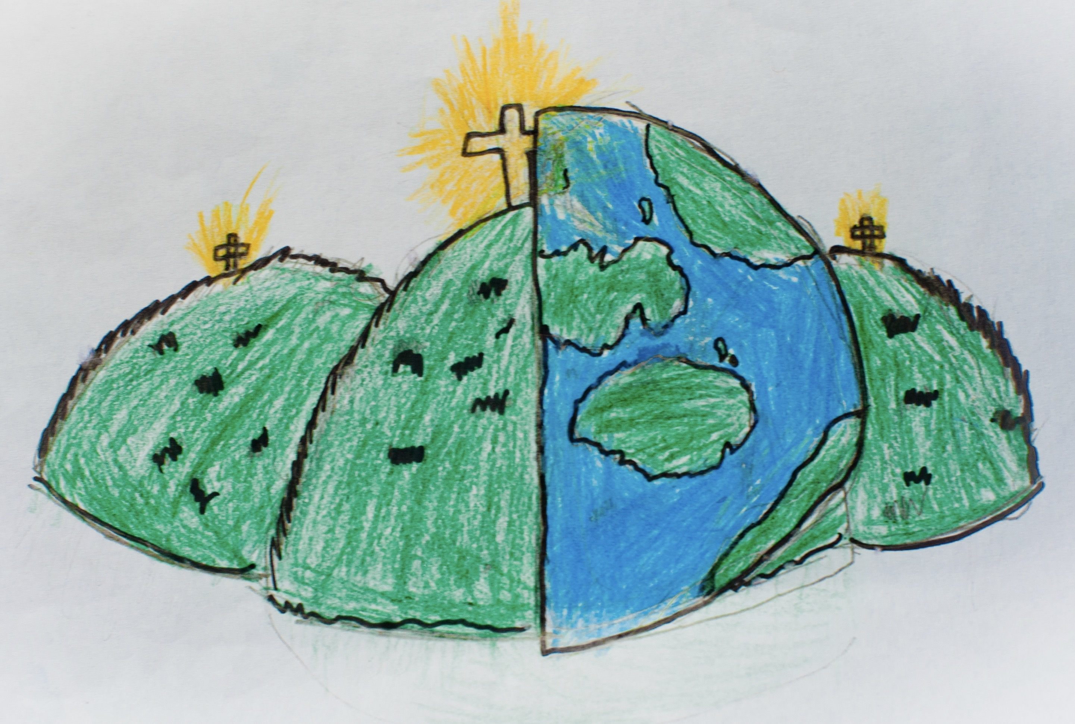

|  |  |  |  |
| --- | --- | --- | --- |
| **Parts of the body** | | | |
| **les yeux –** eyes  **le nez –** nose  **la bouche -** mouth | **les oreilles –** ears  **les cheveux –** hair  **la jambe –** leg | | **le bras –** arm  **la tête -** head |
| **vert –** green  **rouge –** red  **marron –** brown  **jaune –** yellow  **bleu –** blue | **long –** long  **court -** short | | **Days of the week**  **Lundi** - Monday  **Mardi** – Tuesday  **Mercredi** – Wednesday  **Jeudi** – Thursday  **Vendredi** – Friday  **Samedi** – Saturday  **Dimanche** – Sunday |
| **Adjectives** | | |
| **Je suis…**  I am… | **grand(e) –** big  **petit(e) –** small  **timide –** quiet | **bavard(e) –** talkative  **drôle –** funny  **sympa -** nice |