Year 3

French – Les animaux

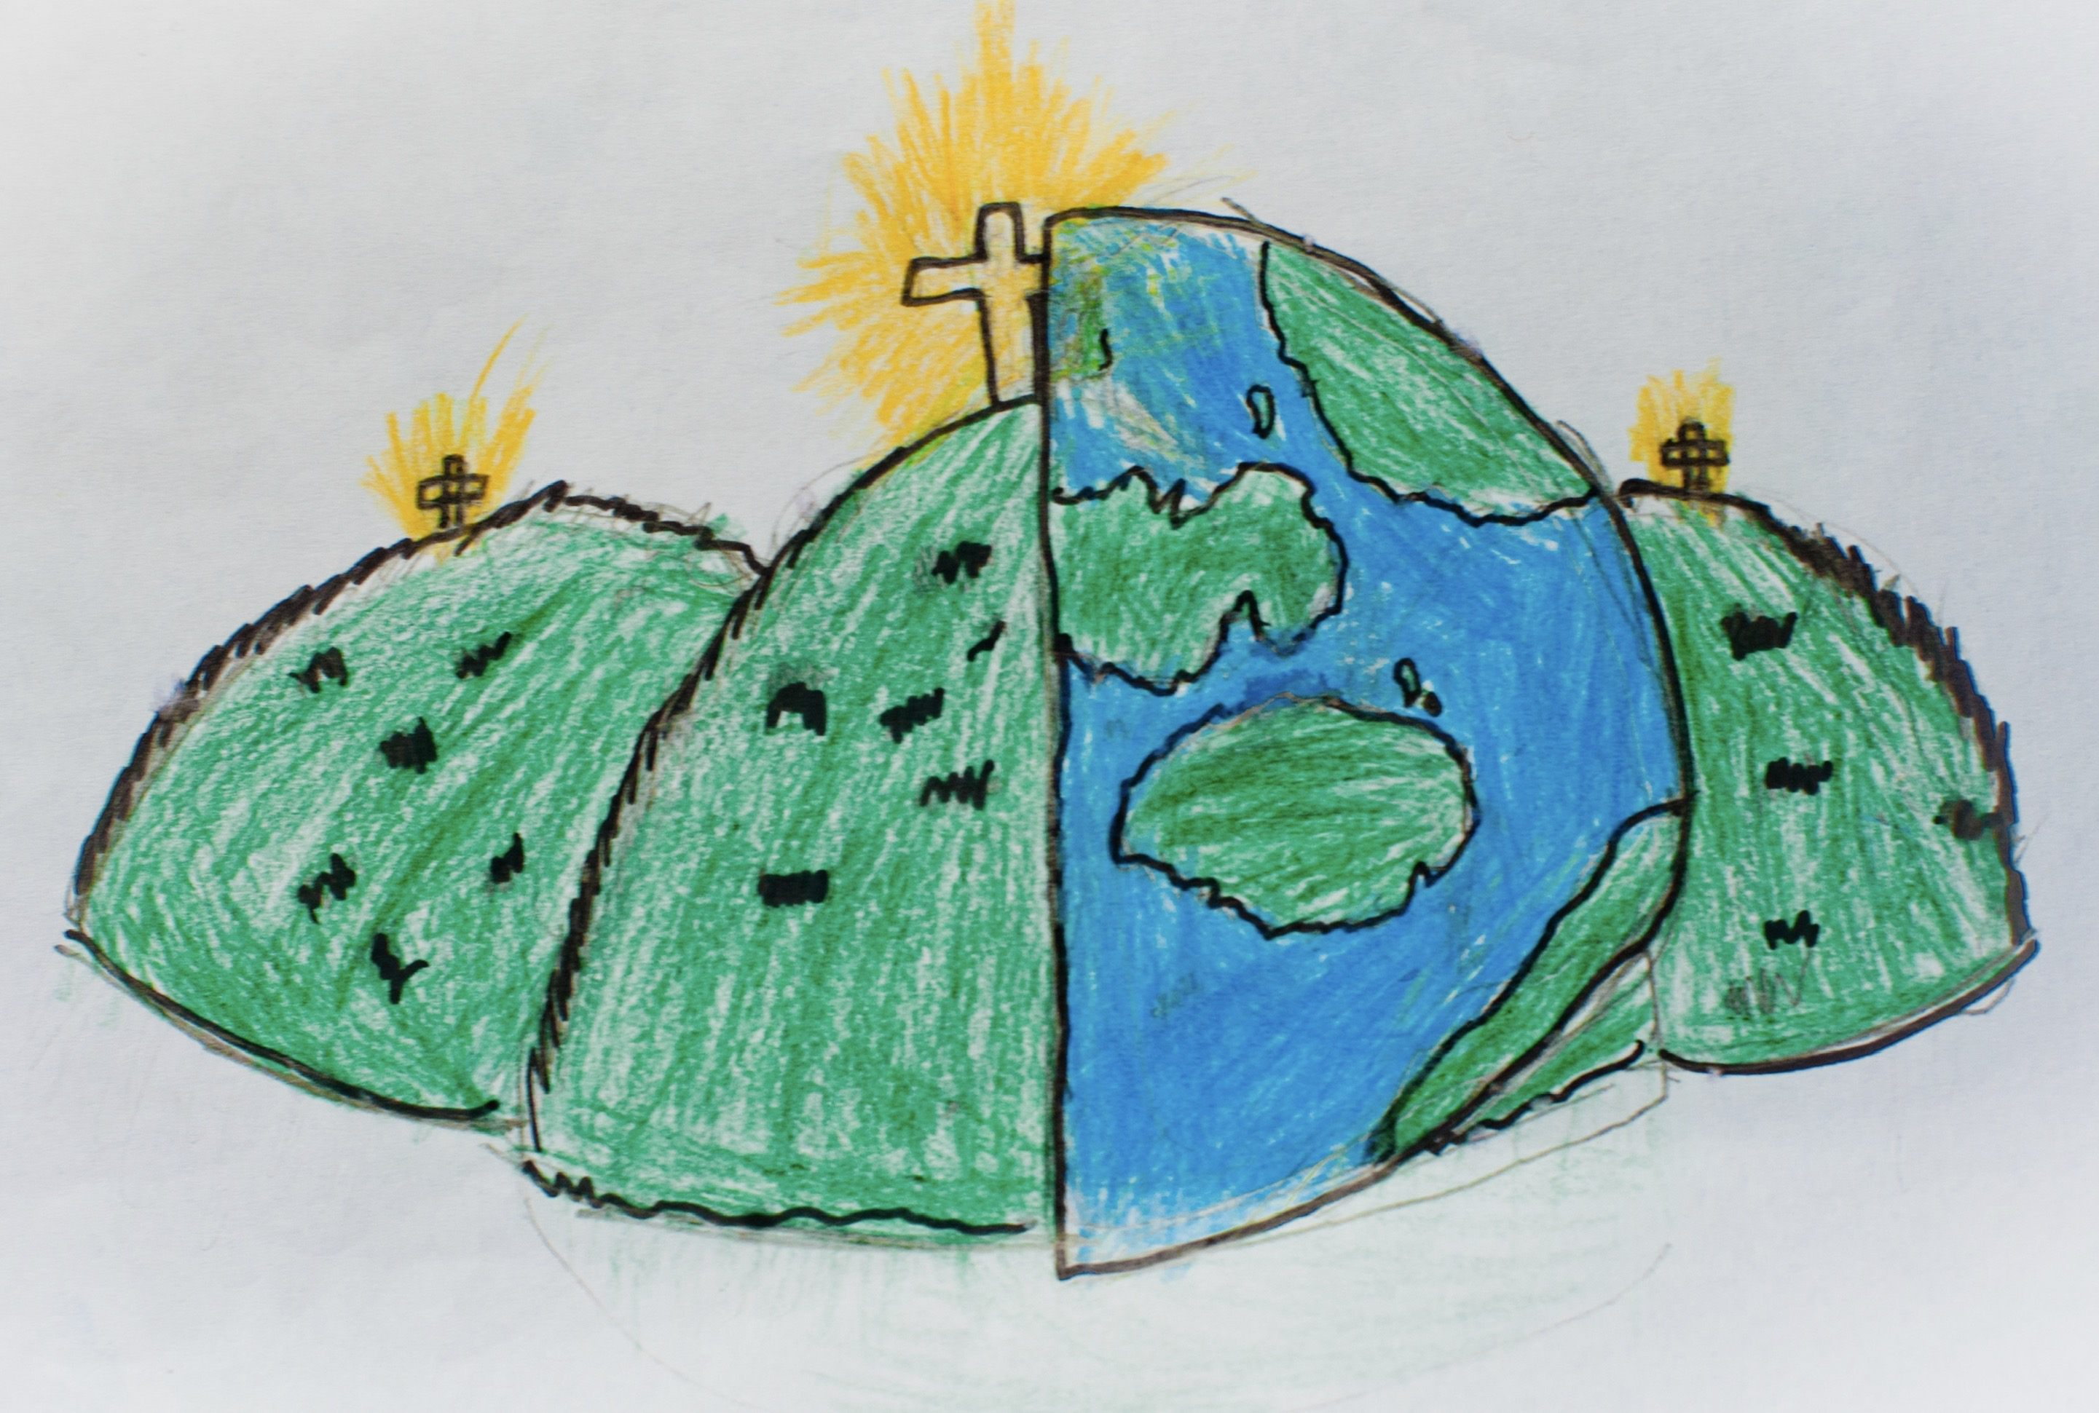

|  |  |  |  |  |
| --- | --- | --- | --- | --- |
| **Animals** | | | | |
| **un chien –** dog | | **un chat -** cat | | **une torture –** tortoise |
| **un lapin –** rabbit | | **un oiseau –** bird | | **une souris –** mouse |
| **Numbers** | | **Adjectives – describing character** | | **Il/Elle s’appelle…**  S/he’s called… |
| **11 onze**  **12 douze**  **13 treize**  **14 quatorze**  **15 quinze** | **16 seize**  **17 dix-sept**  **18 dix-huit**  **19 dix-neuf**  **20 vingt** | **grand(e) –** big  **petit(e) –** small  **timide –** shy | **drôle –** funny  **sévère -** strict |