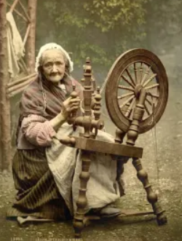

**Substantive concept**

Jobs and lifestyle

**Disciplinary concept**

Change

Year 3

History – Stone Age to Iron Age Britain

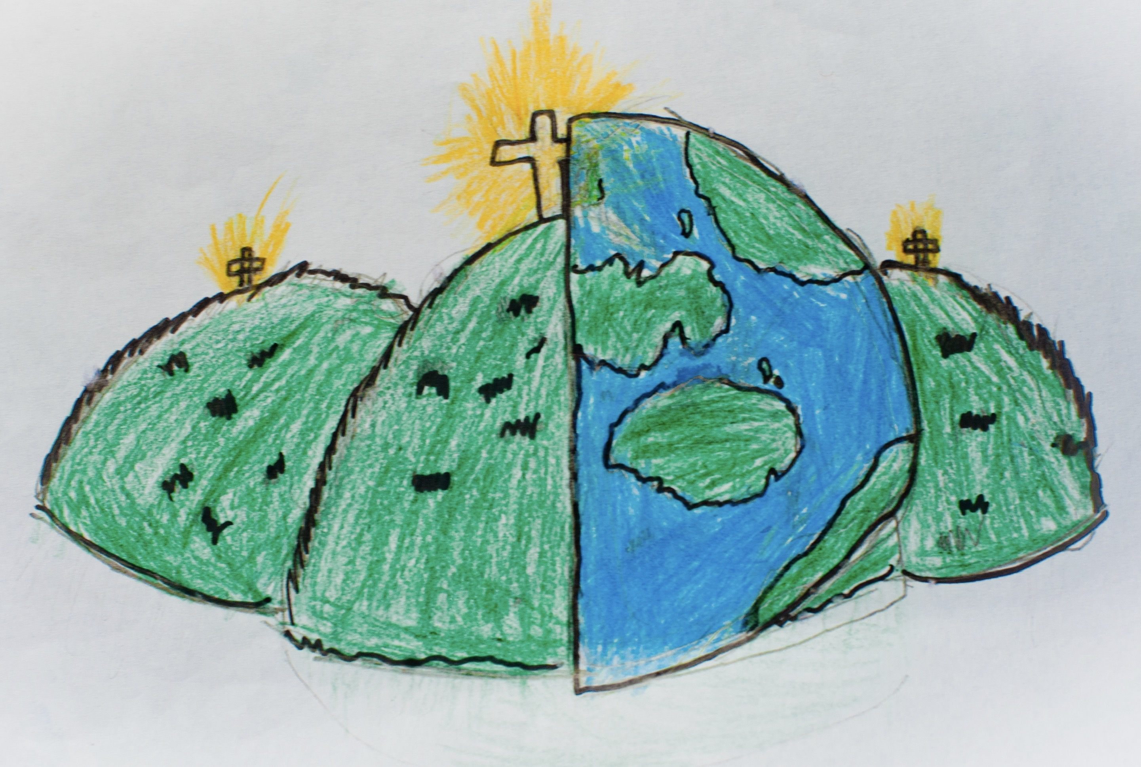

|  |  |  |
| --- | --- | --- |
| hunter-gather  A person who moves from place to place in search of food. | agriculture  Growing crops and keeping animals for food and materials (farming). | settlement  A place where people live together in a community. |
| tribe  A community of people, ruled by a leader, with shared traditions, ancestors and culture. | migration  When people move to live in a different place. | technology  Using knowledge to invent new devices or tools. |
| prehistoric  From a time in the past before there were written records. | archaeologist  A person who studies the past by excavating historical places and studying objects and remains. | Skara Brae  A Stone Age village on the Orkney Islands. |
| BC  Used to show that a date is before the year AD 1. This is counted backwards. | AD  Used to show that a date is after the year AD 1. This is counted forwards. |  |