Year 3

PSHE – Families & Being Safe

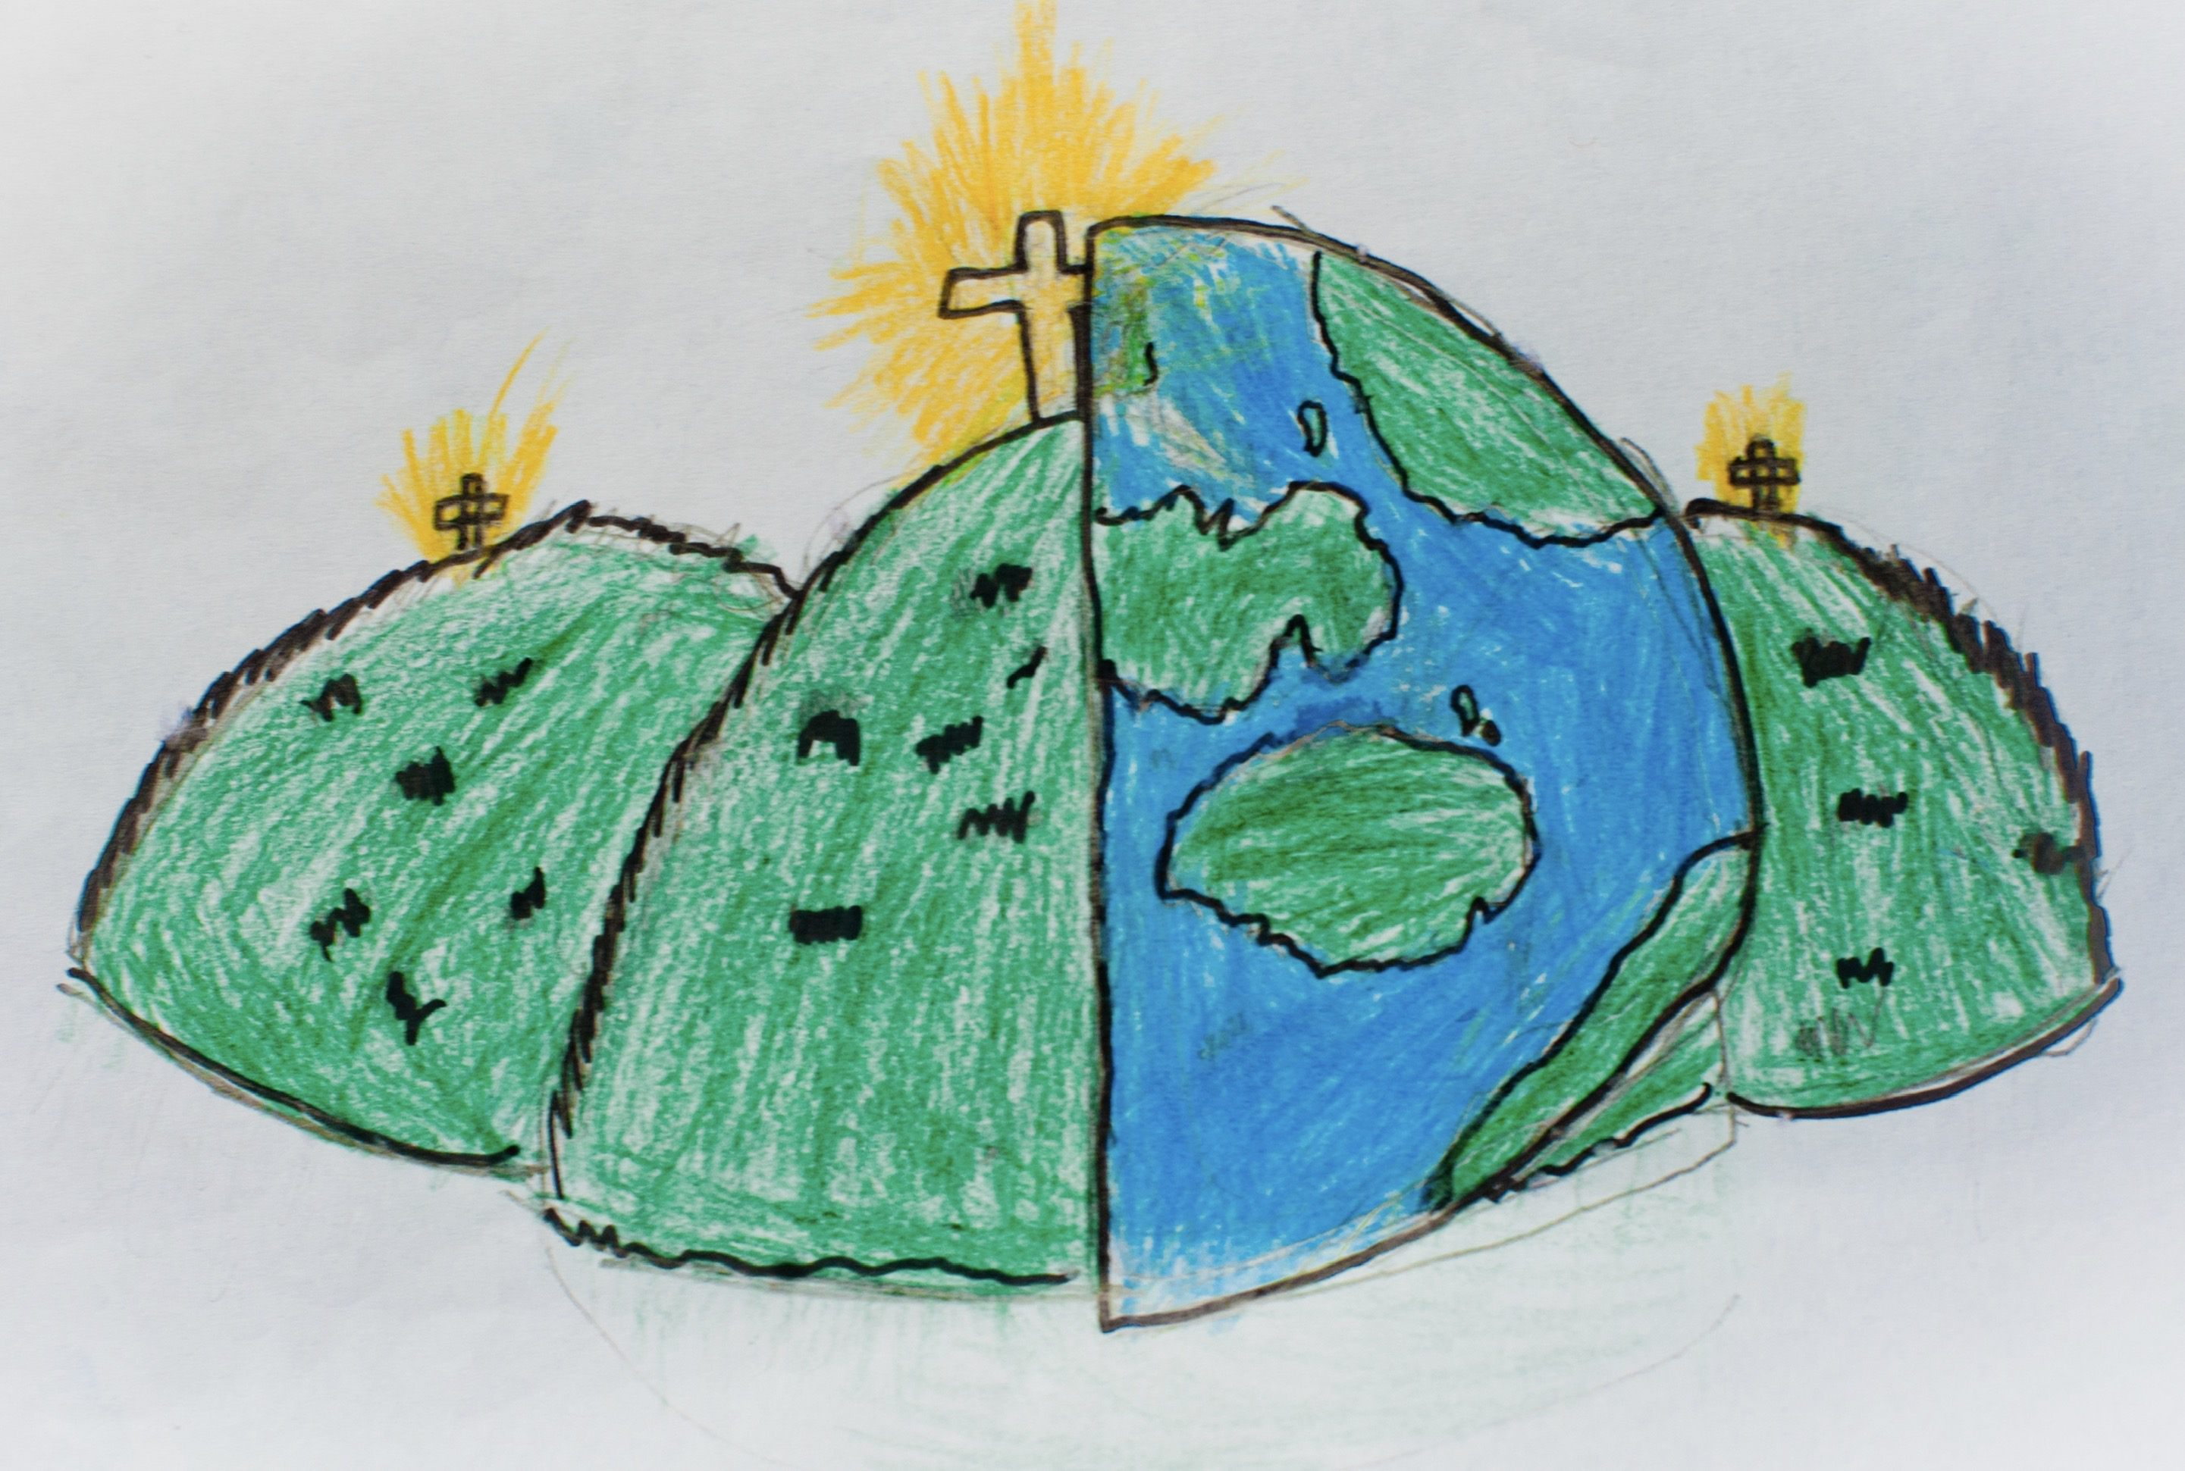

|  |  |  |
| --- | --- | --- |
| relationships | friendship | family |
| positive | care | confidential |
| sibling | relative  a person who is part of your family. | stereotype  an idea about someone based on what they might look like on the outside. |
| challenge | conflict | change |