Year 3

PSHE – Mental Wellbeing

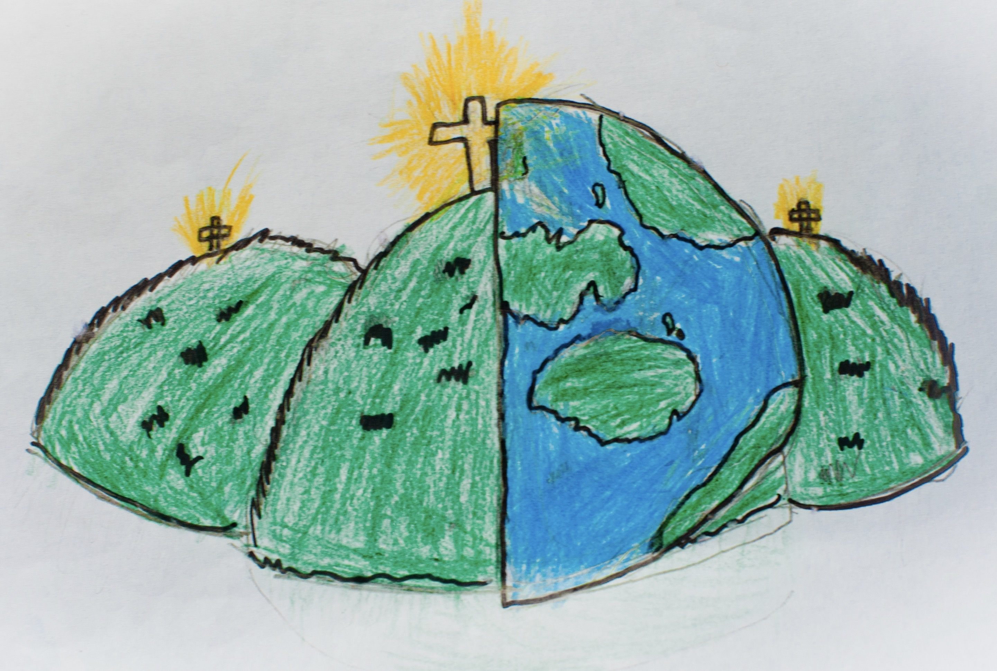

|  |  |  |  |
| --- | --- | --- | --- |
| Happy | Cheery | Joyful | Ecstatic |
| Pleased | Satisfied | Delighted | Overjoyed |
|  |  |  |  |
| Sad | Upset | Forlorn | Heart-broken |
| Scared | Anxious | Frightened | Petrified |
| Angry | Irritated | Cross | Furious |
| Worried | Concerned | Troubled | Distressed |