Year 3

Science – Forces and Magnets

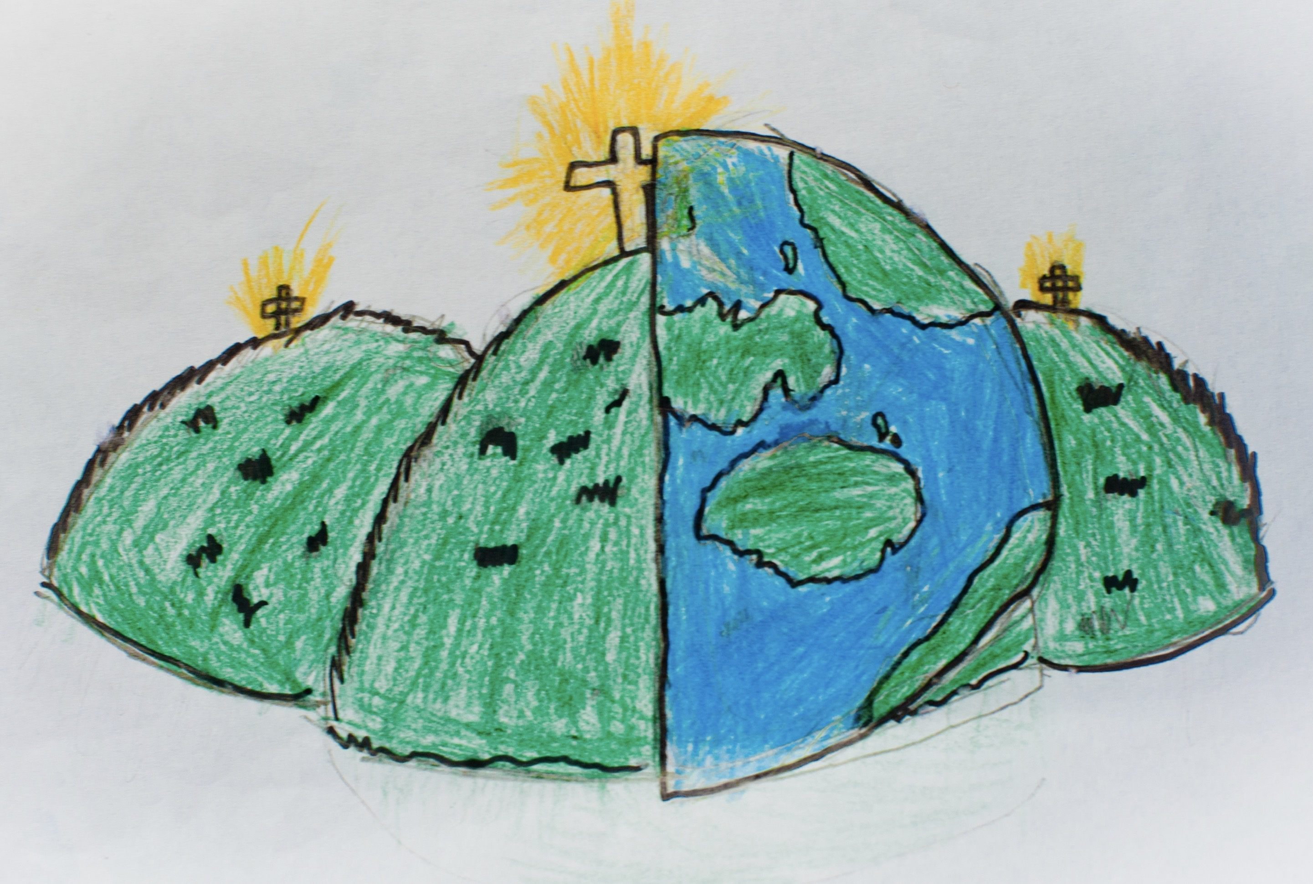

|  |  |  |
| --- | --- | --- |
| attract  When something moves closer to something else. | contact force  When something is moved when touched. | force  A push, pull or other which can make something move. |
| iron  A type of hard magnetic material. | magnet  An object that attracts other objects which have the same or similar characteristics. | magnetic  A push or pull between two objects. |
| material  What something is made of. | metal  A hard solid material. | north pole  The side of the magnet which is opposite to the south pole. |
| non-contact force  When something moves without anything touching. | poles  The sides of a magnet. | pull  To move something closer to you. |
| push  To move something away from you. | repel  When two forces are pushing opposite ways. | south pole  The side of the magnet which is opposite to the north pole. |
| steel  A type of metal. | strength  How weak or strong something is. |  |