Year 3

Science - Light

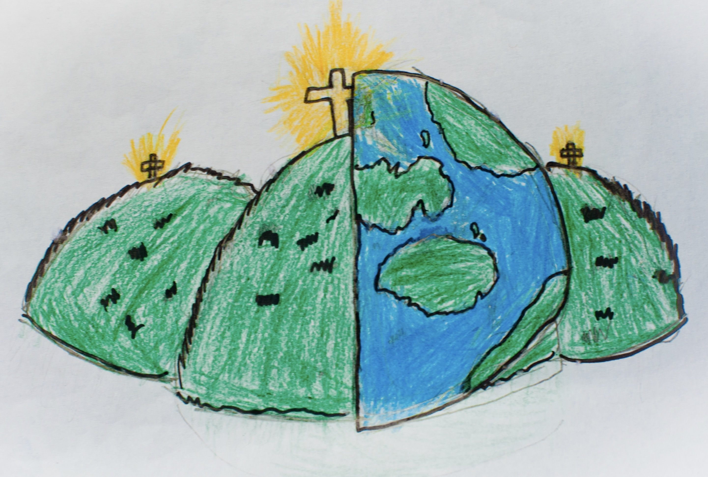

|  |  |  |
| --- | --- | --- |
| light source  Something which provides light. | absence of light  When there is darkness. | transparent  When you can see straight through. |
| translucent  Some light passes through but images are blurry. | opaque  You cannot see through it. | shiny  A surface which light reflects off. |
| matt  A dull, textured surface. | surface  The top of something. | shadow  It forms when something blocks the light. |
| reflect  When light or an image bounces back. | mirror  An object which provides reflection. |  |