Year 3

Science – Nutrition

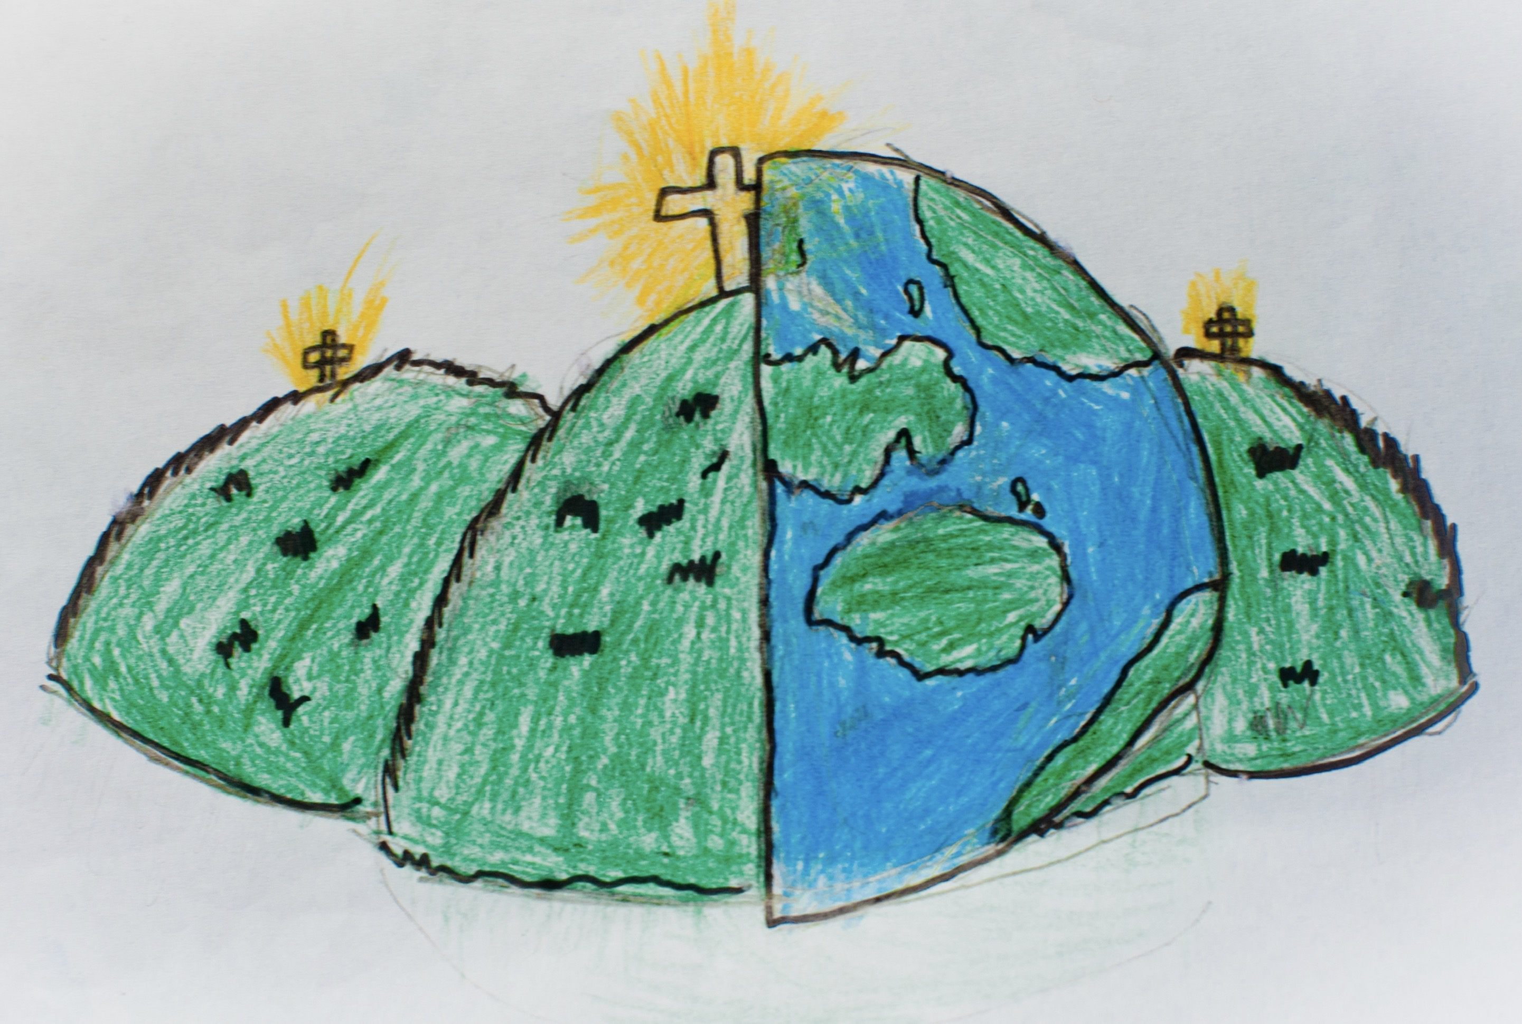

|  |  |  |
| --- | --- | --- |
| carbohydrates  The food group which gives you energy e.g. bread and pasta. |  | nutrition  Part of your diet and what keeps you healthy. |
| fat  They provide energy and help to build up your body. | protein  They help you to grow and your body to repair itself. |
| fibre  It helps you digest your food. | sugars  They give you energy but should be eaten with a balanced diet. |
| minerals  They build healthy cells. | vitamins  They build healthy cells. |
| nutrients  They build healthy cells. | water  A liquid that 70% of your body is made up of. |