Year 3

Science – Skeletons & Muscles

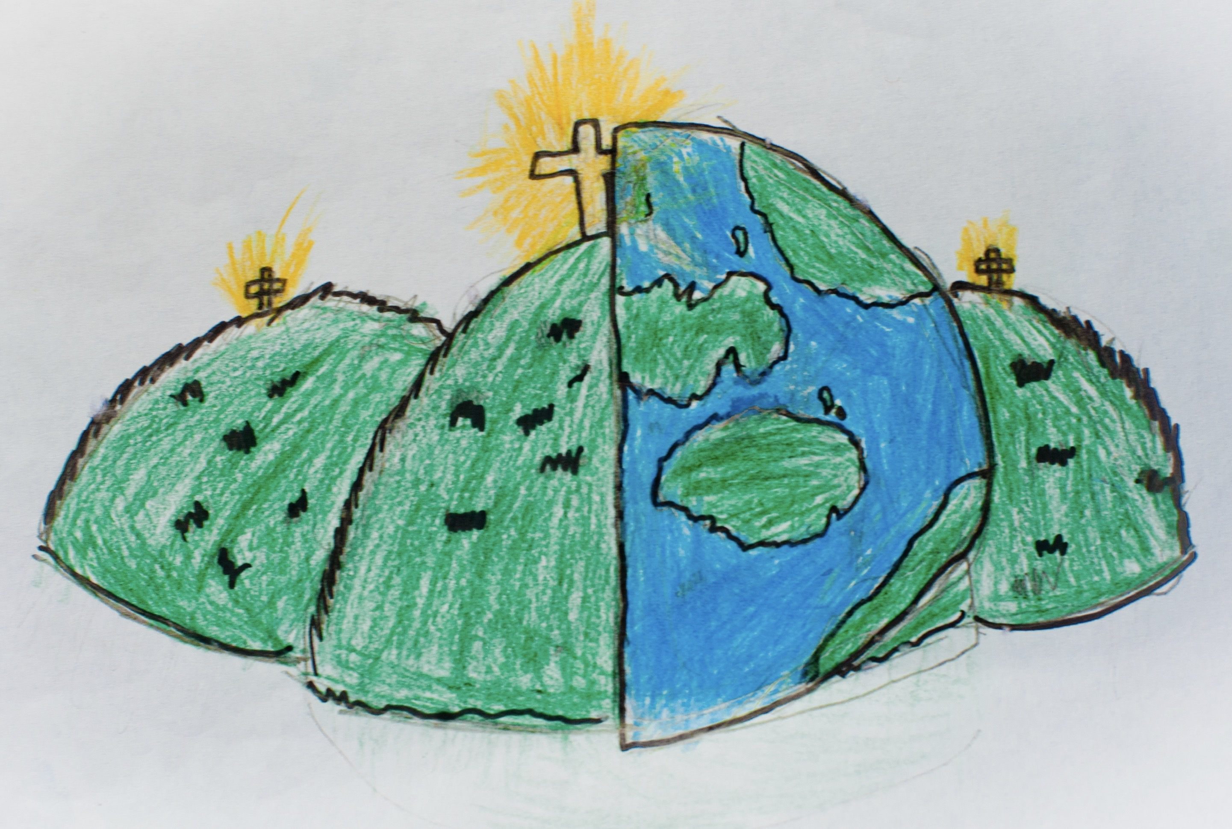

|  |  |  |
| --- | --- | --- |
| bones  The hard structure in your body. |  | move  The process of getting from one place to another. |
| muscles  They keep your body strong and help you to move. | ribs  The bones which protect your organs like your heart. |
| skeleton  All of your bones together which keep you standing. | spine  The group of bones which support your back. |
| support  To help. | joints  They connect your bones and help you to move. |
| protect  To keep someone/something safe. | skull  The big bone in your head which protects your brain. |