Year 5

Computing – Game Creator

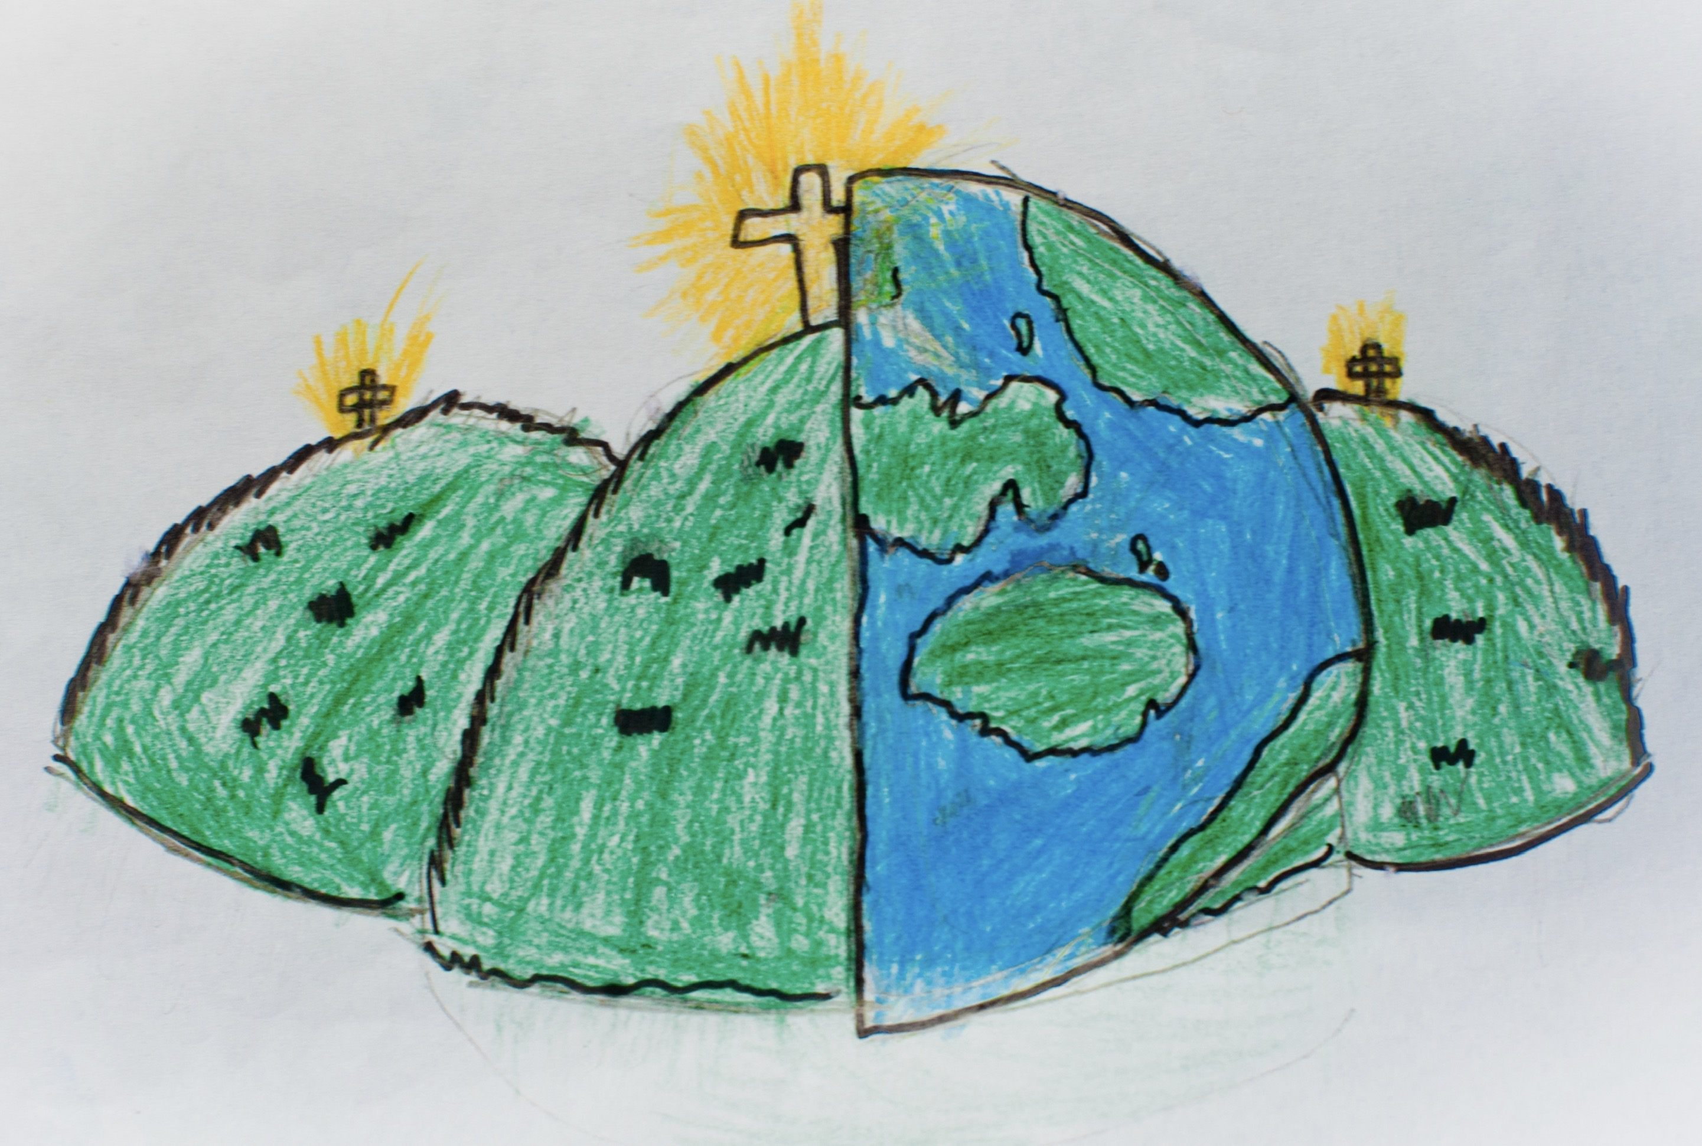

|  |  |  |
| --- | --- | --- |
| animation  Creating an illusion of movement. | computer game  A game played using a computer – typically a video game. | customise  Modify something to suit an individual or task |
| evaluation  The making of a judgement about the value of something. | image  In this case, a picture displayed on the computer screen. | instructions  Detailed information about how something should be done or operated. |
| interactive  Responding to a user’s input on a computer or device. | screenshot  An image of the data displayed on the screen of a computer or mobile device. | texture  High frequency detail of colour information on a computer-generated graphic. |
| perspective  Representing 3D objects on a 2D surface to give the right impression of their height, width, depth and position in relation to each other. | playability  A measure of either the ease by which a video game game can be played, or of the overall quality of its gameplay. | website  A set of related web pages located under a single name. |