Year 5

Music

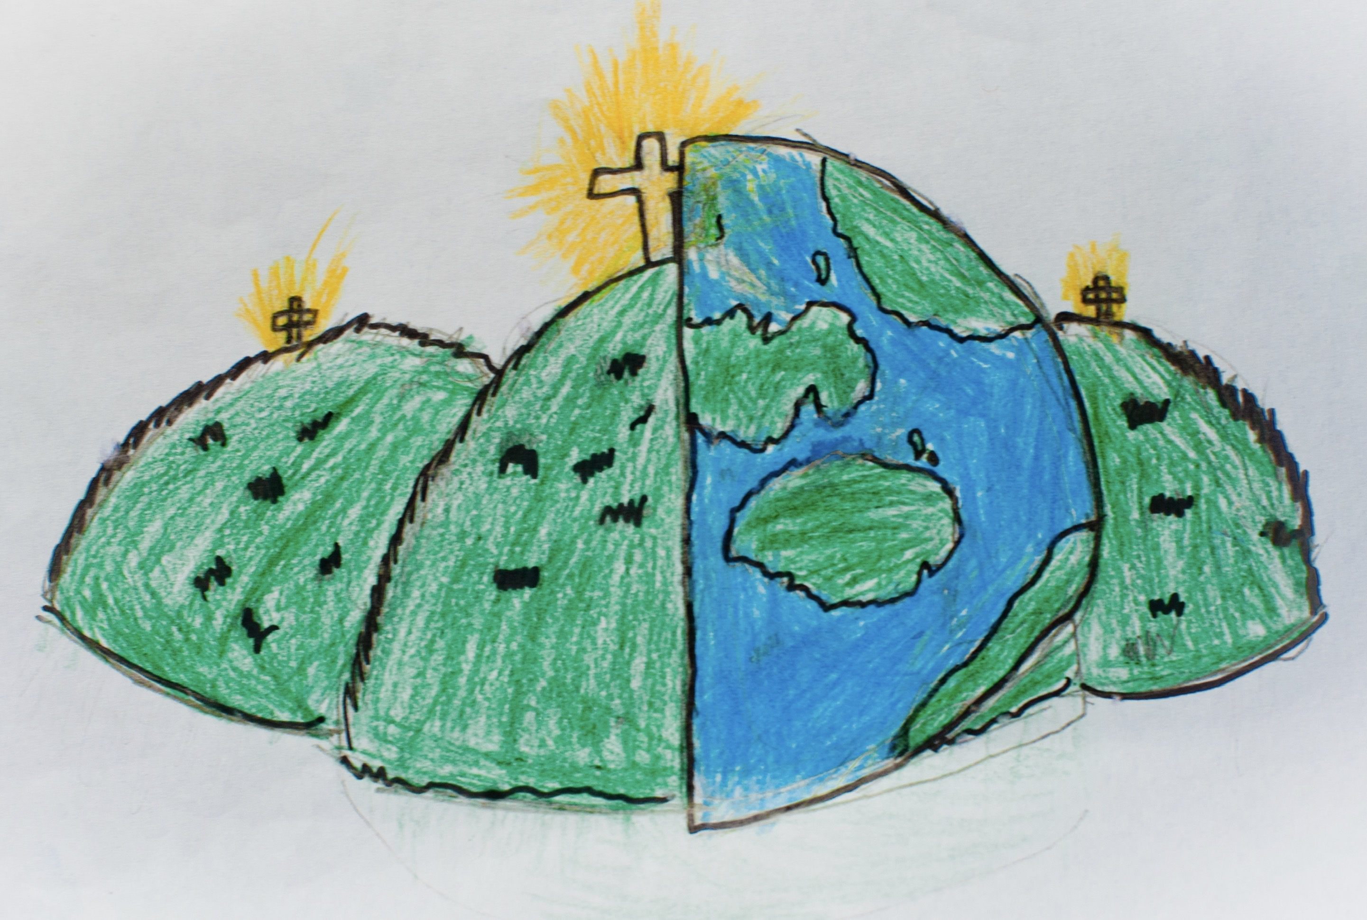

|  |  |  |
| --- | --- | --- |
| beat/pulse  The regular heartbeat of the music. | composition  The arrangement of music. | conductor  The person elected to lead a group of singers or instrumentalists. |
| diction  The style in singing. | dynamics/volume  The loudness of the music, described as loud/quiet. | ensemble  A group of musicians who perform together. |
| genres  A style/type of music | improvisation  A piece of music which is created spontaneously. | instrumental family  The group an instrument belongs to. |
| inter-related dimensions  The building blocks of music – duration, dynamics, pitch, structure, tempo, texture, and timbre. | lead vocal  The main voice part in a song. | melodies  A tune |
| notation  Ways of writing music down. | pitch  The complete range of sounds in a piece of music from the lowest to the highest. | rhythm  Patterns of long and short sounds played within a steady beat. |
| Solo  A piece of music for one singer or instrumentalist. | Structure  The way music is organised e.g. beginning, middle and end. | Tempo  The speed at which music is performed. |
| Texture  Layers of sound such as those created by a melody accompanied by a drum beat. | Timbre  All instruments, including voices, have a particular sound quality which is referred to as a timbre e.g. squeak. | Tuned Persucussion  Percussion instruments which make sounds with a defined pitch e.g. glockenspiel. |