Year 5

PSHE – Caring & Respectful Relationships

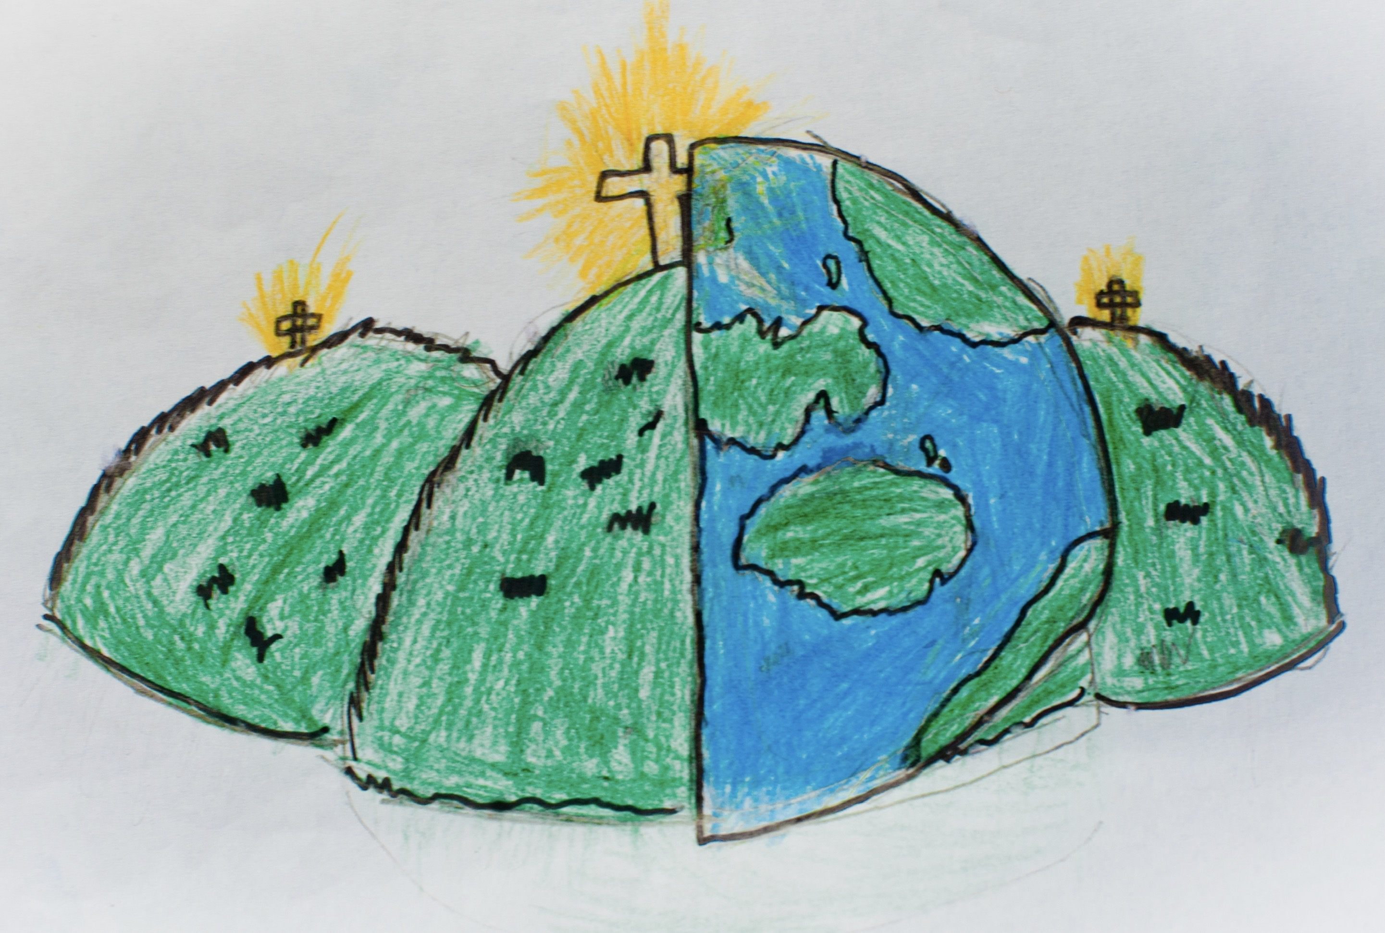

|  |  |  |
| --- | --- | --- |
| bullying – unwanted, aggressive behaviour that is persistent both in person and online | differences – a quality or uniqueness about a particular thing or person | healthy lifestyle – a balanced life that may involve good sleep, exercise, time outdoors, doing things for others, clubs and activities. |
| mental health – the way we think and feel about ourselves and the world around us. | online relationship – how and when you communicate with someone over technology. | peer influence – the control you let others around you have over your decisions. |
| peer approval – seeking out a positive response from those around you even if the action is not positive. | similarities – the things that someone/something have in common with another |  |