Year 5

Jesus the Teacher

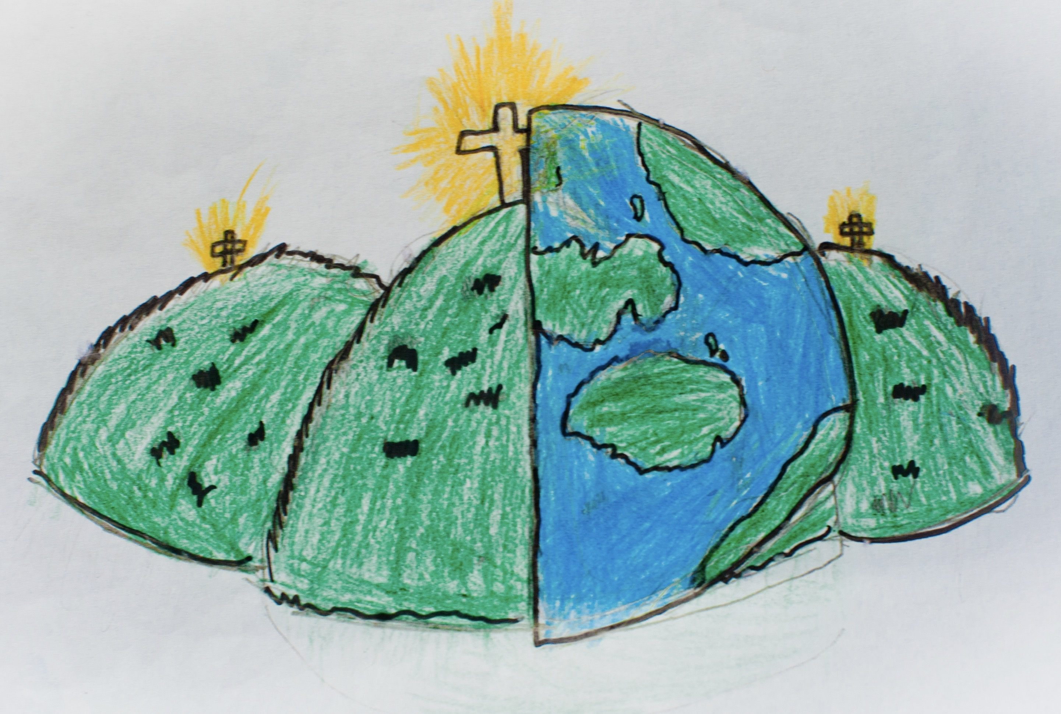

|  |  |  |
| --- | --- | --- |
| teacher | parable | prodigal |
| relevance | interpret | commitment |
| Kingdom of God | abstract | pearl |
| leven | metaphor | imagery |

|  |  |  |  |  |  |  |  |
| --- | --- | --- | --- | --- | --- | --- | --- |
|  |  |  |  |  |  |  |  |
| Creation | Fall | **People of God** | **People of God** | Incarnation | **Gospel** | Salvation | **Kingdom of God** |