Year 6

PSHE

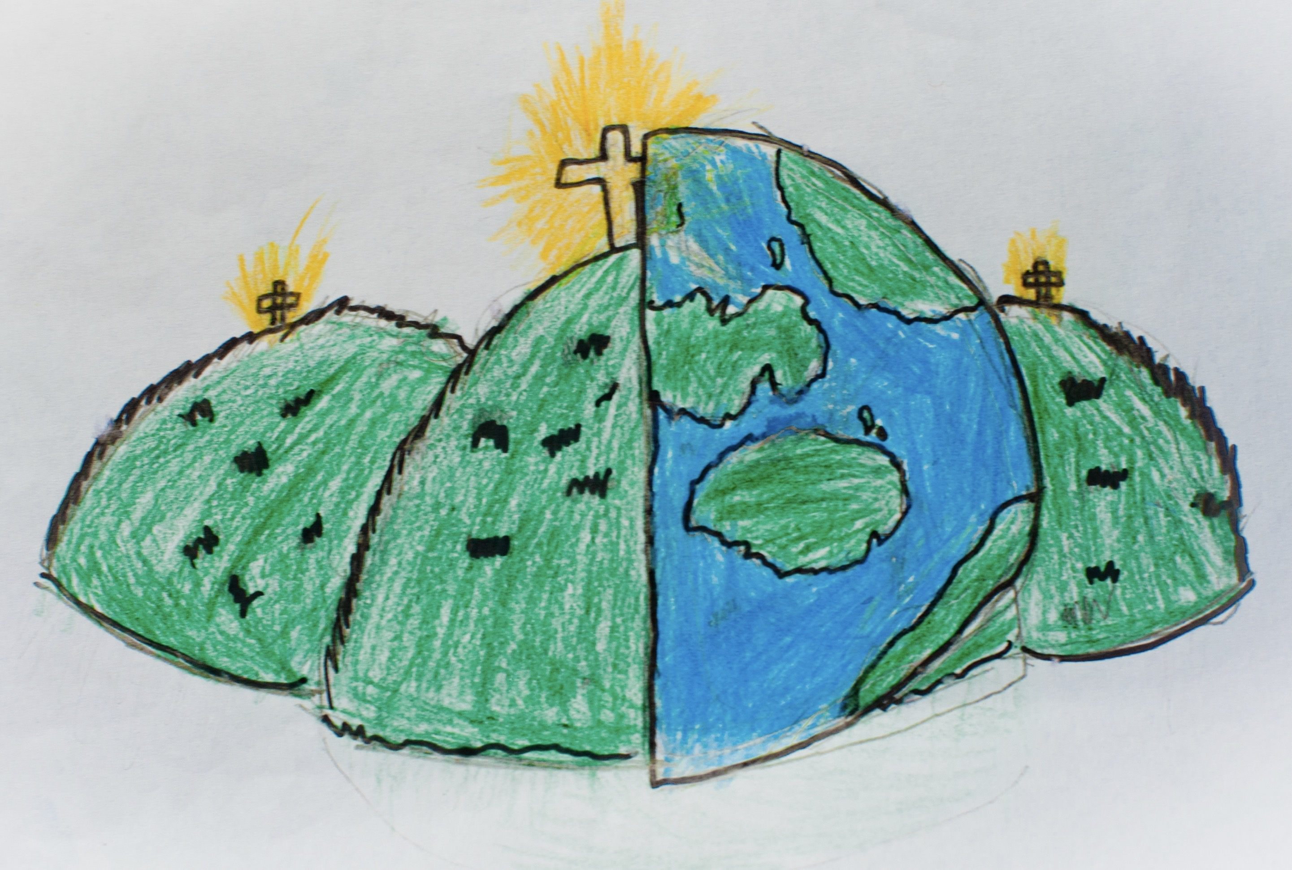

|  |  |  |
| --- | --- | --- |
| trusted adult – someone over the age of 18 who you can speak to in confidence. | communicating – share or exchange information, news or ideas. | healthy lifestyle – a balanced life that may involve good sleep, exercise, time outdoors, doing things for others, clubs and activities. |
| mental health – the way we think and feel about ourselves and the world around us. | emotions – our feelings and how we express these. | well-being – feeling comfortable, healthy and happy. |
| support – how you seek help and feel loved. | balanced lifestyle – health in all aspects of your life e.g. school, family, friends, clubs etc. |  |