Year 6

Health Education

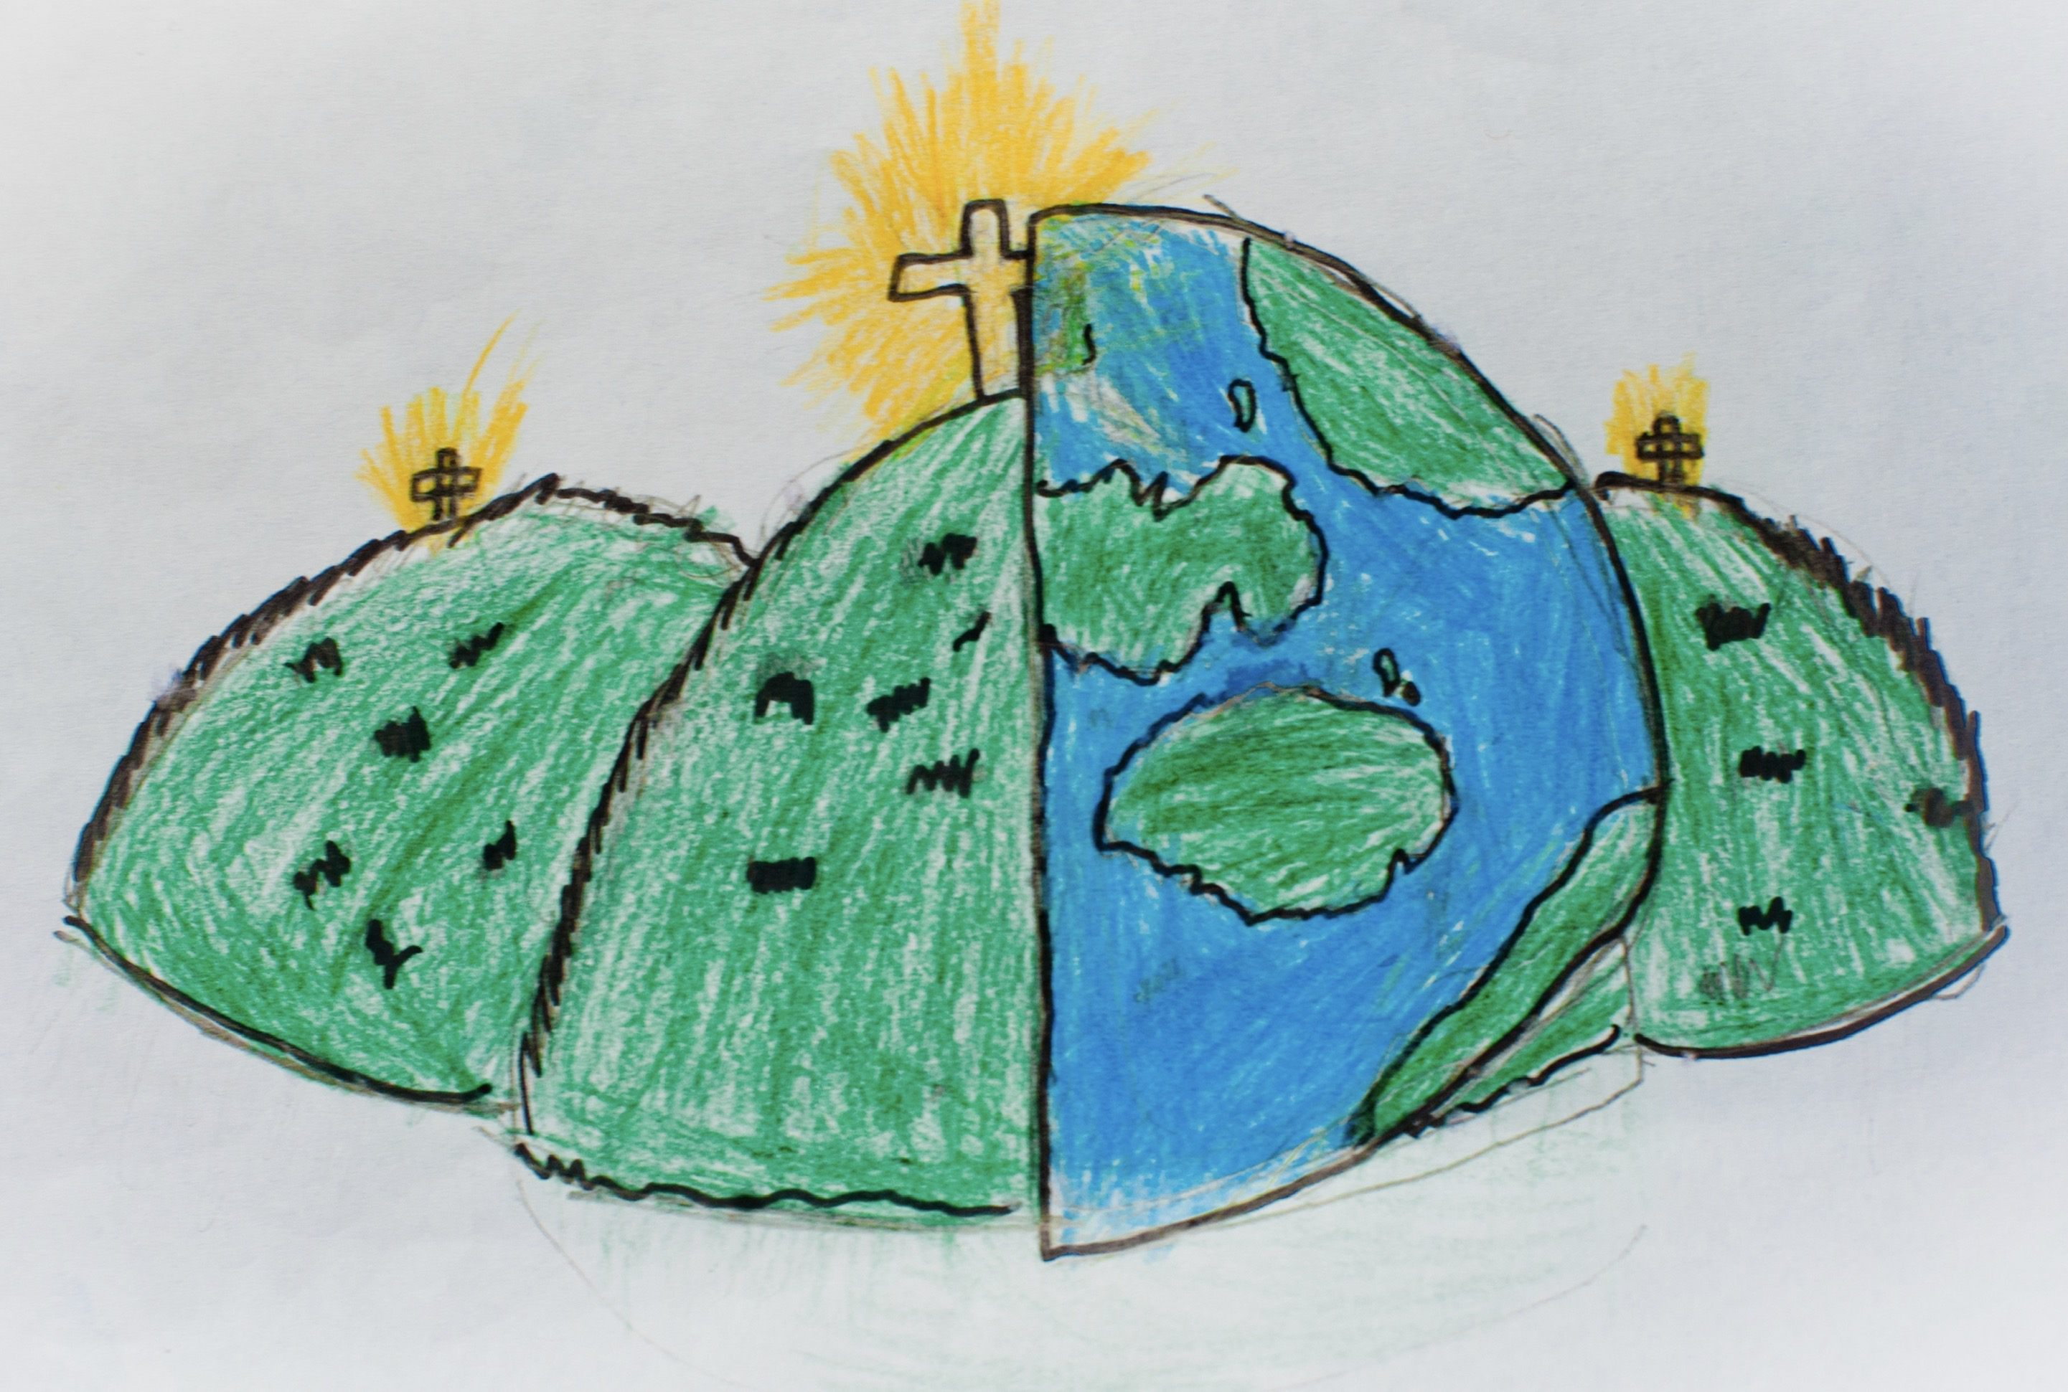

|  |  |  |
| --- | --- | --- |
| age – how old are you. | advice – seeking help or information. | conception – the point at which a baby is created. |
| contraception - medicine you can take to prevent pregnancy. | cycle – a female has a menstrual cycle which is inclusive and linked to her period. | egg – what males sperm meets to create a baby. |
| erection – when a males penis becomes hard. | gender – the roles and characteristics someone has which are decided upon by the person e.g. male or female. | human life – the stages within someone’s life e.g. infancy, childhood, teenager, adult. |
| lifecycle – the stages a living thing goes through in it‘s life. | love – a strong positive feeling towards someone or something. | menstruation - blood and tissue build up in the uterus to prepare for a fertilised egg in case a woman becomes pregnant. If the egg isn't fertilised, that lining leaves the body through the vagina and the girl or woman has her period. |
| organs – vital parts of your body that perform a particular function. | ovum — another word for the egg in a females body. | (biological) parents – the 2 people who have sexual intercourse to create a baby. |
| periods – the loss of blood a female experiences every 28 days. | pregnancy – the period after the sperm has fertilised the egg when the baby is growing inside a female. | puberty – the time when your body changes from being a child to an adult. |
| relationships – a connection between two people. | reproduction – the act of sexual intercourse where a baby is created. | responsibilities – tasks that you are given to do. |
| sex – where a male and female physically connect. | stereotyping – an idea about how someone will behave. | support – providing someone with the feeling of being cared for. |
| uterus - The uterus is the place inside a woman's body where a baby will grow. | vagina – the female organ which receives the penis during sex and serves as the birth canal during childbirth. It is where babies come out. | womb – the part of a female where the baby grows and develops in pregnancy. |