Year 6 Science – Animals including Humans

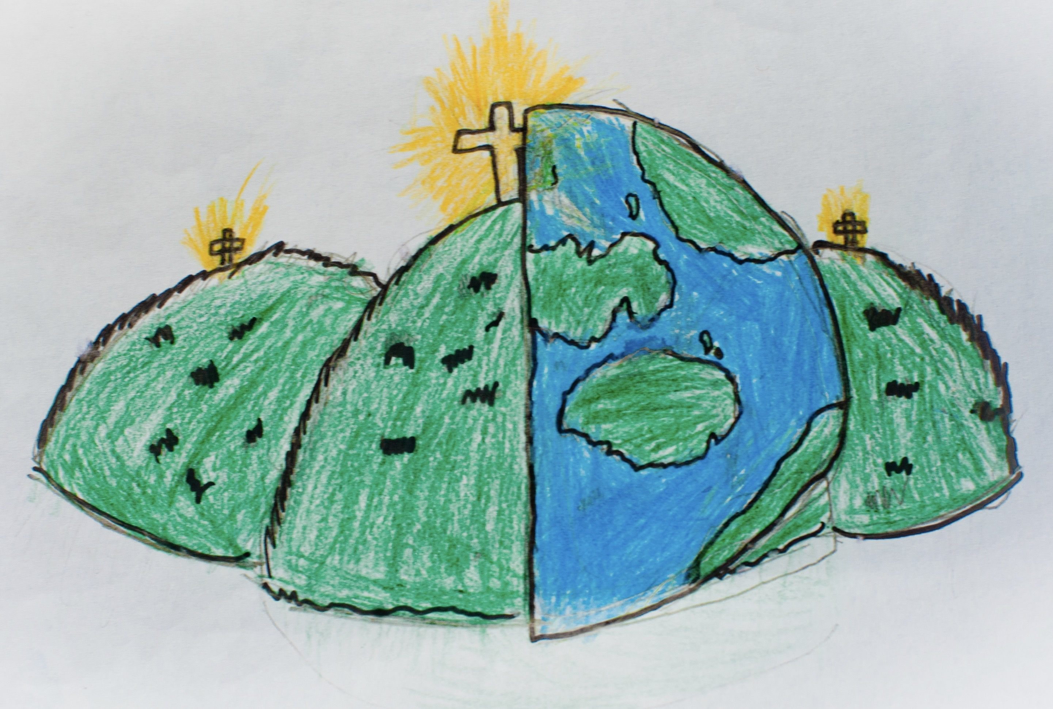

|  |  |  |
| --- | --- | --- |
| blood – the liquid in your body which carries oxygen and nutrients around your body. | blood vessels – the cells in your blood which store nutrients and oxygen. | carbon dioxide – the gas taken in by your body that is a waste gas. |
| circulatory system – the system which involved your heart and blood | cycle – a sequence which repeats. | diet – the balance of types of food and nutrients that someone eats. |
| drugs and lifestyle – the healthy and unhealthy choices people make for their body. | exercise – physical activity which is done to raise your heart rate. | lungs – the organ which allows us to breathe |
| muscles – what is needed to cause a force in your body | oxygen – the gas needed by your body to function | pulse – how quickly or slowly your heart is beating |
| pumps – the way your heart pushes blood around the body | transports – how something is moved. | water – a liquid needed in your body to function |