Year 6 MFL

Ma Journee

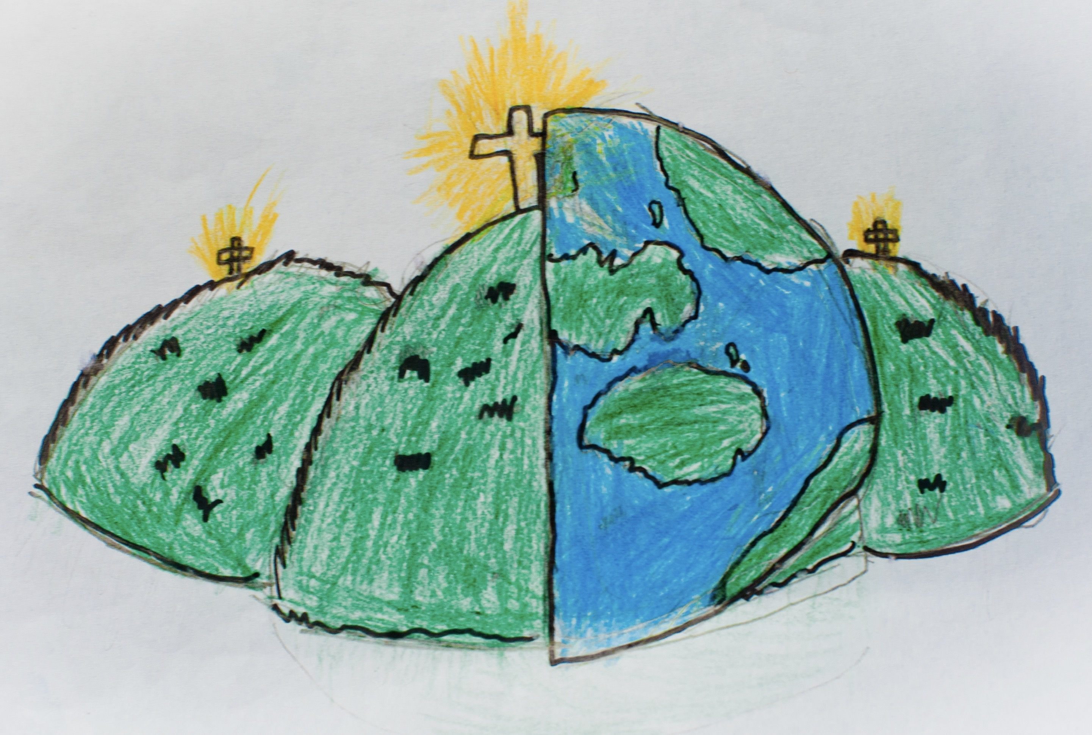

|  |  |  |
| --- | --- | --- |
| Ou vas-tu? – where are you going? | Je vais a lecole – I am going to… | en voiture – by car |
| en bateau – on a boat | Comment vas tu? – how are you? | a la boulangrie - |
| au marche – at the market | a la piscine – at the swimming pool | Qu’est-ce qu’on va faire? – what are we going to do? |
| Je voudrais des billets pour – I have found tickets for | C’est combien de billets? – how much for tickets? |  |