Year 6 MFL

Ma Journee

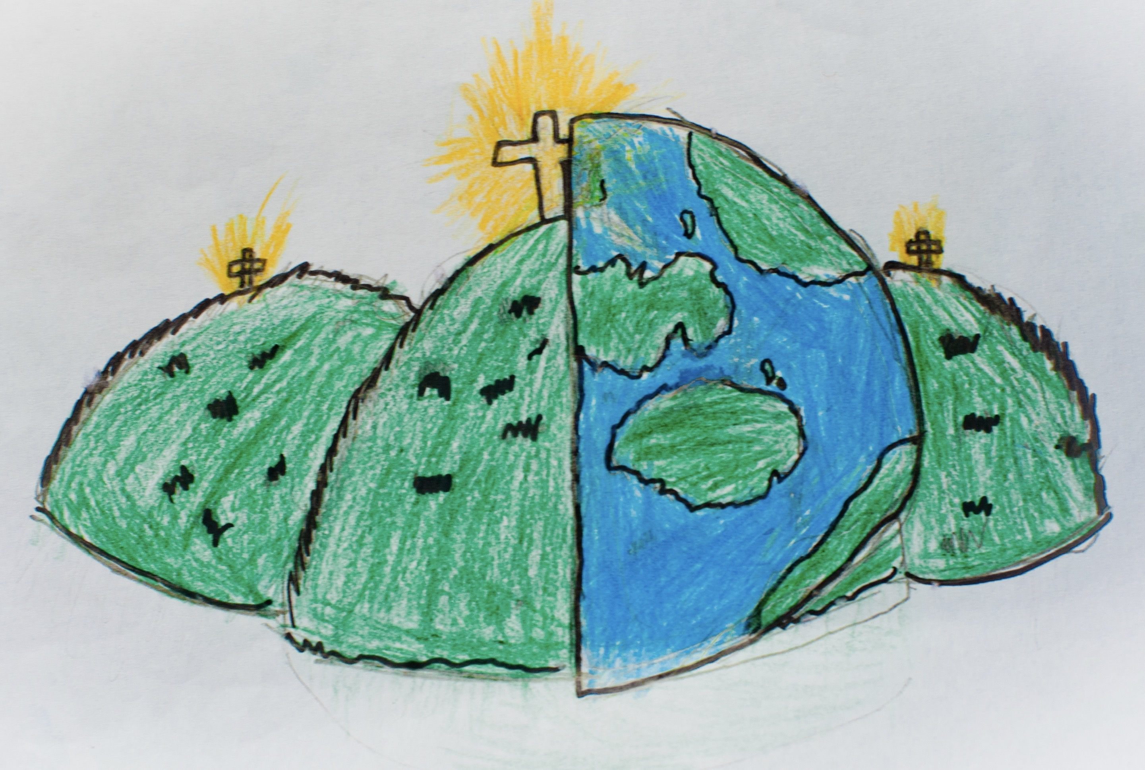

|  |  |  |
| --- | --- | --- |
| Je me leve - I’m getting up | Je prends mon petit dejeuner – I ate my breakfast | Je vais a l’ecole – I go to school |
| Je prends mon dejeuner – I am having lunch | Je quitte l’ecole – I finish school | Je prends mon diner – I have my dinner |
| Je me couche – I go to bed | Une heure – one o’clock | Qu’est-ce que tu prends au petit dejeuner? – what do you have for breakfast? |
| Je prends un chocolat chaud – I have a hot chocolate | Un jus de pomme – apple juice | Normlaement – normally |
| D’aboard – aboard |  |  |