Approved on:
July 2023
Next review:
June-July 2024
SEND Information Report
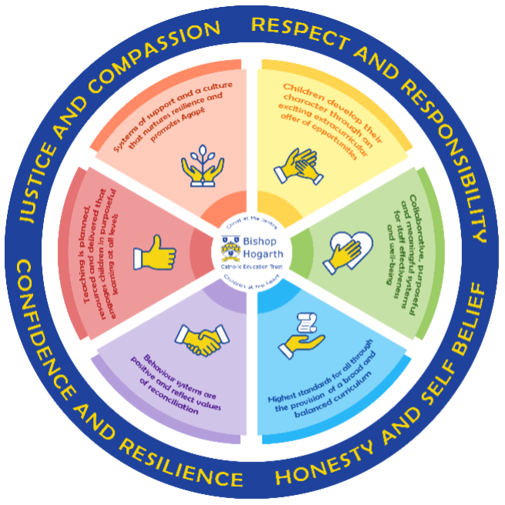
As part of the family of Bishop Hogarth Catholic Education Trust, our school has at its core, the virtues and values of:
Respect for others and ourselves, recognising that we are all created in the image of God and therefore must be compassionate towards others, especially the vulnerable. ​We should have confidence in our own abilities, knowing that our talents are gifts from God, and resilience to persevere when things become difficult. ​We should be honest in regard to the world around us and take responsibility for the times when we may fall short of the mark. ​We should show gratitude for all the amazing gifts from God and have a willingness to share these God-given gifts with others.

As an inclusive school, all teachers are teachers of students with Special Educational Needs & Disabilities. We deliver a challenging curriculum and create a supportive environment that meets the needs of every student within our school. We endeavour to ensure that every student with Special Educational Needs and/or disabilities makes the best possible progress. We foster and
promote effective working partnerships with parents, carers, students,
and outside agencies. We consider the ‘whole’ child and strive to ensure
that all our SEND students are well-prepared for adulthood.​

Our school’s approach to supporting students with SEND

We believe in promoting and supporting an ethos guided by the values of the Gospels where every student is unique and “called by name.” We endeavour to make appropriate provision for students with Special Educational Needs and/or Disabilities to enable them to achieve their full potential academically, personally, spiritually and socially within a safe and caring environment in which all of our students can grow to maturity in an atmosphere of mutual trust. The school is committed to constantly reviewing and evaluating its practices, systems and curriculum provision in order to achieve this.
We would ask parents/carers to discuss the identified needs with the school, prior to their child starting at St John’s so that appropriate intervention and support can be planned and implemented. Advice from the LA or other agencies may be requested to ensure that the school can meet any needs appropriately. Full details of the admission arrangements can be found in the Primary and Secondary Admissions brochure produced by Durham County Council.

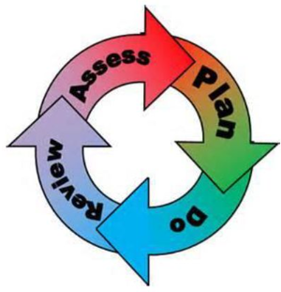
How will the school staff support my child?
Where a student is identified as having a special educational need, St John’s will follow a graduated approach which takes the form of a cycle: Assess, Plan, Do, Review. ​
• Assess a child’s special educational need. ​
• Plan the provision to meet your child’s aspirations and agreed outcomes. ​
• Do put the provision in place to meet those outcomes. ​
• Review the support and progress.

How does the school know if children need extra help and what do I do if I think my child has special educational needs?

- Assess
Identification – Your child will be identified as having SEND and/or a disability if they have a
significantly greater difficulty in learning than the majority of children of the same age, or if
they have a disability preventing or hindering the use of educational facilities provided for
children of the same age within the Local Education Authority. Cause for concern sheets may
be completed by staff that have initial concerns.
• First steps – If, from our rigorous tracking and monitoring of your child’s progress, it
becomes apparent that they are not making expected progress then you will be invited to a
meeting with their teacher(s) and Mrs Kreczak (SENDCo). Where appropriate, your child will be
involved in this meeting. At the meeting we will begin to explore the possible barriers to
learning and you will be asked how we can best support your child.
• Observations and assessments will then be carried out and, if required, input from specialist
services may be sought with your permission.
• Where appropriate, your child may be placed on our school’s SEND Support Register and a
SEN support plan will be devised by the SENDCO that will set achievable targets. These will
be reviewed and updated at least half-termly. Parents/Carers and the young person’s
views, where appropriate, are an integral part of this process.
• EHCPs (Education, Health and Care Plans) will be used when a child’s needs are deemed
more complex and require the input from a range of outside agencies. This could be in the
form of Educational Psychologists, Occupational Therapists or other professionals with an
area of expertise, e.g. Autism. An EHCP helps to determine the level of educational, social
and health support the child needs and will be considered if the interventions set out in the
assess, plan, do, review cycle have not been successful.

- Plan
Our procedures are in line with the SEND Code of Practice (2015).
The first point of contact is the class teacher, who has overall responsibility for the welfare of your
child. Additional provision is planned carefully and overseen by Mrs Kreczak, the SENDCo. The provision
is implemented by a skilled team of teachers and supported by experienced learning support assistants.

SEND Resources
At St John’s we have an extensive range of different SEND resources and interventions available.
These are closely matched to the needs of our children and their progress is monitored by the class
teacher, the SENDCo and staff with specific curriculum responsibilities. Interventions include:
• Talkabout for Teenagers - Developing Social and Emotional Communication Skills
• Precision Teach – Spelling intervention
• Beat Dyslexia – Specific learning disability intervention
• Nurture Group involvement
• Emotional Wellbeing and Effective Learning support
• Social, Emotional and Mental Health support
• Touch type intervention
• Lego therapy
• Drawing and talking intervention
• Zones of regulation support
• Comic strip conversations/social mapping
Where provision does not result in adequate progress, as outlined in the SEND Code of Practice, the
SENDCo should be consulted for advice and external agencies may be involved.

- Do
Our teachers are skilled at adapting teaching and learning to meet the diverse needs of students in each class. ​
Daily planning considers individual children’s needs and requirements and is annotated and adapted according to need. Explicit reference is made in the teacher’s planning to the needs of those children identified with SEND. ​

Adaptive teaching is approached in a variety of ways to support access to the curriculum and to ensure that all children can experience success and challenge in their learning. ​Grouping arrangements consider the different skills and abilities of each child. This ensures that learning is maximised. ​

Additional adults support groups and individual children with the long-term goal of developing independent learning skills. The class teacher monitors this support to avoid students becoming over reliant on support. ​We fully encourage parental support and offer opportunities for individual meetings with parents/carers to provide clarity and recommendations on how they can best support their child at home.

- Review
If, despite all steps taken, good progress is still not being made, we will refer to our graduated approach and increase/change support whilst continuing to monitor and review progress. It may also be necessary at this stage, to consult with the expertise and specialist services secured by the school. Parents/carers that have children on the school’s SEND Support Register, are also invited to termly reviews of their child’s Individual Education Plan. Review sessions are held every term to look at the effectiveness of the SEN support plan and interventions in place to help the student. If these are not successful, they will be reviewed and modified and other external support may be sought.

For every child who is in the care of the Local Authority, (a looked after child - LAC), a Personal Education Plan (PEP) will be devised. This plan will establish clear targets and actions to respond effectively to each child’s needs and provide a continuous record of their achievements. If your child has an EHC plan, you will be invited to an annual review of this plan.

Homework is set regularly, and your child may have the opportunity to access computer programmes to support their learning at home through the school website. You are encouraged to support your child’s learning at home. Home/school planners are used to support communication between home and school and MyEd messaging is used extensively between school and home to keep parents/carers informed.
How will the curriculum at our school be matched to my child’s needs?
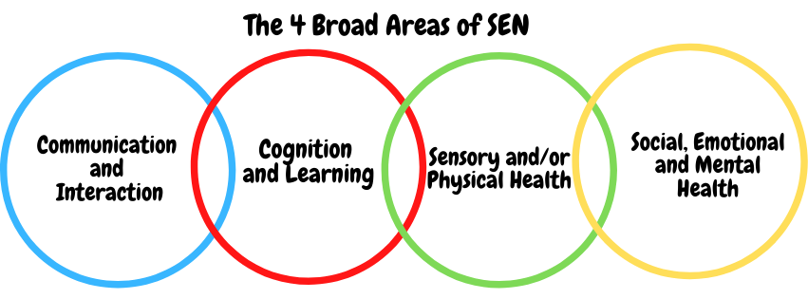
SEN needs are classified under four broad areas of need. Below are the strategies, in-class support and interventions that school may put in place to support your child.

Communication and Interaction
Strategies to support children with these needs include:
- Access to small group and/or individualised interventions to develop skills in communication
and interaction with others, e.g. Talkabout, social stories, comic strip conversations
- Visual/pictorial timetables for students
- Flexible approaches to the timetable
- Modifications to lunch and/or break times, e.g. quiet lunch area, access to the Arc
- Access to additional aids/technology
- Explicit teaching of generalising skills from one context to another
- Careful planning of transitions, e.g. advance notice, familiar resources
- Mentoring and/or buddy systems
Cognition and Learning

Strategies to support children with these needs include:
- Regular, individually focused interventions, e.g. literacy and numeracy: Beat Dyslexia, Precision Teach, Accelerated Reading.
- Access to small group support in class
- Practical aids for learning, e.g. table squares, time/number lines, pictures, photos, accessible reading material suited to age
- Increased access to ICT programmes, e.g. Touch typing, chrome books
- Flexible groupings
- Access to technical aids e.g. spell checker, reader pen, ICT software and/or hardware
- Adaptations to assessments to enable access e.g. readers, scribe, ICT, extra time
- Curriculum/delivery adaptations to meet the learning needs of individuals
Sensory/Physical

Strategies to support children with these needs include:
- Adapted curriculum to enable full access e.g. alternative recording devices, modified PE curriculum
- Sensory resources available e.g. wobble board, headphones/ear guards
- Access to support for personal care, e.g. school nurse service
- Enlargement of resources and modified resources
- Transcripts and ICT software

Social, Emotional and Mental Health
Strategies to support children with these needs include:
- Access to time out (passes)
- Mentoring/Buddy system
- Access to counselling services, e.g. CAMHS or school counsellor
- Increased access to additional adults in and out of the classroom
- Supported transition programme with chosen Post 16 provider
- Opportunities to develop social and emotional aspects of learning through small groupwork, e.g. Talkabout
- Access to the emotional resilience nurse

What training is provided for staff supporting children with SEND?
Whole school training is delivered by Lucy Kreczak, SENDCO, and external agencies. Examples of such training include Understanding Autism and Understanding Specific Learning Difficulties. A half termly handout is created and circulated by the SENDCO that explains an area of SEND and suggested strategies to engage students; free e-learning courses are distributed to all staff to complete. New staff and NQTs take part in a SEND induction where they have a session with the SEDNCO and shadow a learning support assistant to gain an insight and understanding of how we approach SEND at St John’s.

How do we support transition in our school?

Transition between classes/key stages: ​

Early passes can be obtained by students that struggle with transition between classes. This allows students to walk freely around less congested corridors so takes away without the pressure of sensory overload. Buddy systems can also be used for students that struggle to move between lessons. Students remain with the same Head of Year throughout Years 8-11, which allows continuity across the Key Stages.

Transition to Secondary/Post 16 settings: ​

We work closely with all primary schools. We have 11 Catholic primary feeder schools but we also take students from other local primary schools. The transition process begins early, usually in Year 5 for Primary to Secondary Transition for some of our more vulnerable children. This process may involve several visits to St John’s to become more familiar with the environment, staff and students.

At post-16, a significant number of our Year 11 students choose to continue their studies at St John’s Sixth Form. Other students decide to study at FE Colleges. Transition for secondary to post-16 begins early (Year 10) for some of our more vulnerable students. This process may include meetings with our Director of Sixth Form and our Key Stage 5 subject staff. Several visits to other FE Colleges in the area may also be arranged for targeted students.

Meetings are held for the transfer of essential information relating to SEN support plans, EHCPs, Child and Family Services and pastoral matters. Louise Wilkinson, our Transition Coordinator, works closely with the SENDCo, our Welfare Team and Year 6 class teachers to support children who require additional provision during their transition period. When reviewing an EHCP for children in Year 6, Lucy Kreczak (SENDCo) will attend the annual review where possible. The Preparing for Adulthood Pathway will be used to aid planning.

Transition to a New School

If your child moves to a new school within or at the end of an academic year, our SENDCo will contact the school’s SENDCo to ensure they know about any special arrangements or support that needs to be made for your child. If necessary, a meeting will be arranged with other professionals. Our SENDCo will also transfer all records held for your child to the new school as soon as possible.

Where can I get further information about services for my child?

The Local Offer

Durham County Council local offer can be found here:

https://www.durham.gov.uk/article/3722/About-the-Local-Offer-in-County-Durham

Parents/carers can seek further advice from SENDIASS on 03000 267 007 or sendiass@durham.gov.uk

What key school documents refer to support and provision for students with SEND?

- SEND Policy​
- Admissions Policy​
- Supporting Students with Medical Needs Policy​
- Accessibility Plan​

Accessibility​

With due regard to our admission policy, parental choice and accessibility of the school building,
all children with special educational needs who apply will be accepted by the school.
• The ground floor is fully wheelchair accessible.
• Disabled toilet facilities are located near the main school entrance and at student reception.
• Communication with parents/carers whose first language is not English is supported by advice from
Durham Local Authority’s English as an Additional Language (EAL) team.

Activities Outside of School​

St John’s is a fully inclusive school and we will provide appropriate support, wherever possible, to enable
your child to be educated alongside their peers. This may include extra staffing, where possible, and/or equipment.

Staff, who are arranging an offsite trip, will discuss with parents/carers and the SENDCO any requirements needed and the suitability of any trip which the school is organising. We will not stop your child from going on a trip due to their special educational needs and/or disability. We will ensure that the trip is suitable for your child, prioritising the safety of your child and the safety of others. The Deputy Headteacher (Chris Parker) oversees all trips to ensure children are safe and included where possible.

What to do if you have a complaint, a compliment, or a query.

St John’s details and relevant contacts
St John’s welcomes compliments and feedback on our provision for SEND students as we seek to improve on the quality of education we provide. We like to hear from parents/carers about their child’s experiences. Compliments, complaints and feedback can be sent to the school email address staff@stjohnsrc.org.uk and the email will be passed to the relevant staff member. Alternatively, parents/carers can speak to the class teacher or pastoral tutor as well as making an appointment to meet with the SENDCo or Head of Year. If matters are unresolved, parents/carers can seek further advice from SENDIASS on 03000 267 007 or sendiass@durham.gov.uk If the concern is directly related to decisions around an EHC Assessment or EHCP, this will be managed directly by the Durham Statutory Casework Team. Parents/carers will be contacted directly by the team to receive information about mediation and other services.
​
Names of St John’s SEND Governors

Ann Wake, Chair of the Local Governing Committee
Mary Wood, Foundation Governor
Jeanette Shaughnessy, Foundation Governor
Joanne Walton, Community Governor

