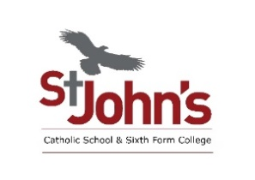

**ADMISSIONS POLICY 2026-27 CONSULTATION RESPONSE FORM**

**Do you agree to the policy for 2026-2027?**

|  |  |  |  |  |
| --- | --- | --- | --- | --- |
| Strongly agree | Agree | Unsure | Disagree | Strongly Disagree |
|  |  |  |  |  |

**Please give any comments below:**

**Are you?** (**please tick and use the space provided to state which school you are from):**

A parent/carer of a student………………………………………………………………………………….

Staff member of a school/academy ………………………………………………………………..…….

Student …………………………………………………………………………………..

Governor …………………………………………………………………………………..

**Other representative**: **(please tick and use the space provided to state which organisation you are from):**

Diocesan representative ………….………………………………………………………

Union ………….…………………………………………………………………..…

Voluntary Sector representative…………………………………………………………………………………..

Other ………………………………………………………………………………….

**If you wish to let us know your name and address, please complete your details below:**

**Name:**

**Address:**

This response form should be emailed to [jsummerbell@stjohns.bhcet.org.uk](mailto:jsummerbell@stjohns.bhcet.org.uk) or posted to: Jayne Summerbell, St John’s Catholic School & Sixth Form College, Woodhouse Lane, Bishop Auckland, County Durham, DL14 6JT.

Response forms should be returned **no later than Monday, 27 January 2025.**

Thank you for your views.