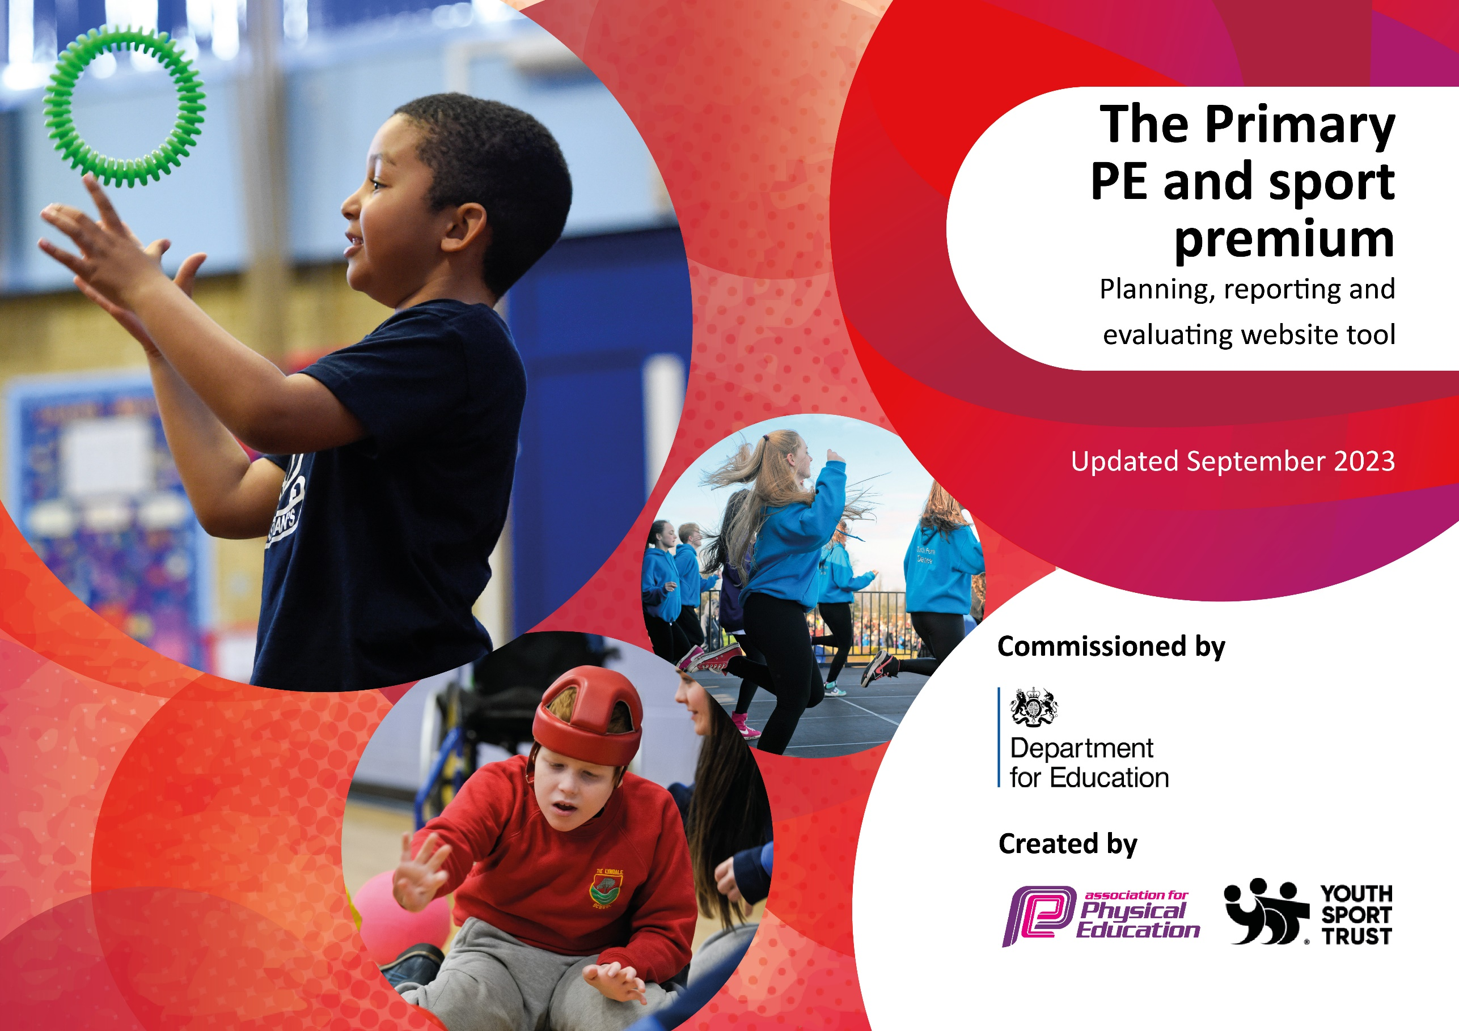

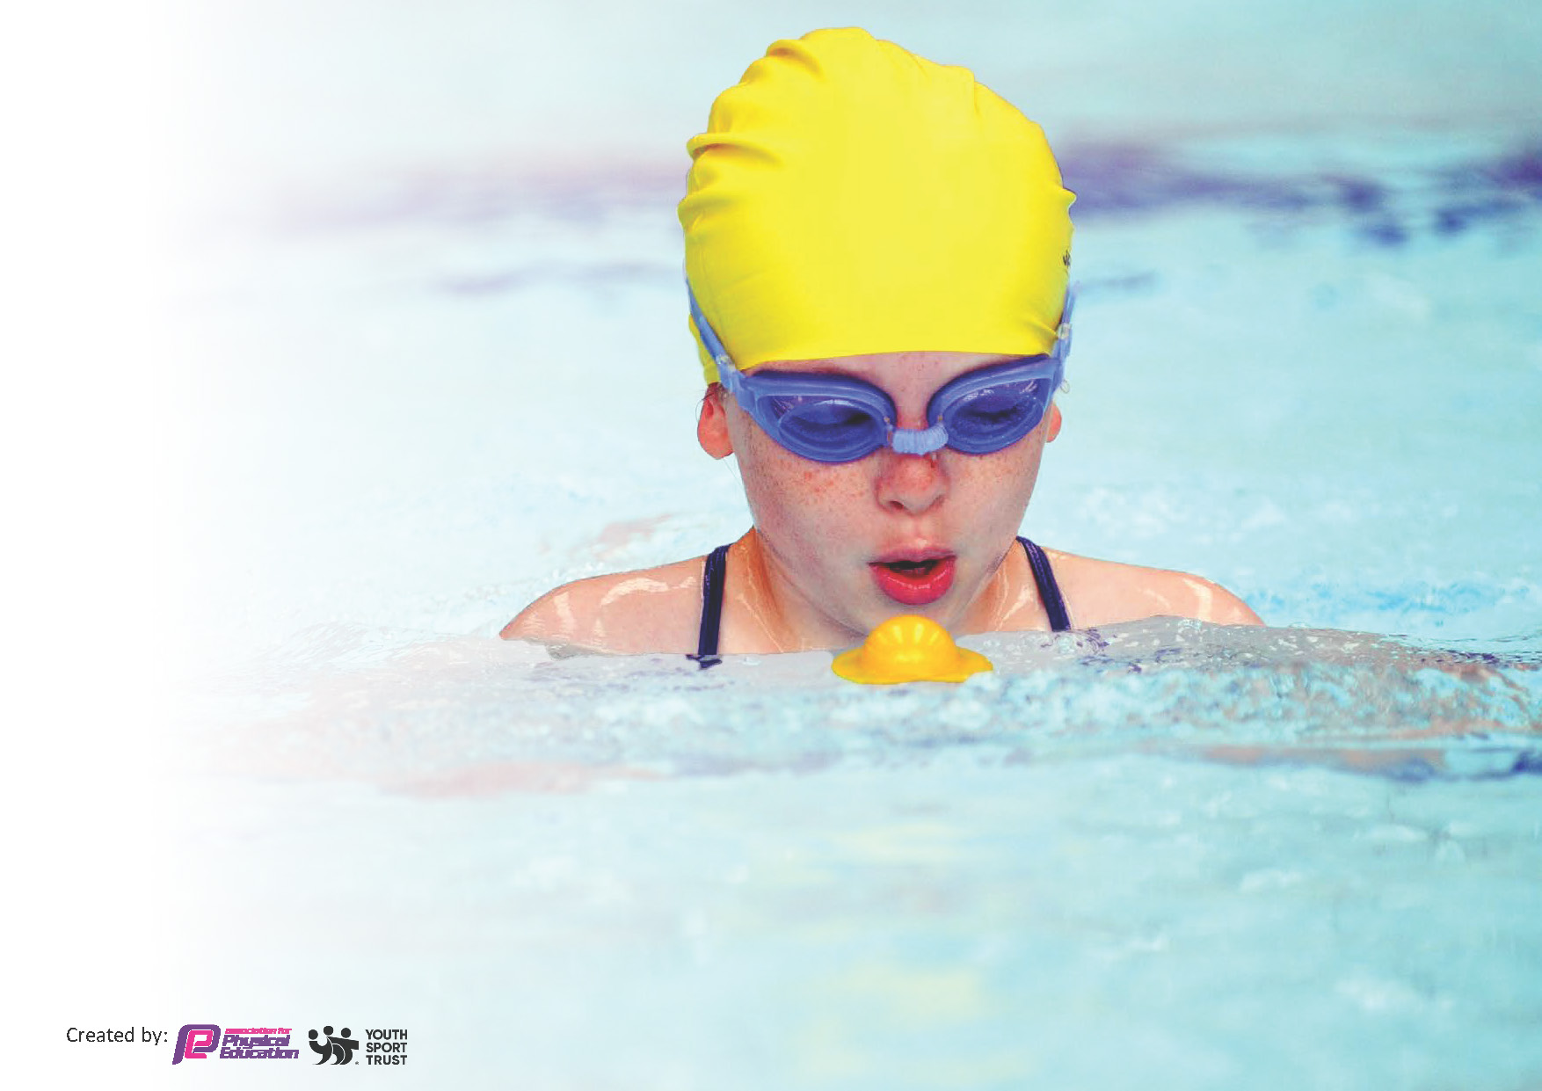
This template can be used for multiple purposes:
by:
- It enables schools to effectively plan their use of the Primary PE and sport premium
- It helps schools to meet the requirements (as set out in guidance) to publish information on their Primary PE and sport premium
- It will be an effective document to support Ofsted inspections enabling schools to evidence progress in Physical Education (PE) and evidence swimming attainment, which forms part of the PE National Curriculum. We would recommend schools consider
the Intent, Implementation and Impact of any spend, as examined within the Education Inspection Framework.

It is important that your grant is used effectively and based on school need.

Schools must use the funding to make additional and sustainable
improvements to the quality of the PE, School Sport and Physical Activity (PESSPA)
they offer. This means that you should use the Primary PE and sport premium to:

- Build capacity and capability within the school to ensure that improvements made now will benefit pupils joining the school in future years
- Develop or add to the PESSPA activities that your school already offers.

The Primary PE and sport premium should not be used to fund capital spend projects; the school’s core budget should fund these. Further detail on capital expenditure can be found in the updated Primary PE and sport premium guidance.

The Primary PE and sport premium guidance, outlines 5 key priorities that funding should be used towards. It is not

necessary that spending has to meet all the key priorities, you should select the priorities that you aim to use any funding towards.

Although completing this template is not a requirement for schools, schools are required to publish details of how they spend this funding. Schools must also outline what the impact this funding has had on pupils’ PE and sport participation and attainment and how any spending will be sustainable in the future. All funding must be spent by 31st July 2024.

The Department for Education has worked closely with the Association for Physical Education (afPE) and the Youth Sport Trust (YST) to develop this template and encourages schools to use it. This template is an effective way of meeting the reporting requirements of the Primary PE and sport premium.
Review of last year’s spend and key achievements (2022/2023)

We recommend you start by reflecting on the impact of current provision and reviewing your previous spend.

Activity/Action | Impact | Comments
Children had access to high quality resources during play time (Playground floor markings, playground equipment, playground toys set aside for play times). Enough quantity of resources to enable access for all  Purchased soft playground balls.  Afterschool clubs delivered by sports coach.  PE coach in school for 1 full day delivering PE lessons to all children. To upskill teaching staff  Tennis sessions delivered to all children Y1-6  Swimming sessions delivered to all Y4/ Y5 and any Y6 children who still need opportunity to swim 25m. | All pupils from Reception - Y6 had opportunities to play with PE equipment, playground markings and playground equipment at playtimes. Increased participation of sport during playtimes.  Increased participation of sport during playtimes. Replaced hard, worn balls with soft playground balls so children could enjoy ball games safely.  Increased participation in sport ensuring children are active, engaged and taking part in competitive sport  Children had a positive and fun experience in school sports and PE.  Tennis coach delivered additional tennis lessons to increase skills and engagement in the sport and helped with their confidence in a range of sports.  Children had a positive and fun experience in swimming whilst also building confidence, strength and the ability to swim in different swimming styles. | Opportunity for Year 6 children to take on responsibilities through PE leadership. Children would organize games at lunchtimes with the equipment and allocate the resources to different days.  More participation is clear but constantly needs monitoring as more balls have needed to be brought in.  The children loved the variety of clubs we offered this year and there was a high-intake of children.  Pupil voice shows that children love their PE lessons from the coach and feel like they are challenged.  Children became more confident and competent in a sport in which that had not had a lot of experience before.  High percentage of children at age-related expectations in swimming.

Key priorities and Planning
This planning template will allow schools to accurately plan their spending.

Action – what are you planning to do | Who does this action impact? | Key indicator to meet | Impacts and how sustainability will be achieved? | Cost linked to the action
Access to high quality resources during play time (Playground floor markings, playground equipment, playground toys set aside for play times). Enough quantity of resources to enable access for all.  Lunchtime/After school clubs delivered by sports coach.  PE coach in school for 1 full day working with school staff, upskilling staff on PE curriculum.  Swimming sessions delivered in 2 week blocks in each term of the year.  Attend competitive sporting events and festivals.  Mighty Warriors to deliver lessons to EY children. | All pupils from Reception-Y6 Lunch time supervisors.  Sports Coach: All pupils from Reception- Y6  Staff  Pupils  Staff  Pupils  Staff  Pupils  EY children  Staff | Key indicator 1: The engagement of all pupils in regular physical activity – Chief Medical Officers guidelines recommend that primary school pupils undertake at least 30 minutes of physical activity a day in school.  Key indicator 2: The profile of PESSPA being raised across the school as a tool for whole school improvement  Key indicator 3: Increased confidence, knowledge and skills of all staff in teaching PE and sport.  Key indicator 4: Broader experience of a range of sports and activities offered to all pupils.  Key indicator 5: Increased participation in competitive sport  Key indicator 4: Broader experience of a range of sports and activities offered to all pupils | Increased participation of sport during playtimes. Continued monitoring of PE resources for wear and tear.  Increased participation in sport ensuring children are active, engaged and taking part in competitive sport. Member of staff works alongside coach to have constant upskilling on different sports throughout the year. If funding were to stop, teacher would continue with clubs.  Increased confidence and subject knowledge of staff. Staff to have opportunity to attend CPD throughout the year to have constant refreshers.  Children to have a positive and fun experience in swimming whilst also building confidence, strength and the ability to swim in different swimming styles. Member of staff works alongside coach to have upskilling on supporting children in their swimming lessons.  Attended the collective cluster’s sports provisions throughout the academic year. Continue to enter competitive sporting events to ensure it gives St. John’s pupils an enriched opportunity to take part in competitive sports.  Children to enjoy experience of a different sporting past time and given the opportunity to focus on enhancing core strength and gross motor skills. | £0  £1050  £5000  £2247  £1100

Pupils Y1- 6 in receipt of tennis lessons delivered by a Tennis coach.  Commando Joe  Transport to events | Pupils Y1-6  Staff  Pupils  Staff  Pupils  Staff | Key indicator 4: Broader experience of a range of sports and activities offered to all pupils  Key indicator 4: Broader experience of a range of sports and activities offered to all pupils  Key indicator 2: The profile of PESSPA being raised across the school as a tool for whole school improvement | Children to enjoy experience of a different sporting past time.  Staff to gain CPD. Children to have fun experiences within PE to improve their character, citizenship, communication, collaboration and critical thinking. Children to receive extra hour of PE. Monitor impact throughout the year | £1034  £7200  £745

Key achievements 2023-2024
This template will be completed at the end of the academic year and will showcase the key achievements schools have made with their Primary PE and sport premium spending.

Activity/Action | Impact | Comments
Afterschool clubs delivered by sports coach. All pupils from Y1-6 have opportunities to take part in free afterschool sports clubs across the school year.  PE coach in school for 1 full day delivering PE lessons to all children. All pupils from Nursery- Y6 have PE lessons delivered to them for one hour a week. Working with staff, upskilling staff on PE curriculum.  DF Coaching in to teach football afterschool club. Semiprofessional footballer in, to coach children at afterschool football club. Opportunity for boys and girls from Y2-Y6 to take part in football. Started Spring Term to every week until we break up. One session after school a week.  Commando Joe. An inclusive school-led programme. They allow children and young people to develop life skills, improve attendance, develop a growth mindset and build resilience. Alongside supporting behaviour management, which will all have a positive impact on their educational engagement, future employability and importantly physical and mental well-being.  1 st, 2nd, 3rd stickers for Sports Day. Celebrating the achievements of children within athletics.  Swimming sessions delivered to all Y4/ Y5 and Y6 children (where appropriate) in two week blocks every term. Swimming coach to deliver a swimming lesson to increase children’s skills and abilities whilst swimming. Swimming transport within spend. | Increased participation in sport ensuring children are active, engaged and taking part in competitive sport.  Children have had a positive and fun experience in school sports and PE  Children have had a fun experience receiving coaching lessons from a semi-professional footballer from Hartlepool. Opportunity to see as inspiration  Children to have fun experiences within PE to improve their character, citizenship, communication, collaboration and critical thinking.  Children motivated and celebrating one another’s achievements.  Children have had a positive and fun experience in swimming whilst also building confidence, strength and the ability to swim in different swimming styles. | Member of staff works alongside coach to have constant upskilling on different sports throughout the year. If funding were to stop, teacher would continue with clubs.  St. John’s will continue to use coaching services in the next academic year.  St. John’s will continue to use DF Coaching for football coaching next academic year.  Liaise with Commando Joe to see if there is an opportunity to continue next year.  Order for Sport’s Day next year.  Member of staff works alongside coach to have upskilling on supporting children in their swimming lessons

Swimming Data
Meeting National Curriculum requirements for swimming and water safety.
Priority should always be given to ensuring that pupils can perform safe self-rescue even if they do not fully meet the first two requirements of the National Curriculum programme of study

Question | Stats: | Further context  Relative to local challenges
What percentage of your current Year 6 cohort can swim competently, confidently and proficiently over a distance of at least 25 metres? | 94.4% | 5.5 % of the children were fearful of the water and would not always attend swimming or join in. These children premonitory spent their swimming lessons in the training pool which has a depth of 2-3 feet.
What percentage of your current Year 6 cohort can use a range of strokes effectively [for example, front crawl, backstroke, and breaststroke]? | 94.4% | Swimming lessons concentrated mainly on front crawl and backstroke which 61.1% of children were able to confidently do and achieved their 25 metres certificate before the summer term.

What percentage of your current Year 6 cohort are able to perform safe self-rescue in different water-based situations? | 94.4% | All children gained their safety in water certificate and could preform safe self-rescue confidently. 61.1% of the children gained this within the Spring term.  Safety in water concentrate on children been able to float on their back, exit the pool safely, being aware of others in the water and never jumping or diving straight into water.
If your schools swimming data is below national expectation, you can choose to use the Primary PE and sport premium to provide additional top-up sessions for those pupils that did not meet National Curriculum  requirements after the completion of core lessons. Have you done this? | Yes/No
Have you provided CPD to improve the knowledge and confidence of staff to be able to teach swimming and water safety? | Yes/No | Lessons are instructed by fully qualified swimming teachers at Billingham Forum.

Signed off by:

Head Teacher: | Mrs Linzi Nelson
Subject Leader or the individual responsible for the Primary PE and sport premium: | Nicola Taylor
Governor:
Date: | 25.09.24

