How do I access Accelerated Reader at home?
- To access AR, you must go on the website: https://ukhosted81.renlearn.co.uk/2241646/ (The website is specific to each school, so please check you are using the correct website).
- Click on ‘I’m a student’
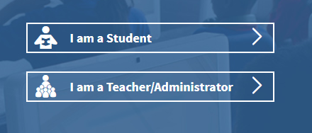
- Type in your username and password (Children should know these, but if you have any problems, please email your child’s Teacher and they will be able to send it out to you).
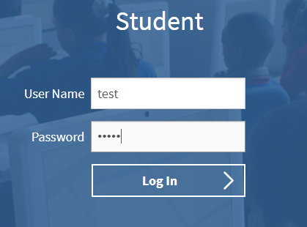
- Click on ‘Accelerated Reader’ (the third box).
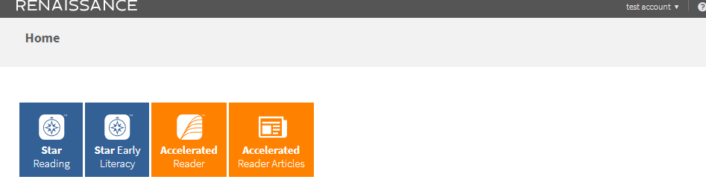
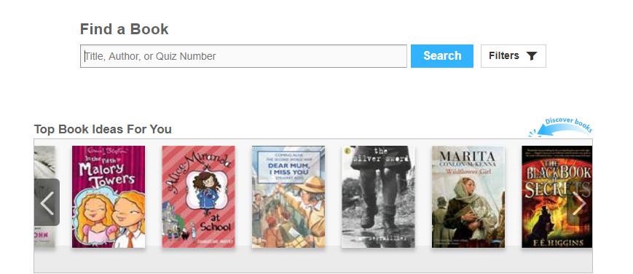
- Type in the book details. (See ‘How do I know if their book is on AR?’ for how to find a quiz number).
- Select the correct book from the list. Be mindful that the picture sometimes looks different to the front cover, as some books have different versions of front covers. Click on ‘Take Quiz’. 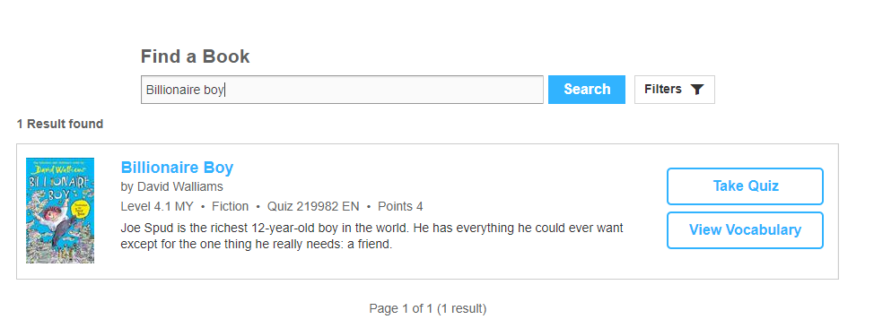

- When you click ‘Take Quiz’, it will ask how your child read the book. If they read independently, your child should do the test independently. If they read with someone or if they were read to, you can read the questions to your child but do not help them with the answers. The ‘Start Quiz’ button will appear once you have selected one of the options. On some tests it will ask if you want the recorded voice on or off (the questions are read aloud).
The children are allowed to use the books to retrieve the answers.
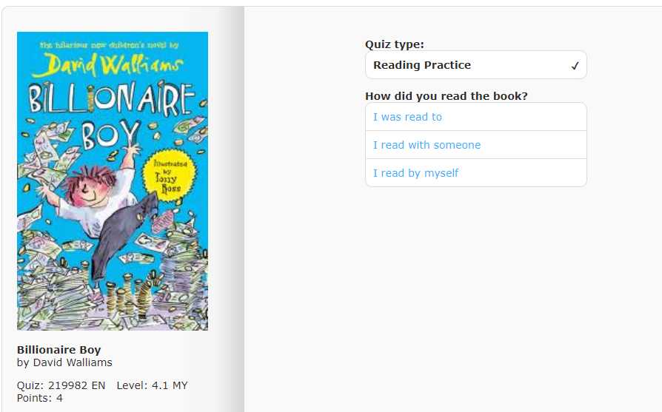
- When you finish the test, it will give you your score and how many words you have read.
- If it offers a Vocabulary test, then your child should do it.
- Click on ‘Find my next book’ to end. This will take you back to the ‘Find a Book’ page.
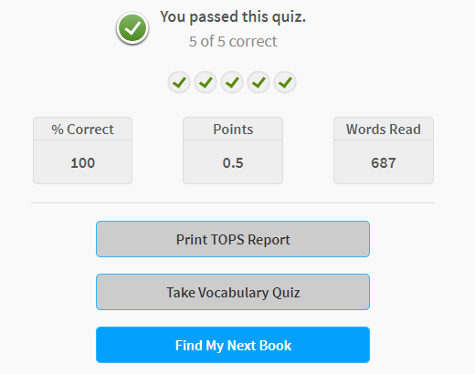
How do I know if the book is on AR?
- Visit https://www.arbookfind.co.uk/
- It will ask you who you are (It does not make a difference when you click on the different options).
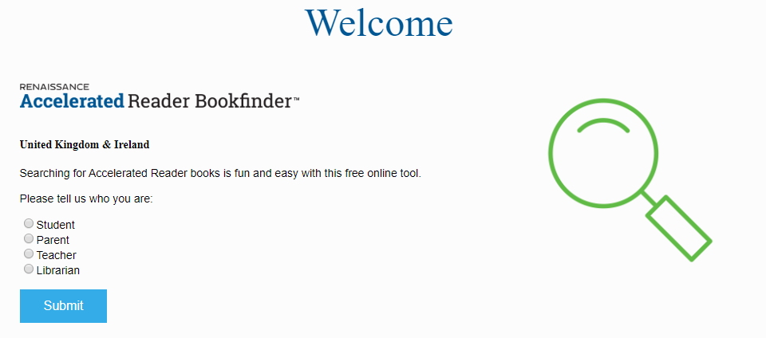
- Type in the name of the book (Be mindful that the book covers might not look the same).
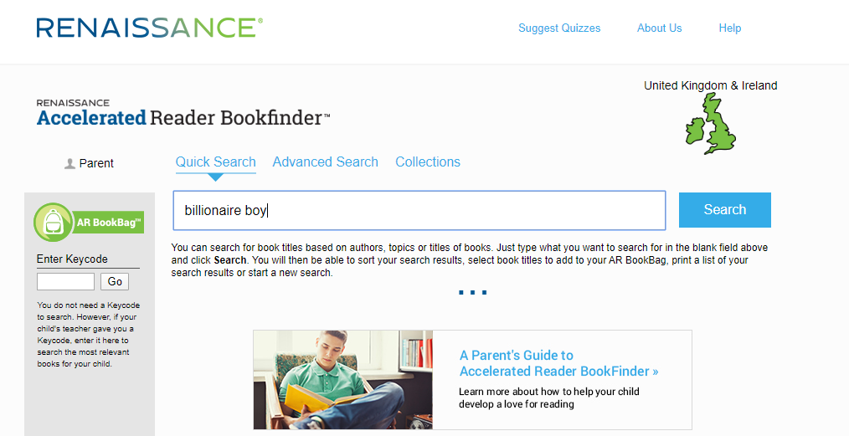

- Locate the book in the list. It will show the quiz number under the title and author.
- BL = Book level (this is the levels within their ZPD - e.g. your child’s ZPD range may be 2.1 – 3.2).
- IL = Interest level. LY is Lower Years, so more appropriate for Y2, Y3 and some Y4 children and MY is Middle Years, so age-appropriate for some Y4 children and the Y5 and Y6 children.
Do not worry about the interest level, unless you are concerned over the content of the book. If the book is not in their ZPD for now, then that’s okay too! It is hard to accommodate this without accessing the school reading books, we just want the children to read as much as they can and more importantly, enjoy what they are reading!
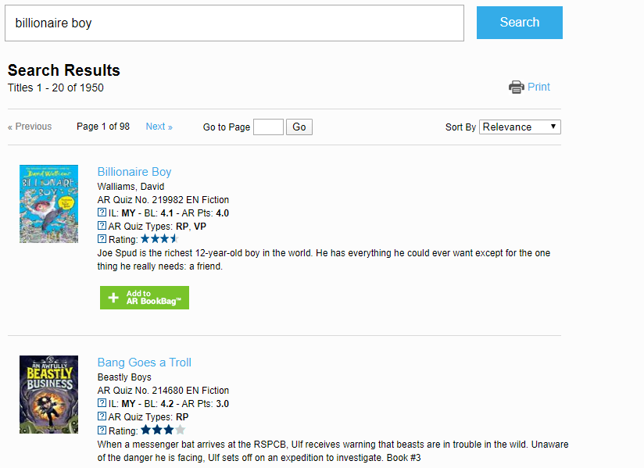

“I do not have access to many books/my child has read all of their books. Where can I locate other books?”
This can be tricky, but there are thousands of books available as eBooks online. It would be worth checking the following sites if they have any books that can be used on AR. If they do not, then that is okay. The priority is reading. We would much rather the children reading and enjoying books, so if it does not have a quiz then please do not worry.
If you find any additional websites with free books, please share them on our school Twitter page, or email them to your child’s Class Teacher. We will of course, also continue to share anything that we find!

Renaissance myON:
https://readon.myon.co.uk/?fbclid=IwAR2TqhH592mxUUr5qCA92npYE1c9PQ-Ns3G2HaVYsRkAQ75VdAryu-hOhzM

Blackpool Libraries:
Now that all of our children are members of the Blackpool Library Service, you can also access free eBooks through them. You will need your Library Card number (you will find this on the Library card) to access this online.
https://www.blackpool.gov.uk/Residents/Libraries-arts-and-heritage/Libraries/e-Books-and-e-audiobooks.aspx

MagicBlox:
https://magicblox.com/?fbclid=IwAR0W9oA3LS2scBK73tA6CKQJ3YcnD3gxVN8i1vbhFC-ISvKMUlRkaTBqoW4

