ART CHALLENGE - THREE LITTLE BIRDS
WE WOULD LIKE YOU TO CREATE YOUR OWN THREE LITTLE BIRDS PICTURE.
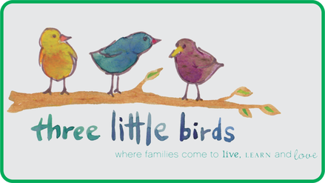
You can:
Paint
Draw
Collage
Or any other art form that you’d like!
Make it fun and creative

Please send any completed pieces of art to your class email.

This is a whole activity to bring us all together during this very unusual time.

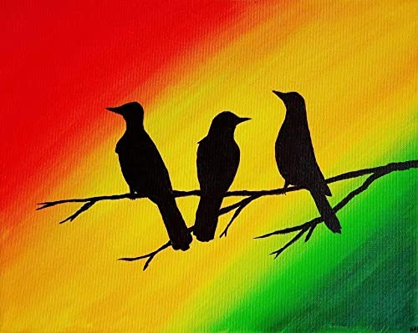
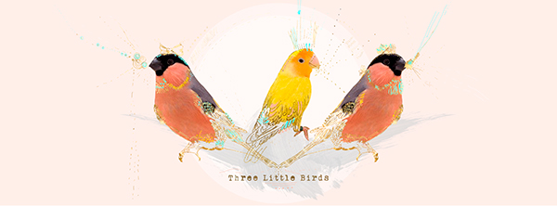
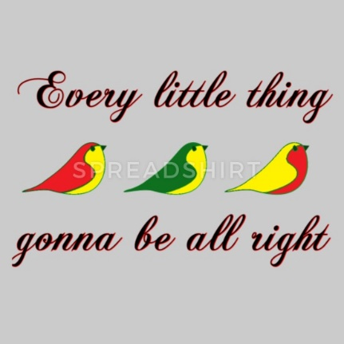
Why not listen to the song: 3 little birds (Bob Marley) for inspiration!

