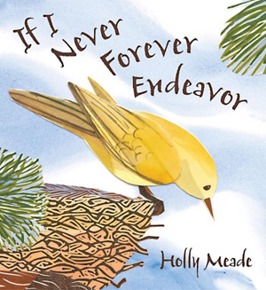
This book was about a bird who didn't yet know how to fly.
The bird has to decide if it will try to fly, but it was not sure if it wants to. The bird thought, "If I never forever endeavour" then I won't ever learn. On one wing, he worries he might fail and on the other wing he thinks of how he may succeed. He worries that if he tries, he may get lost in the world. That makes him want to stay in his nest where he's safe.
I think this book would help other children to learn that trying new things can be scary, but sometimes when we try, we can find things that make us happy too. And this book will help others know that mistakes are okay and part of learning.
My favourite part is that the bird tried and learned that she could fly. I also liked that I read this book because it gave me a chance to talk to mum about making mistakes and how I don't like making them. Then I learned they are good and part of learning.
Boys and girls who are 3 to 8 years old would like this book because it teaches about trying a new thing and how it's important to get past being scared so you can learn new things.
I give the book 5 stars since I think it's important for other children to learn about courage.

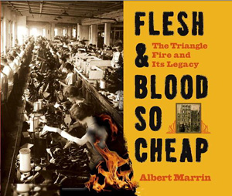
I liked this book. People who are interested in national disasters and US history as well will most probably be interested in reading this book.
Readers can gain knowledge of what it was like to work in New York City in the early 1900s. One of the things that was especially interesting was that there were no safety laws at work. Also, there was a big contrast between the rich and the poor. Some people may not like this book because it is very depressing, but it is an important event in history to remember.
This book was very well written. It has black and white photos along with descriptions of the photos. These photos give us a better idea of what people's lives were like. This book is suitable for 9-20 year olds.
I give this book 5 stars.

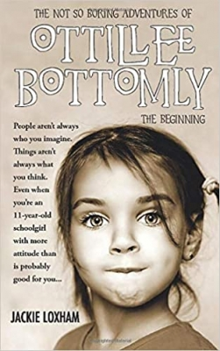
This is a very adventurous story about Ottillee who mysteriously inherits a house in Cornwall called Dragondah Hall – she’s never even met her benefactor Mrs. Crow before. Ottillee doesn't want to go but her mother decides for them. What makes it worse is that all of this happens soon after Ottillee’s father dies. When something happens that Ottillee can't understand, she writes a letter to her dead dad. This seems to help her clarify things.
Once in Cornwall, Ottillee starts looking around the beautiful countryside. She meets a boy about her age named Finn, and they become friends. Finn also has two animal companions, Shadow the bat and Vixen the silver fox. The children’s adventures take them inside a cave where they meet a strange man called Arlock. They start to learn more about Mrs. Crow, as well as Dragondah itself. It turns out Ottillee’s new home has a long and turbulent history not only involving castles and kings, but also smugglers and a man with ‘a heart as black as coal’. Ottillee is desperate to make sure Dragondah doesn’t return to the dark side once again.
Just before the end of Part One, Ottillee discovers the real reason she has inherited Dragondah Hall. And that is the end of Part One. I can't wait to read Part Two. It is such a great story, for young and old. I really enjoyed the adventures. Great read!!

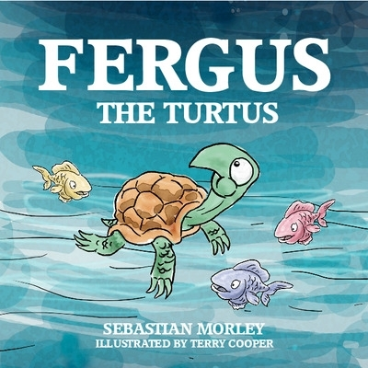
The story follows little Turtus as he hatches and makes his way towards the sea along with the other little turtles. However, he does not feel that he is like his brothers and sisters and this is confirmed as his journey continues. Eventually, he meets his mother who explains that his father was in fact a giant land tortoise and tells him that he will meet him one day. This is a charming picture book using an effective and simple rhyme which tends to appeal to young children. The illustrations are varied and appealing and match the text extremely well. We were drawn us in at the beginning with the mystery of what is a 'Turtus'. The end of the tale makes the reader excited with the expectation of eventually meeting Turtus' father in the next book. The story is an introduction to the fact that we are all different and can have a variety of different family situations. My granddaughter is 7 and really enjoyed this story and wants to know what happens next!

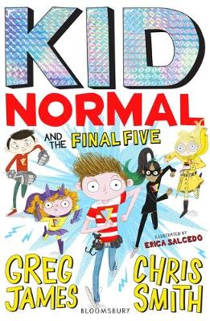
Under-age super-heroes assemble for the last time (boo)!
Secrecy is a big thing for super-heroes (ask Batman) and so far, the Heroes’ Alliance have been keeping the world safe and their identities unknown. But now all that has changed: evil Nicholas Knox has blown their cover and is working to destroy them forever, and take over the world (of course). All that’s standing in the way is one normal eleven-year old, aka Murph Cooper, aka Kid Normal plus his very special friends. This series is hugely popular with readers, deservedly so, and it ends as it began – in style! There are bizarre baddies, lots of great gags, and some wonderfully witty put-downs. Plus, more action than you could throw a comic book at. Adventures don’t come much faster, funnier or more feel-good. Don’t miss!

