Name | 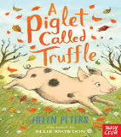 |  |  | Date
Opening Paragraph – Paragraph 1:  What sort of day it’s been so far… |  |  |  |  | Thought or Feeling
Fronted Adverbial – Place -

Paragraph 2:  Jasmine’s thoughts when she first arrived at the farm… |  |  |  |  | Thoughts and Feelings
Fronted Adverbial – Manner -

Paragraph 3:  What was her plan when she first saw the piglet… |  |  |  |  | Thoughts and Feelings
Fronted Adverbial – Place -

Closing Paragraph – Paragraph 4:  What will she do when Mr Carter leaves the room… |  |  |  |  | Rhetorical Question
Fronted Adverbial – Time -

Ambitious Vocabulary
Expanded Noun Phrases

