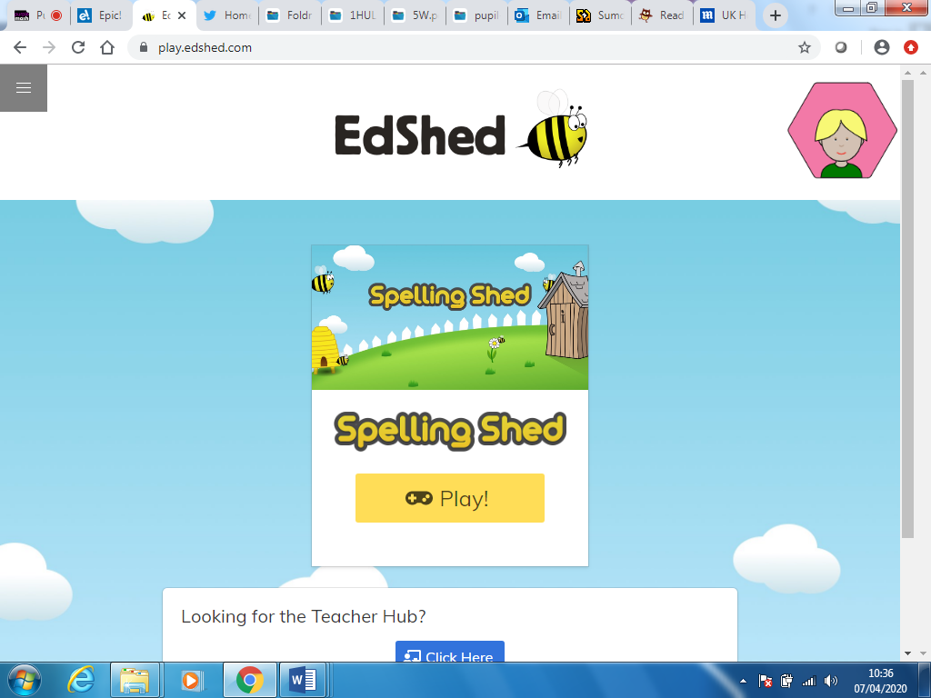

**Spelling shed live games!**

Hi, first login to Spelling shed -

Then press play

Click the three lines in the top left

This will bring another drop down menu

Click join hive game

Input the code send out

It will say waiting….. until Mr Walsh presses go on his computer so don’t panic! He will do that when it gets to the time to start the test!

Good luck!

Remember if you get one wrong keep going! Don’t give up!

Mr Walsh

