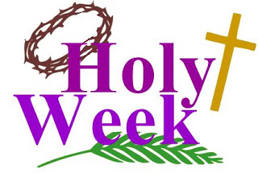
Holy Week Competition!

We have reached the most important week in our Church calendar and we would like to celebrate with a competition!

Please see the list below to find out which art activity your year group is going to do!

Year Groups | Day of Holy Week to Celebrate | RE with Art – Creative Picture/Sculpture Focus | Media Ideas
Nursery & Reception | Palm Sunday | Palm leaves, Jesus on donkey, road into Jerusalem | collage, painting, sponge paints, finger paints, sculpture  cross stitch;  use Pinterest for some ideas too!
Year 1 & Year 2 | Maundy Thursday | The Washing of the Feet, The Last Supper, Jesus in the Garden of Gethsemane
Year 3 & Year 4 | Good Friday | Stations of the Cross (could choose one or all), Calvary
Year 5 & Year 6 | Easter Sunday | The Tomb, He is Risen, Scripture Quotes
*Challenge!
Can you complete any artwork or information for other Holy Week days such as Spy Wednesday - What happened on this day?
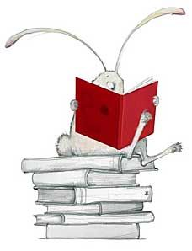

The artwork will be judged on Maundy Thursday 9th April @12 noon and the winners will be announced via text and Twitter in the afternoon.
- There will be a book token award for the best entry in each year group!
- Those who have put in particular effort will also receive a postcard of praise!
- Please email your entries to your year group email address!
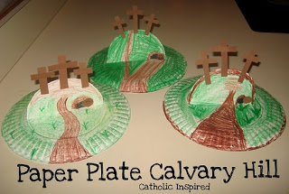
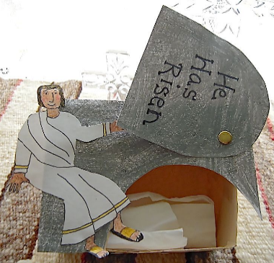
- In the subject box write ‘NAME – HOLY WEEK COMPETITION ENTRY’
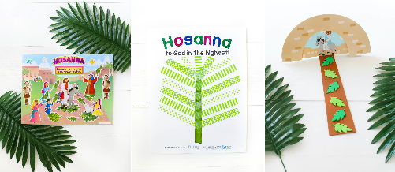
Good Luck!

