Nursery Activities

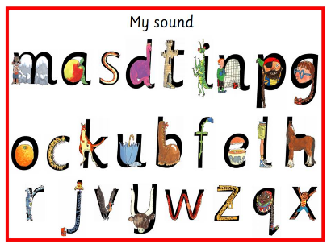
Read Write Inc

Please continue to practise the letters that we have learnt so far. The more the children hear the sounds, the better they will be at them! We have learnt
m, a, s, t, d, p, i, n, g, o, b, c, u.

Attached is a sheet for each of these letters. The children can colour them in and practise forming them.

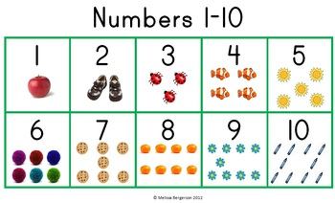
Counting and Number Recognition

Please count with your children when given the chance (number songs, counting out cups at dinner time, counting toys etc). Also, any opportunity to practise their number recognition would be great too!

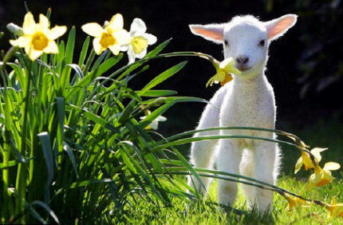
Topic

As we prepare for Easter, we will be learning about New Life. Look out for signs of Spring such as baby animals and plants growing. Talk to the children about what you see and any pictures or drawings the children would like to do to do with New Life would be fabulous!

Thank you for your support!
The Nursery team

