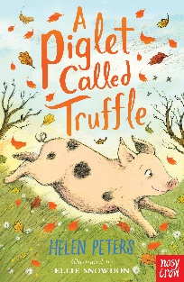

Who are the characters?

What happens?

What do you predict will happen next?

**A summary of chapter 1 from the story “A piglet called Truffle”**