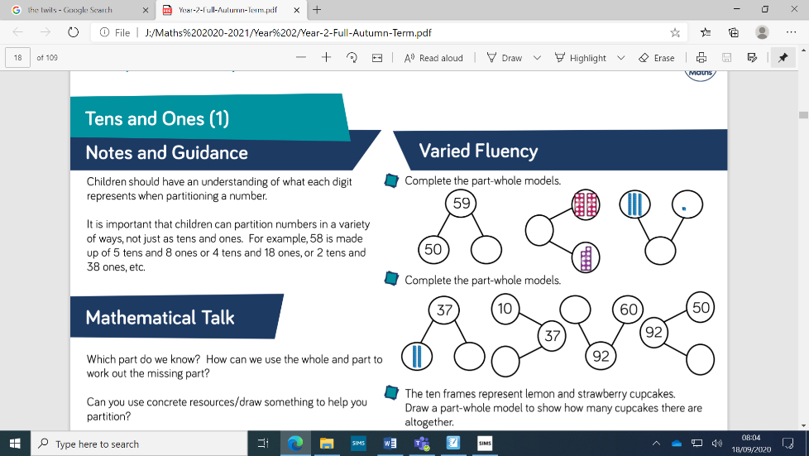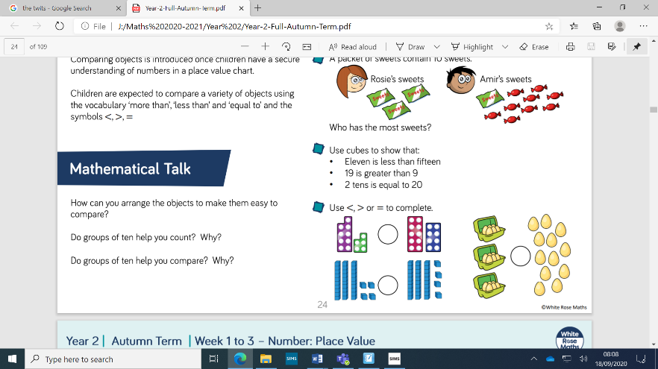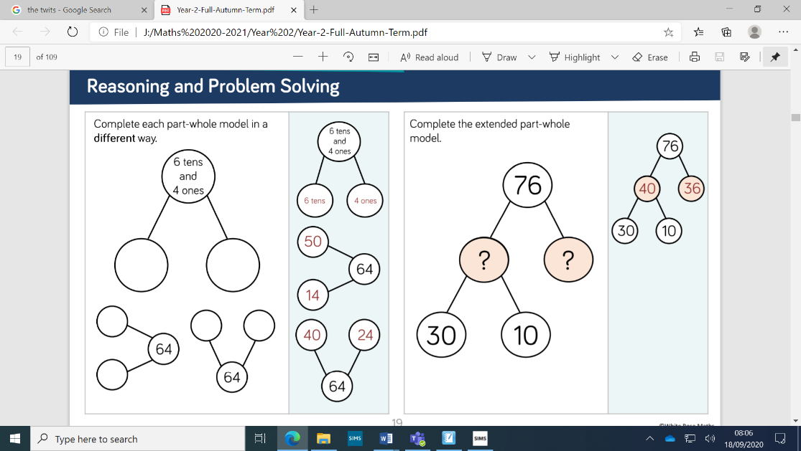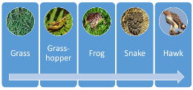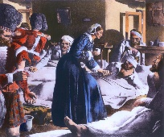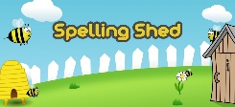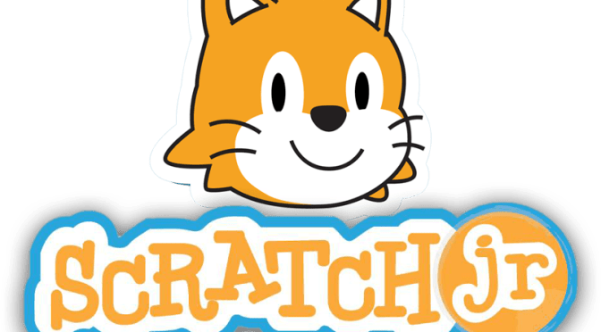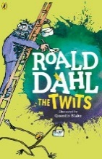

**‘Seeking Growth Together’**

We will be looking at how our behaviour can change and what we can do to resolve things. Recognising choices and how these can affect people in certain ways – as well as Jesus’ commandments – Love one another as I have loved you. The children will be finding out what is in their Community and how we can improve things it in and how we can make my class a safe and fair place. Friendships, what does that mean and how can we reconcile our differences if we do fall out.

**Humanities**

Our wonderful world including the continents and oceans – being very creative and the children we will make a balloon globe. In History we will be delving into the past to find out who Florence Nightingale was

and what she

was famous for.

**The Arts**

This half term the children will be focusing on sketching for exploring ideas. To do this, they will create a sketch book from scratch! They will cardboard, paper, magazines and any other resources they can find to create the sketchbook. They will then jot down any ideas or drawings they think of in each lesson. We will also explore the sounds and noises we can make with our bodies in each of our music sessions.

**ICT**

We are programming robots, planes, monkeys and cars by using Purplemash. The children will know how basic programming works and how we can fix them if there is a problem. Scratchjr is an app which we will also be using to programme in class and this is free to

download if you want

your child to use it at

home.

**PE**

This half term we have been focusing on building Resilience through the invasion game, Bounce Ball. The children have worked on their control and accuracy when bouncing and throwing a ball. They will then participate in a game and be able to demonstrate their technique and skill in this area.

**Science**

In this module children will observe animals in different habitats and notice how they change through the year. They use this developing understanding of the different animals living in a habitat to build up simple food chains. The children will make observations over time, using simple equipment and recording their observations in a range of different ways, and use their data to suggest

answers to questions.

**Home Learning Platforms**

We will be using Microsoft Teams for our homework.

Spelling shed our online spelling words game aswell as Mymaths work to do each week. This can be uploaded directly to the teachers even with photos and comments!

**Maths**

We follow the White Rose scheme of work and in this half term we will be looking at Number place value and Number addition and subtraction. The children will be using plenty of equipment such as numicon and rods to make numbers up to 100. Finding where numbers sit on a number line and using the part whole method of working out how we partition a number. Plenty of practical activities.

**English**

We will be looking at the book by Oliver Jeffers – Here we are. Looking at keeping safe and our wonderful world.

The Twits!!! This will be our key text and will fit alongside poems – the Dentist and the crocodile by Roald Dahl and Be kind by Patricia Gatto. The Twits is definitely a favourite book of every teacher, the children will be looking at recipes, instructions, eating spaghetti worms and writing tricks on a

member of their family so

**BEWARE!** You have been

Warned to look over your

shoulder!!!