

St Joseph’s Catholic Academy

Prayer and Liturgy Policy

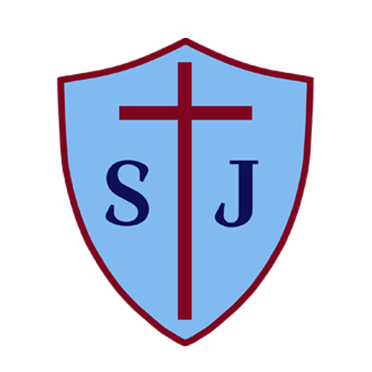

Document Management:

Date Policy Approved: June 2017

Date Amended: September 2025

Next Review Date: September 2028

Version: 4

Approving Body: Board of Directors

Change Log
Updates: | This policy has been revised in line with the new Diocesan model policy, which has been introduced following the publication of the national Prayer and Liturgy Directory, To Love You More Dearly, by the Catholic Education Service. The adoption of this new directory has prompted a review of the Trust’s existing prayer and liturgy policy template to ensure alignment with national guidance and best practice.
Location: | Throughout
Summary Date: | September 2025
Completed By: | Andrew Gardner (Head of Catholic Life), Joseph Walker (Policy and Governance Officer)
School Mission Statement - Christ be our Light
St Joseph’s is a prayerful community grounded in the Catholic faith, in which Gospel values shape our lives and our work. Our school is a loving, caring and happy place where all are welcomed and everyone is valued and respected. We recognise our uniqueness in Christ and celebrate diversity and difference. Through hard work and high expectations, we nurture and challenge each other to develop our gifts and talents. We do our best, even when we find things difficult.
Created by staff, governors, children and parents – June 2013

Trust Mission Statement
Our Catholic ethos and support for one another as a family of schools drives all that we do. Our mission is guided by a collective culture and vision where:

‘Our schools are places of excellence – providing service and witness to children, their families and the wider Catholic community, adding value as a family of schools and enriching the learning and experience of all our young people, so they may achieve their full potential.’

1. The context of this prayer and liturgy policy
Within the Bishop Hogarth Catholic Education Trust, prayer and liturgy are central to the life of every school. This policy is shaped by To Love You More Dearly – The Prayer and Liturgy Directory for Catholic Schools, Academies and Colleges in England and Wales (PLD), which guides how worship is lived and celebrated across our communities.

Prayer and liturgy are not optional extras but vital moments when our school communities encounter the living God. As Bishop Marcus Stock reminds us:

“The celebration of Catholic liturgies and prayers as an integral part of the learning and teaching should enable the school community to become reflective, experience the presence of God, and should develop a mature spiritual life.”
(Christ at the Centre, 2012, p.23)

The PLD emphasises that worship always draws us into the mystery of God’s life:

“Worship, whether carried out in our parishes, schools, or homes, is intimately bound up with the life of the Blessed Trinity. Whenever we offer our worship to God the Father, we do so in union with Christ – a union which is brought about by the Holy Spirit.”
(PLD, p.1)

In our schools, this worship takes many different forms: daily classroom prayer, meditation and reflection, Celebrations of the Word shaped by Scripture and the liturgical year, devotions such as the Rosary, Stations of the Cross and Eucharistic Adoration, alongside the celebration of Mass and the Sacrament of Reconciliation. As the Directory notes, each of these forms has its own character, depending on the size and age of the group, the setting, and the occasion (PLD, p.7).

This Trust policy sets out how the rich heritage and variety of Catholic prayer and liturgy is planned, celebrated, and reviewed across all BHCET schools, so that Christ is placed at the centre of every community.

2. Statement of requirement
The law requires all maintained Catholic schools to provide an act of daily collective worship (prayer and liturgy) for all pupils, including those in the sixth form (Section 70, 1988 Education Act) that is in accordance with the rites, practices, disciplines, and liturgical norms of the Catholic Church (School Standards and Framework Act 1998, schedule 20; Instrument of Government, clause 2). Academies in England are required by their funding agreement and Articles of Association to comply with similar requirements (The Mainstream Academy and Free School: Supplemental Funding Agreement, December 2020; Model Articles for Catholic Academies, February 2019).
The law requires all maintained Catholic schools to recognise and respect that parents have the legal right to withdraw their children up to the age of 16 from prayer and liturgy (School Standards and Framework Act 1998, s.71(1A)). Sixth-form pupils can choose to withdraw themselves from prayer and liturgy (School Standards and Framework Act 1998, s.71(1B)).
The school’s provision for prayer and liturgy will fulfil pupils’ entitlement to experience the range of liturgical treasures of the Church, including a shared repertoire of prayers and liturgical music with which pupils in the school will be familiar.
Prayer and liturgy are not within designated curriculum time. In the context of the Catholic school, this means that times of prayer and liturgy are not considered to be part of the allocation of curriculum time for Religious Education.
In line with the Prayer and Liturgy Directory (2025), pupils should be familiar with an age-related repertoire of common prayers (see Appendix 1) and actively use them in daily prayer and liturgy.

3. Diocesan Bishop directive
The Prayer and Liturgy Directory refers to the norm at all Masses that only those who normally receive Holy Communion at Mass be invited to proclaim the Word of God. It continues that on exceptional occasions and for a just cause the Diocesan Bishop will give permission for a Christian from another denomination to proclaim scriptures at Mass.
“As an exception to the norms and when there is a pastoral just cause exercised on his behalf by the Headteacher, the Bishop gives permission for children from other Christian denominations to read the scriptures at school Masses. Permission is also given for baptised Catholics who have not received First Holy Communion, and are of sufficient maturity, to read the scriptures at school Masses. Children of other faiths are welcome to actively participate in school Masses and liturgies in keeping with The Prayer and Liturgy Directory. A just cause may also be applied due to the diversity of faith backgrounds in a school, cohort or the age profile of those attending a Mass.”
All schools must ensure that ministries foster full, conscious, and active participation (Directory §3.3), reflect the diversity of the school community, and respect the distinctions laid down in the Directory (§4.2, §5.2–§5.5).
4. Roles and Responsibilities
(a) Governance
The governors, as guardians of the Catholic school’s life and mission, have a responsibility to ensure that:
- prayer and liturgy are central to the Catholic life of the school and therefore are in line with the guidance set out by the Prayer and Liturgy Directory
- there is a named person(s) who is responsible for prayer and liturgy in the school (the Prayer and Liturgy Coordinator)
- the prayer and liturgy policy is updated regularly and shared with all stakeholders
- there is a budget for prayer and liturgy that reflects its centrality to the life of a Catholic school.
- governors receive a regular update on prayer and liturgy through the termly headteacher report, including evidence of pupil participation, familiarity with common prayers, and evaluation outcomes.
(b) Headteacher
The headteacher, as the spiritual leader of the school as a Catholic community, ensures that:
- prayer and liturgy are central to the Catholic life of the school and therefore are in line with the guidance set out by the Prayer and Liturgy Directory
- they work in partnership with the leader(s) for prayer and liturgy
- those responsible for prayer and liturgy in the school have been given appropriate training and formation to ensure that all guidance is followed and adhered to
- there are suitable resources for prayer and liturgy in the school.
- they collaborate with the, School Improvement Team, the Trust Head of Catholic Life and diocesan advisers to ensure consistency and support.
(c) Prayer and Liturgy Coordinator
Those responsible for prayer and liturgy ensure that:
- prayer and liturgy are central to the Catholic life of the school and therefore are in line with the guidance set out by the Prayer and Liturgy Directory
- there is an Annual Plan of Provision for prayer and liturgy across the school year which identifies liturgical seasons and key celebrations, as well as opportunities for the celebration of the Sacraments.
- there is daily planned prayer for all pupils, appropriate to age and ability (see appendix 1), as outlined in the Prayer and Liturgy Directory
- pupils are supported in their liturgical formation to take an active role in the planning, preparation, delivery and evaluation of prayer and liturgy according to their age and capacity, and in a manner which facilitates their progressive participation
- resources to support the planning of prayer and liturgy are appropriate and readily available to staff and pupils
- induction on prayer and liturgy takes place for new members of staff as required
- staff have access to effective training and formation opportunities
- monitoring and evaluation of prayer and liturgy take place regularly and feed back into planning for future liturgies
- monitoring of prayer and liturgy is reported to the headteacher and governing body to support whole-school development and the Catholic life of the school
- there is collaboration with local clergy and parishes
- liaison with the Diocesan Department for Education and others is maintained to ensure they keep updated with best practice
- they engage with Trust-provided resources (weekly guidance emails, shared templates, central resource bank, support visits)
Teachers and support staff
The PLD states that:

All adults, whatever their personal religious affiliation, can contribute to
the spiritual life of the school. Each can draw on their unique experience
and talents to enhance the preparation and celebration of prayer and liturgy.
In their classrooms, adults facilitate prayer and liturgy for pupils,
teaching them how to participate meaningfully
in different forms of these in order to grow in faith.
They can provide formation for pupils to organise, lead, and evaluate prayer
in a variety of contexts, and collaborate with other professionals
to ensure that this is in line with best practice.

[To Love You More Dearly - The Prayer & Liturgy Directory for Catholic Schools, Academies and Colleges in England and Wales, https://cdn.prod.website-files.com/67165df208d9e689b4d32648/6790d7b972ae1c32df3e3e0a_PLD_FINAL.pdf

5. Overview of school’s prayer and liturgy provision
[Found for each individual school in Appendix 2)
Trust expectation (Directory §7.2–§7.7):
- Daily prayer in every class, morning and end of day.
- Weekly Celebrations of the Word for pupils, following the fourfold structure Gather–Listen–Respond–Go Forth.
- Mass termly, on Holy Days of Obligation if possible, and at key moments in the year.
- Sacrament of Reconciliation offered, where possible in Advent and Lent.
- Devotions (Rosary, Angelus, Stations, Adoration) appropriate to the liturgical season.
- Provision must enable pupils to grow in full, conscious, and active participation (§3.3).

6. Resourcing
Prayer and liturgy is central to the school’s understanding of itself as a Catholic school, and this is reflected in the annual budget allocation and available resources, including staff time, chaplaincy provision, and dedicated spaces for prayer and liturgy. The Catholic character of the school is reflected in religious artefacts and images on display throughout the building. Dedicated spaces for prayer and liturgy will be furnished and maintained as such, and updated to reflect the Church’s liturgical season. Staff training and formation costs will be funded separately to ensure that all staff are able to fulfil their responsibility to contribute to the prayer and liturgical life of the school.
Schools will also have access to Trust-level resource banks, exemplars, and shared CPD provided by the Head of Catholic Life.

7. Training and formation
All new staff will be supported during induction and beyond, so that they fully understand the responsibility they carry within their individual role for leading prayer and liturgy in the school. Any individual training needs will be identified and addressed through training and formation. There will also be the opportunity for whole-staff professional development at least once a year, so that all staff understand the importance of prayer and liturgy and relevant staff are well supported to lead as required.
Formation must include “before, during, after” (mystagogy, Directory §8.1–§8.3) and focus on enabling pupils’ progressive participation in prayer and liturgy. The Trust Head of Catholic Life coordinates INSET, visits, and weekly guidance.

8. Monitoring and evaluation
Monitoring and evaluation of the quality and impact of prayer and liturgy will take place regularly and will involve key stakeholders such as pupils, parents, staff, clergy, and governors. Areas for development will be identified and issues raised will be actioned and evidenced as appropriate.
Evaluation should include staff reflections, pupil voice, chaplaincy records, and governor visits. Governors and Directors will receive reports from the Prayer and Liturgy Coordinator as part of the Headteachers report and the Trust Head of Catholic Life.
9. Review
The policy will be reviewed and updated as necessary or at intervals of 3 years by the Trust’s Head of Catholic Life and the Governance Team.

Appendix 1 — Common prayers (Directory §7.10, §9.5)
Pupils should be familiar with the following prayers and texts at each age phase and should have regular opportunities to use them in school prayer and liturgy.
Key Stage 1 (Ages 5–7)
Prayer | Best Time(s) to Introduce / Embed | Liturgical / School Context
Sign of the Cross | Daily, from Reception | Start and end of all prayers.
Our Father | Year-round | Mass, daily prayer, RE lessons.
Hail Mary | May & October- All year round! | Rosary months, Marian feasts.
Glory Be | Daily | Concluding prayer, Trinity Sunday.
Morning Offering (short form, full text later) | Daily, especially September / new term | Start of school day.
Grace Before Meals | Daily at lunchtime (KS1); reinforced on retreats/residentials | Everyday prayer of thanks.
Grace After Meals | Daily / residentials | Often overlooked – reintroduce.

Key Stage 2 (Ages 7–11)
Prayer | Best Time(s) to Introduce / Embed | Liturgical / School Context
Apostles’ Creed | Lent/Eastertide | Linked to renewal of Baptismal promises at Easter.
Act of Contrition | Advent & Lent | Penitential Services & Reconciliation.
Angelus | Daily at noon, esp. October & Advent | End of morning / start of afternoon; Marian devotion.
Expanded Mass Responses | Year-round | Taught as part of liturgical formation.
Simple Psalms (e.g. Psalm 23) | Throughout year | Assemblies, RE, Celebrations of the Word.

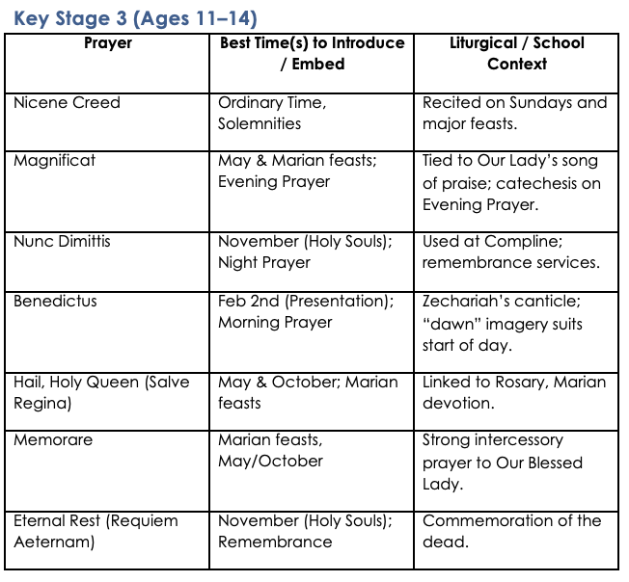

The Sign of the Cross
In the name of the Father and of the Son
and of the Holy Spirit. Amen.
The sign of the cross is both an action and a statement of faith.
A physical reminder of our redemption in the cross and an expression of faith in the Trinity.

The Lord’s Prayer
Our Father who art in heaven, hallowed be thy name.
Thy kingdom come.
Thy will be done on earth, as it is in heaven.
Give us this day our daily bread, and forgive us our trespasses,
as we forgive those who trespass against us, and lead us not into temptation,
but deliver us from evil.
The Lord’s Prayer ‘is truly the summary of the whole of the Gospel’. (CCC 2761.)

The Hail Mary
Hail, Mary, full of grace, the Lord is with thee.
Blessed art thou among women
and blessed is the fruit of thy womb, Jesus. Holy Mary, Mother of God,
pray for us sinners,
now and at the hour of our death. Amen.
The first part of the Hail Mary is biblical, drawn from Gabriel’s greeting to Mary at the Annunciation and Elizabeth’s greeting at the Visitation. The second part of the
prayer has its origins in 15th-century Italy.

Glory be to the Father
Glory be to the Father and to the Son
and to the Holy Spirit,
as it was in the beginning is now, and ever shall be world without end. Amen.
The doxology is a short expression of praise of the Trinity dating back to the early Church. It is used extensively in the Liturgy of the Hours and in devotions such as the Rosary.

Grace before meals
Bless us, O Lord, and these your gifts
which we are about to receive from your bounty. Through Christ our Lord.
Amen.

Grace after meals
We give you thanks, Almighty God, for all your benefits,
who live and reign, world without end. Amen.

The Apostles’ Creed
I believe in God,
the Father almighty
Creator of heaven and earth,
and in Jesus Christ, his only Son, our Lord,
At the words that follow, up to and including the Virgin Mary, all bow.
who was conceived by the Holy Spirit, born of the Virgin Mary,
suffered under Pontius Pilate,
was crucified, died and was buried; he descended into hell;
on the third day he rose again from the dead; he ascended into heaven,
and is seated at the right hand of God the Father almighty; from there he will come to judge the living and the dead.
I believe in the Holy Spirit, the holy catholic Church, the communion of saints, the forgiveness of sins,
the resurrection of the body, and life everlasting. Amen.

Based on baptismal documents of the 8th century but related to texts of an earlier origin.

Act of Contrition
O my God,
because you are so good,
I am very sorry that I have sinned against you, and with the help of your grace
I will not sin again.
One of the forms of the Penitent’s Prayer of Sorrow found in the Rite of Penance.

Angel of God
Angel of God,
my guardian dear,
to whom God’s love commits me here, ever this day be at my side,
to light and guard, to rule and guide. Amen.
The prayer is based on one by Reginald of Canterbury in the early 12th century.

Come, Holy Spirit
V. Come, Holy Spirit, fill the hearts of your faithful.
R. And kindle in them the fire of your love.
V. Send forth your Spirit and they shall be created.
R. And you will renew the face of the earth.
Let us pray
O God, who by the light of the Holy Spirit, did instruct the hearts of your faithful, grant that by that same Holy Spirit,
we may be truly wise, and ever rejoice in your consolation, Through Christ our Lord.
Amen.
This prayer is a compilation of a number of liturgical texts drawn from the Mass and Office of Pentecost and the Votive Mass of the Holy Spirit.

Prayer of St Richard of Chichester
Thanks be to you, my Lord Jesus Christ,
for all the benefits which you have given me,
for all the pains and insults which you have borne for me. O most merciful Redeemer, friend and brother,
may I know you more clearly, love you more dearly,
and follow you more nearly, day by day.
Amen.

Morning Offering
O Jesus,
through the most pure heart of Mary, I offer you all my prayers,
thoughts, works and sufferings of this day
for all the intentions of your most Sacred heart.

The Rosary
For each mystery or decade, one Our Father, ten Hail Marys and the Glory be is recited.

The Joyful Mysteries
(Recited Monday and Saturday)
The Annunciation (Luke 1:26–38) The Visitation (Luke 1:39–45) The Nativity (Luke 2:1–7)
The Presentation in the Temple (Luke 2:22–35) The Finding in the Temple (Luke 2:41–52)

The Mysteries of Light
(Recited Thursday)
The Baptism of Jesus (Matthew 3:13–17) The Wedding Feast of Cana (John 2:1–12)
The Proclamation of the Kingdom, with the call to Conversion (Mark 1:14–15; 2:3–12) The Transfiguration (Luke 9:28–36)
The Institution of the Eucharist (Matthew 26:26–29)

The Sorrowful Mysteries
(Recited Tuesday and Friday)
The Agony in the Garden (Mark 14:32–42)
The Scourging at the Pillar (Matthew 27:15–26) The Crowning with Thorns (Matthew 27:27–31)
The Carrying of the Cross (John 19:15–17; Luke 23:27–32) The Crucifixion (Luke 23:33–38, 44–46)

The Glorious Mysteries
(Recited Wednesday and Sunday)
The Resurrection (Matthew 28:1–8) The Ascension (Acts 1:6–11)
The Descent of the Holy Spirit (Acts 2:1–12) The Assumption (1 Thessalonians 4:13–19)
The Coronation of Mary Queen of Heaven and Earth (Revelation 12:1; 14:1–5; Isaiah 6:1–3)

Prayer concluding the Rosary
[Hail, Holy Queen, etc. as above]
V. Pray for us, O holy Mother of God.
R. That we may be made worthy of the promises of Christ.
Let us pray.
O God, whose only-begotten Son, by his life, death and resurrection,
has purchased for us the rewards of eternal life, grant, we beseech thee,
that meditating on these mysteries
of the most holy Rosary of the Blessed Virgin Mary, we may imitate what they contain
and obtain what they promise, through the same Christ our Lord. Amen.

The Magnificat
My soul proclaims the greatness of the Lord, and my spirit rejoices in God my Saviour,
for he has looked upon his handmaid in her lowliness; for behold, from this day forward,
all generations will call me blessed.
For the Almighty has done great things for me, and holy is his name.
His mercy is from age to age for those who fear him.
He has made known the strength of his arm,
and has scattered the proud in their conceit of heart.
He has cast down the mighty from their thrones and has exalted those who are lowly.
He has filled the hungry with good things, and has sent the rich away empty.
He has helped his servant Israel, mindful of his mercy,
even as he promised to our fathers,
to Abraham and his descendants for ever.
Glory be to the Father and to the Son and to the Holy Spirit,
as it was in the beginning, is now, and ever shall be, world without end. Amen.
Mary’s song of praise was first sung to her cousin Elizabeth (Luke 1:46–55).
It is sung daily at Evening Prayer.

Act of Faith
My God, I believe in you
and all that your Church teaches, because you have said it,
and your word is true.

Act of Hope
My God, I hope in you, for grace and for glory,
because of your promises, your mercy and your power.

Act of Love
My God, because you are so good, I love you with all my heart,
and for your sake,
I love your neighbour as myself.

The Benedictus
Blessed be the Lord God of Israel:
for he has visited his people and redeemed them; he has raised up for us a horn of salvation
in the House of David his servant,
as he spoke through the mouth of his holy ones, his prophets from ages past:
To grant salvation from our foes,
and from the hand of all who hate us, showing mercy to our fathers,remembering his holy covenant;
the oath he swore to Abraham our father,
To grant that freed from the hand of our foes, we may serve him without fear
in holiness and righteousness all the days of our life.
And you, little child, will be called the Prophet of the Most High,
for you will go before the Lord to make ready his ways:
to grant knowledge of salvation to his people by the forgiveness of their sins;
Through the tender mercy of our God, the Dawn from on high will visit us,
to shine on those who sit in darkness, and those in the shadow of death;
to guide our feet into the way of peace.
Glory be to the Father and to the Son and to the Holy Spirit,
as it was in the beginning, is now, and ever shall be, world without end.
Amen.
The Canticle of Zechariah, father of John the Baptist, is taken from Luke’s Gospel (Luke 1:68–79).
It is sung daily at Morning Prayer

The Angelus
V. The Angel of the Lord declared unto Mary.
R. And she conceived of the Holy Spirit.
Hail, Mary, full of grace, the Lord is with thee. Blessed art thou among women,
and blessed is the fruit of thy womb, Jesus. Holy Mary, Mother of God,
pray for us sinners,
now and at the hour of our death. Amen.
V. Behold the handmaid of the Lord.
R. Be it done unto me according to thy word. Hail Mary.
V. And the Word was made flesh.
R. And dwelt among us. Hail Mary.
V. Pray for us, O holy Mother of God.
R. That we may be made worthy of the promises of Christ.
Let us pray;
Pour forth, we beseech thee, O Lord, thy grace into our hearts;
that we, to whom the Incarnation of Christ, thy Son, was made known by the message of an angel,
may by his Passion and Cross be brought to the glory of his Resurrection. Through the same Christ, our Lord.
Amen.
The Angelus is traditionally said three times a day: at 6am, 12 noon, and 6pm.

Hail, Holy Queen (Salve Regina)
Hail, Holy Queen, Mother of Mercy,
Hail our life, our sweetness and our hope!
To thee do we cry, poor banished children of Eve. To thee do we send up our sighs,
mourning and weeping in this valley of tears! Turn, then, most gracious Advocate,
thine eyes of mercy toward us, and after this, our exile,
show unto us the blessed fruit of thy womb, Jesus. O clement, O loving,
O sweet Virgin Mary.
The Salve Regina is one of the Marian Anthems sung at Night Prayer.

The Memorare
Remember, O most gracious Virgin Mary,
that never was it known that anyone who fled to thy protection, implored thy help, or sought thy intercession, was left unaided. Inspired by this confidence I fly unto thee,
O Virgin of virgins, my Mother.
To thee do I come, before thee I stand, sinful and sorrowful. O Mother of the Word Incarnate, despise not my petitions, but in thy mercy hear and answer me.
Amen.
A 16th-century version of a longer 15th-century prayer.

Jesus, Mary and Joseph
Jesus, Mary and Joseph, I give you my heart and my soul. Jesus, Mary and Joseph, assist me in my last agony.
Jesus, Mary and Joseph, may I breathe forth my soul in peace with you.

Eternal Rest
Eternal rest grant unto them, O Lord, and let perpetual light shine upon them. May they rest in peace. Amen.
Based on the Entrance Antiphon of the Mass for the Dead.

Appendix 2 — School Procedures Annex:

1. Daily Prayer Pattern
At St Joseph’s, prayer is the foundation of all we do. As St John Damascene describes, prayer is “the raising of one’s mind and heart to God or the requesting of good things from God” (Catechism of the Catholic Church, 2559). This reflects why prayer punctuates our day: it nurtures a living relationship with a God who loves, listens, and responds.
Prayer in school takes many forms. The PLD reminds us that:
“There is virtue in variety and also great scope for creativity: varying the focus and the format according to the liturgical year reinforces the essential Catholic focus of the school while providing opportunities for pupil engagement.” (PLD, p.7)
Thus, at St Joseph’s prayer is offered:
- in whole-college gatherings (Mass, Celebrations of the Word, devotions),
- in key stages and classes,
- by staff together,
- and in moments of individual reflection and silence.
The forms of prayer include:
- Vocal prayer – traditional prayers of the Church prayed aloud, along with spoken petitions and intentions composed by pupils.
- Meditative, creative prayer – guided prayer that uses Scripture, art, music, or other stimuli, helping pupils to engage “thought, imagination, emotion, and desire” (CCC 2723).
- Silent, contemplative prayer – moments of stillness which grow with age. As John Main OSB reflects: “In contemplative prayer we seek to become the person we are called to be, not by thinking of God, but by being with God.”

St Joseph’s daily rhythm of prayer
- Morning Prayer: Led in classrooms.
- Examen: Prayed daily at the end of the school day in all classes from Early Years to Y6, encouraging reflection and thanksgiving at the end of the day.
- Angelus: Especially in October and May, the Angelus is recited in place of the end of the day examen. (PLD §7.10, §9.5).
- Staff prayer: Takes places daily before the morning briefing on a Monday and before staff meeting afterschool on a Tuesday.
- Grace before and after meals: Prayed on retreats and residential visits.

Day | Event | Time and Location | Directory Links / Notes
Monday | Whole School Celebration of the Word | 9am in the hall, led by SLT | Daily prayer, age-appropriate (PLD §7.7). Gospel theme of the week introduced.
 | Rosary and Devotions | 11:55am, in Poustinia or in a classroom gathered around a prayer space. | Marian devotion; decades of the Rosary prayed by pupils.
 | End of Day Prayer: Examen / Angelus (Marian months & Advent) | End of the day in Classrooms | Pupils practise thanksgiving and reflection (Examen) or Marian devotion (Angelus) in line with PLD §9.5.
Tuesday | Key Stage Celebration of the Word | Afternoon sessions, in the hall as a key stage, led by class teachers | Continuation of Gospel theme, links to Catholic Social Teaching and Statements to Live By.
 | End of Day Prayer: Examen / Angelus (Marian months & Advent) | End of the day in Classrooms | Pupils practise thanksgiving and reflection (Examen) or Marian devotion (Angelus) in line with PLD §9.5.
Wednesday | Class Celebration of the Word | Child led, groups of children prepare and deliver for their class. Parents are on a rota throughout the year to join. | Daily prayer rhythm.
 | End of Day Prayer: Examen / Angelus (Marian months & Advent) | End of the day in Classrooms | Pupils practise thanksgiving and reflection (Examen) or Marian devotion (Angelus) in line with PLD §9.5.
Thursday | Holy Mass | 9:30am at St Joseph’s Church (next door to school). | Mass as “source and summit of the Christian life” (PLD §7.4). Ministries in line with baptismal dignity.
 | End of Day Prayer: Examen / Angelus (Marian months & Advent) | End of the day in Classrooms | Pupils practise thanksgiving and reflection (Examen) or Marian devotion (Angelus) in line with PLD §9.5.
Friday | Creative Prayer | 1pm in classrooms, prepared by RE coordinator and delivered by class teachers.
Advent liturgies | Whole school Celebrations of the Word, every day during Advent | 9am in the hall, led by a rota of SLT and class teachers. | Devotion appropriate to the season (PLD §9.5).
Stations of the Cross | Lenten Stations of the Cross | Key Stage 2 children in Church during Holy Week, Key Stage 1 children in the school hall during Holy Week. | Devotion appropriate to the season (PLD §9.5).
 | End of Day Prayer: Examen / Angelus (Marian months & Advent) | End of the day in Classrooms | Pupils practise thanksgiving and reflection (Examen) or Marian devotion (Angelus) in line with PLD §9.5.

Examples of Whole School Celebration of the Word:

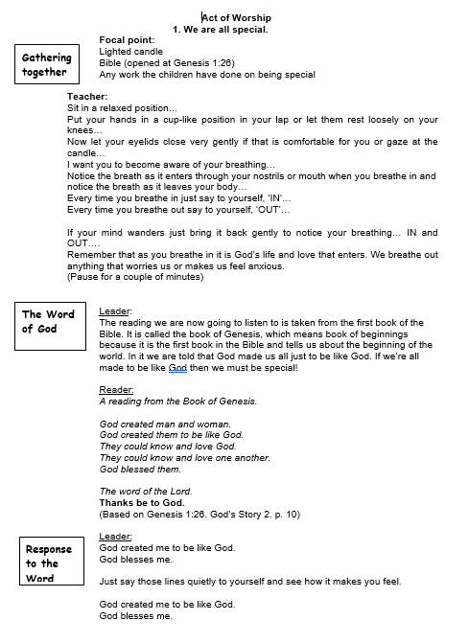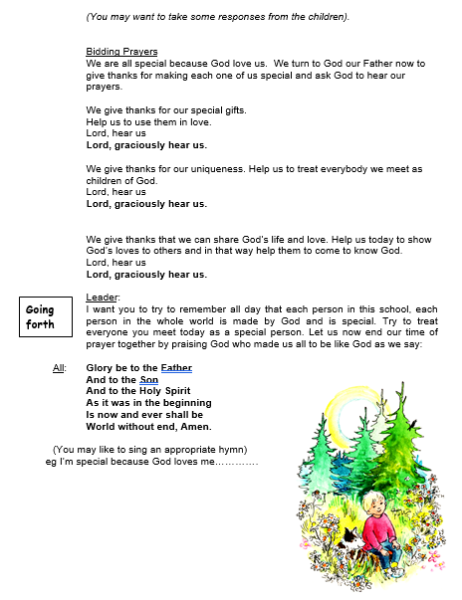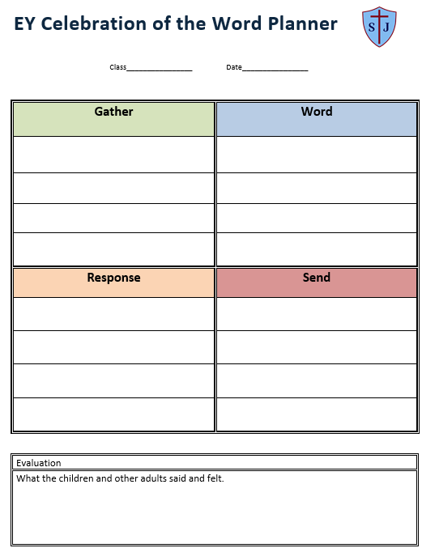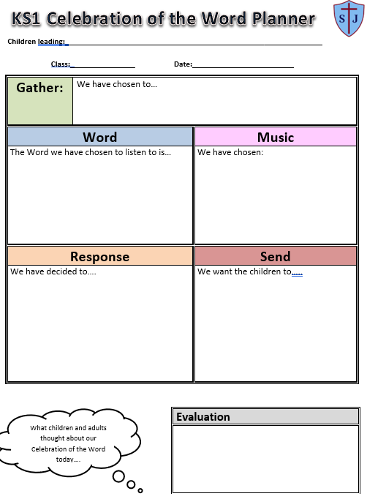

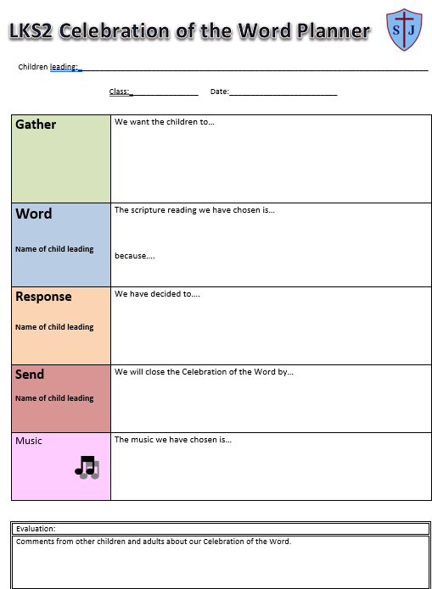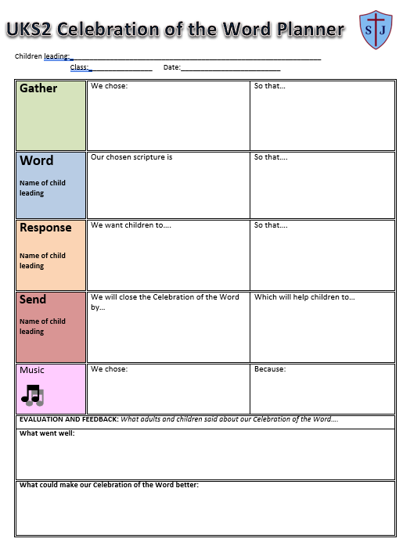

Progression of common prayers by age
In line with the PLD (§7.10, §9.5), St Joseph’s ensures that pupils are familiar with and use the age-related prayers of the Church through daily and seasonal opportunities:
Key Stage 1(ages 5-7):

The Sign of the Cross, The Lord’s Prayer, Hail Mary, Glory be, Grace before meals, Grace after meals.
Lower Key Stage 2(ages 7-9):
The Apostles’ Creed, An Act of Contrition, Angel of God, Come, Holy Spirit, The Prayer of St Richard of Chichester.

Upper Key Stage 2(ages 9-11):

Morning Offering, The Rosary, The Magnificat, Act of Faith, Act of Hope, Act of Love.

Celebrations of the Word
- Weekly whole school Celebrations of the Word, prepared by SLT using Bishop Hogarth resources and delivered to all children in the hall.
- Weekly key stage Celebrations of the Word, prepared by class teachers, using Statement to Live by and Catholic social teaching, delivered to children in the hall.
- Weekly class Celebrations of the Word, prepared by groups of children using their phase planning sheet, delivered in classrooms. Parents invited once a year to join their child’s class for this.
- Class Assemblies – each class prepares an assembly once a year, with a liturgical theme or link (for example Remembrance, Harvest, Reconciliation), delivered in the hall to the whole school and parents.
- Seasonal services for Advent, Lent, Easter, and Marian feasts. Celebration of the Word every morning during Advent, led by SLT and class teachers and Stations of the Cross during Holy Week.
- Celebrations follow the fourfold structure Gather–Word–Respond–Send (Directory §7.2).
- Scripture is at the centre, drawn from the Lectionary and aligned to the liturgical year.
- Pupils proclaim readings appropriate to their baptismal dignity.
These Celebrations of the Word, when planned by students follow this proforma:

Mass Provision
- The Eucharist is placed at the centre of all that we do at St Joseph’s.
- Holy Mass is celebrated weekly and attended in key stages. When a key stage is not attending Mass, they follow a prayer based British Values assembly.
- Holy Mass is celebrated throughout the year as a whole class as a Welcome Mass, Advent Mass, St Joseph’s Feast Day Mass and Leaver’s Mass.
- Holy Days of Obligation are all marked with a Celebration of the Word focus.
- Ash Wednesday is recognised with the distribution of Ashes, when this is during term time.
- Mass preparation includes formation of pupils for ministries (servers, readers, musicians, welcomers), ensuring progressive participation according to age (Directory §3.3, §8.1).

Sacrament of Reconciliation
- Children who are taking part in the Sacramental Preparation programme, take their First Reconciliation during November/December.
- Pupils taught and use an age-appropriate Act of Contrition (Directory §9.5).

Other Liturgies and Devotions
- Stations of the Cross during Lent, prepared by Pupil Chaplains teams.
- Angelus prayed in October and Advent.
- Hymn practices scheduled when appropriate in preparation for Masses and Celebration of the Word. Hymns are selected in accordance with the liturgical calendar.

Retreats
- Year 5 Students have the opportunity to take part in a residential retreat. These are facilitated by the Youth Ministry Team.
- The school works with the Diocesan Youth Service to tailor retreats to the maturity and needs of students.
- The school provide opportunities for students to attend diocesan events e.g Diocese Masses and Y6 Festival at the youth village

Sacred Spaces and Resources
- Focal points in each classroom and throughout the school will reflect the liturgical season. In this way they will be an outward sign of the school's ethos.
- Each classroom has a crucifix.
- Each classroom has a prayer space and prayer resource storage- complete with liturgical coloured ribbons or cloth, prayer cards, a class candle, crucifix etc. The class teacher takes ownership of this resource, ensuring it is cared for an appropriate to the current liturgical season.
- The Poustinia is made available to all members of the Community and is used regularly for Worship and reflection.
- RE coordinator stores and distributes resources for creative prayer, each class takes turn to complete a page of evidence in the creative prayer floor book.

Pupil Leadership
- Y6 Pupil Chaplaincy Team prepares Celebrations of the Word, devotions, and liturgies.
- KS2 Mini Vinnies group supports prayer through service and outreach.
- KS2 Stewards of Creation group supports prayer and our school and community environment by helping to look after God’s creation.
- Participation develops progressively: interior (silence, reflection), exterior (responses, gestures), conscious (understanding why), and active (genuine involvement) (§3.3).

Parish and Community Links

- St Joseph’s works with clergy to ensure that Mass is celebrated weekly, on special occasions and on our school feast day.
- The Clergy of the Deanery offer the Sacrament of Reconciliation once a year at Church.
- Parishioners of the Deanery are invited to join in the school’s prayer life, especially the Christmas Liturgy and Holy Mass.
- The Lay Chaplain supports the Deanery by providing Sacramental Catechesis for the Sacramental Preparation.
- Each Sunday and on major Feasts and Memorials, a reflection is shared on the social media pages.
- The school is a signpost for families to join in parish life with the sharing of information about events etc.

Monitoring and Evaluation
- Phase planning sheets for every Celebration of the Word.
- Evaluations completed by pupils (WWW/EBI).
- Yearly survey completed by students.
- Monitoring by Prayer and Liturgy Coordinator, reported to governors.
- Evidence recorded in the Catholic School Evaluation Document (CSED).
- Annual Prayer & Liturgy monitoring visit from the Trust Head of Catholic Life, outcomes shared with governors and Trust board.

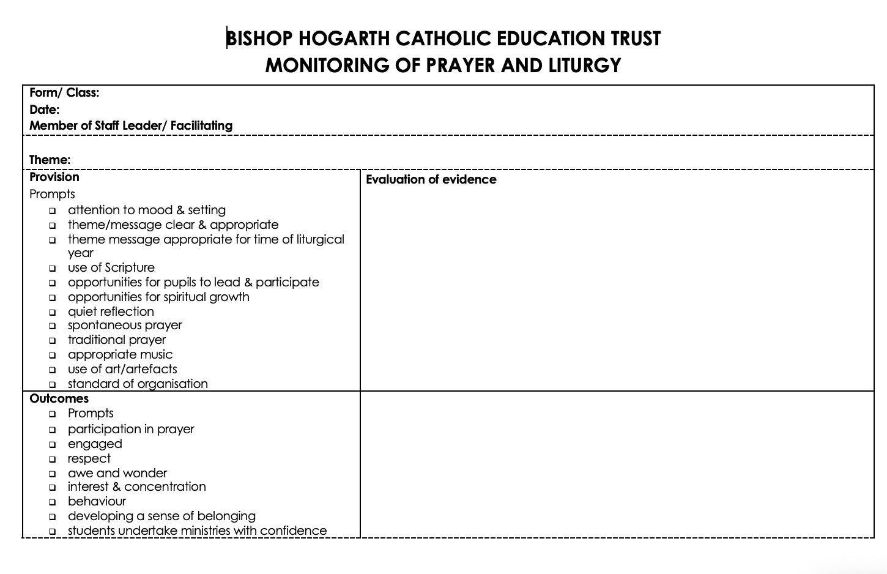
The Role of the school’s Lay Chaplain and RE coordinator

- Praying daily for the needs of the St Joseph’s community
- Maintaining a high-profile presence around the school and at school events
- Preparation of school liturgies (including school and class liturgies, weekly Mass, Masses for Holy Days of Obligation Marian, Advent and Lenten devotions, Reconciliation Services, preparing readers, servers and others involved in the liturgy, and liaising with the Music department with regards to fitting musical accompaniment to enhance the celebration of these liturgies.
- To be a presence in all aspects of pastoral care within St Joseph’s, working closely with the Senior Leadership Team.
- Developing opportunities for prayer and meditation during the St Joseph’s school day and beyond.
- Promotion of staff faith development and providing opportunities for Staff to gather together for prayer (including induction of new staff)
- Care of the St Joseph’s Poustinia - ensuring that it is well appointed and conducive to prayer and reflection.
- Preparation of materials for Morning Acts of Worship within form time and also to produce and provide guidance to Pastoral Learning Managers about Acts of Worship taking place in Year group assemblies.
- Devising and running the Chaplaincy Timetable.
- Working with the RE Department to support the RE curriculum, giving guidance on matters of liturgy and spirituality.
- Offering support to staff and students facing particular challenges and difficulties, (especially in times of personal and family crisis such as bereavement)
- Liaising with local parishes and with the Roman Catholic Diocese of Hexham and Newcastle.
- Leading a Mini Vinnie group in Years 3-5.
- Leading a Pupil Chaplaincy group in Year 6.
- Co-ordination of charitable giving within the school.
- To work closely with parishes in providing and developing Sacramental Catechesis.
- To be a school link to the Catholic press and the Northern Cross.
- Leading the Staff Chaplaincy Team.
- To be a witness to Christian living and a signpost to the wider Church family.

The Trust Head of Catholic Life acts as a resource to support to Lay Chaplains and Chaplaincy Teams. Their role is to provide:

- Training and support
- Point of contact
- Identify and meet the training needs of those involved in chaplaincy in our schools
- Oversee spirituality timetables
- Assistance with sacred spaces
- Opportunities to meet and discuss ideas and problem-solve together
- Assistance with the planning and preparation of key Liturgical celebrations including major feasts and seasons across sectors
- Resources for websites

Annex A: Introduction of the Richness of the Catholic Prayer Tradition
The Prayer and Liturgy Directory (§7.10, §9.5) requires that pupils are familiar with a repertoire of common prayers, texts, and devotions by the end of each age phase. St Joseph’s introduces and embeds these progressively, ensuring pupils encounter the richness of Catholic tradition at the right times in their journey of faith.

Key Stage 1 (Ages 5–7)
- Introduced: Sign of the Cross, Our Father, Hail Mary, Glory Be, Grace before/after meals.
- When/How:
  - Daily: Sign of the Cross at start and end of prayer.
  - Daily meals/retreats: Grace before and after meals.
  - Year-round: Our Father as the central Christian prayer.
  - May/October: Hail Mary introduced in class prayer and Rosary.
  - End of day prayer: Glory Be.
- Focus: Gestures and memorability, building foundations for participation.

Lower Key Stage 2 (Ages 7–9)
- Introduced: Apostles’ Creed, Act of Contrition, Angel of God, Come Holy Spirit, Prayer of St Richard of Chichester.
- When/How:
  - Lent & Eastertide: Apostles’ Creed linked to Baptismal promises.
  - Advent & Lent: Act of Contrition used in penitential services.
  - Start of day prayer: Angel of God.
  - Pentecost: Come Holy Spirit.
  - Mission Weeks/End of Term: Prayer of St Richard.
- Focus: Identity as baptised Christians and discipleship.

Upper Key Stage 2 (Ages 9–11)
- Introduced: Morning Offering, Rosary, Magnificat, Acts of Faith, Hope, and Love.
- When/How:
  - Daily: Morning Offering at the start of the day.
  - May/October: Rosary decades in chapel or class.
  - May/Marian feasts: Magnificat introduced.
  - Lent/retreats: Acts of Faith, Hope, Love linked to virtues.
- Focus: Marian devotion, theological virtues, and mission.
Trust expectation:
- Prayers are not only “taught” but embedded into daily practice and seasonal celebrations, so pupils become familiar with and confident in their use.
- By the end of KS2, pupils should be able to actively participate in the full repertoire of common prayers, linked to Scripture, tradition, and the liturgy.

Appendix 3 – From Directory to Daily Practise – Prayer and Liturgy in our Trust

A link to Andrew Gardener’s (Trust Head of Catholic Life) training can be found here - From Directory to Daily Practice- Prayer & Liturgy in our Trust.pptx

Appendix 4: FAQ’s – Below you will find a set of Frequently Asked Questions and answers from the Diocese of Hexham and Newcastle

What is the Bishops’ Conference of England and Wales?
The Conference is the permanent assembly of the Catholic Bishops of England and Wales. It is a manifestation of collegial collaboration. The website is: https://www.cbcew.org.uk/

What is a ‘liturgical norm’?
The Catholic Church uses the term ‘liturgical norm’ in the sense that the norm is the normal way of doing things. Norms can be issued for the universal Church (all Catholics) or at a national level (Catholics in England and Wales). For example, it is the norm in England and Wales for Communion to be received standing; however, it is the (universal) right of the communicant to choose whether they receive standing or kneeling.

Why should people pray before meals?
This is a Christian tradition based on Jesus’ own practice of thanksgiving.
Should a school have their own prayer that they say regularly? Yes, this can be helpful; however, this is no requirement for this. Do Catholics worship Mary and the Saints?
No.

I am not a Catholic. Do I have to make the sign of the cross?
You do not have to but can if you wish.

Who can attend liturgies?
Everyone is welcome.

What happens where a teacher is required to lead prayer but does not believe in God?
Where the teacher has a contractual obligation to facilitate prayer, this might be done with the support of other adults (e.g., teaching assistants) or pupils.

In prayer and liturgy, could scripture readings start and end with the responses used in Mass?
This can be helpful as a way of developing participation. However, only a priest or deacon should use the invitation, ‘The Lord be with you.’

Should we stand for the Gospel when it is proclaimed outside of Mass?
Standing is a sign of respect. In a similar way it is usual to stand for the Gospel Canticles, such as the Magnificat at Evening Prayer. It can be helpful therefore to make links between how the Gospel is venerated in each of these two liturgical settings by the action of standing to listen to it.

Where do I find the readings of the day?
In the diocesan liturgical calendar (or ordo), which is published by each diocese annually. Websites and apps which give the readings of the day are also available.

Could another text be used instead of a scripture reading in Mass?
No.

Who can read the Gospel and preach the homily at Mass?
The priest proclaims the Gospels unless a deacon is present. Only clergy can preach the homily, unless they delegate this to another as specified in the Directory for Masses with Children.

At Mass, can scripture readings be adapted for younger children?
Yes, the Directory for Masses with Children makes this provision.

Are electric candles ever acceptable as a substitute for wax candles?
Candles not only give light but are a symbol of the passage of time as they are consumed. At Mass, therefore, only natural wax candles may be used.27

Can drama be used in Mass?
Drama can be used to enhance the pupils’ response to the liturgy of the word but should not replace a scripture reading. Care should be taken that it is appropriate and proportionate.

Should prayer and liturgy start and end with the sign of the cross?
This tradition can be a helpful custom, particularly for pupils, in framing prayer and liturgy.

Does it matter which hand you use to make the sign of the cross?
It is customary for people to use their right hand, but it is not obligatory.

What is appropriate to have on my class prayer table?
Key Christian symbols (crucifix, Bible) and some connection to the liturgical year.

What arrangements should be made for the Blessed Sacrament during school holidays?
For extended periods of time, for example, the summer holidays, it is good practice for the tabernacle to be emptied.

Why don’t we sing the Alleluia and the Gloria during Lent?
In a similar way to fasting from certain foods, we fast from the Alleluia and Gloria so that they are more joyful when they return at Easter.

Who can lead an Ash Wednesday liturgy?
Clergy or Catholic staff and students.

Who can distribute ashes at an Ash Wednesday liturgy?
Students and staff who are Christians.

What should ashes be mixed with – oil or water?
Follow the directions given by liturgical suppliers.

Do all liturgies and assemblies have to follow the model of Gather, Listen, Response, Send?
It provides a simple and very flexible structure, which is modelled on the principle liturgical pattern of the Eucharist.

Who is allowed to distribute Communion?
Where there are insufficient clergy present, a commissioned extraordinary minister of Holy Communion can assist.

What should be brought forward in a procession with gifts (offertory procession)?
Principally the bread and wine. This gives an indication that anything brought forward is something which will not just be returned but will in some way be transformed. Artefacts and displays may be better incorporated in the Introductory Rites.

Is there guidance on writing the Prayer of the Faithful (bidding prayers)?
Yes, see https://www.liturgyoffice.org.uk/Resources/Documents/Intercessions.shtml

Who can lead a penitential liturgy?
Non-sacramental penitential liturgies may be led by clergy or Catholic staff and students.

Is applause appropriate during Mass?
It is helpful for pupils to understand that liturgical celebrations are not performances. However, it can be appropriate to thank all those who have ministered at the end.

How can we encourage our students to respond during the Responsorial Psalm and other prayers?
Responses can be taught in a similar way to hymn practice, which can develop communal singing.

