SEND Information Report
St. Joseph’s Catholic Primary School

Approved on:
July 2023
Next review:
June-July 2024

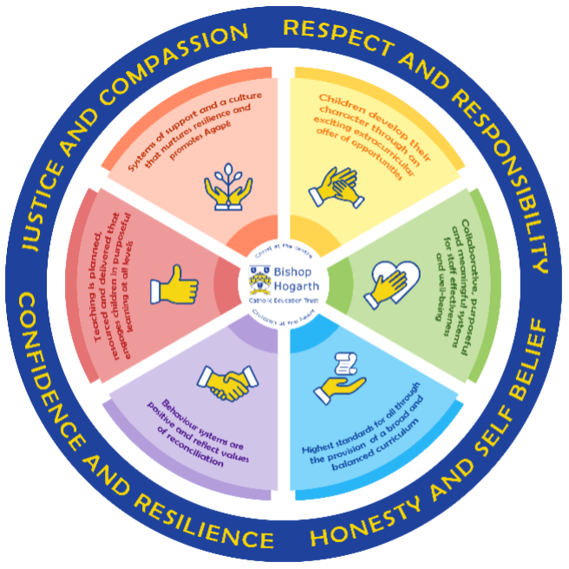
As part of the family of Bishop Hogarth Catholic Education Trust, our school has at its core, the virtues, and values of:
Respect for others and themselves, recognising that we are all created in the image of God and therefore must be compassionate towards others, especially the vulnerable. ​
Confidence in their own abilities, knowing that their talents are gifts from God and resilience to persevere when things become difficult. ​
Honesty in regard to the world around them and themselves and the ability to take responsibility for the times we may fall short of the mark. ​
Gratitude for all the amazing gifts from God and willingness to share their gifts both personal and material. ​

As an inclusive school, all teachers are teachers of pupils with Special Educational Needs & Disabilities. We deliver a curriculum and create an environment that meets the needs of every pupil within our school. We ensure that every pupil with Special Educational Needs and / or disabilities makes the best progress possible. We foster and promote effective working partnerships with parents / carers, pupils, and outside agencies. We consider the ‘whole’ child and strive to ensure that all our SEND pupils are prepared for adulthood.​

Our school’s approach to supporting pupils with SEND
- Teachers are responsible for the progress of ALL pupils in their class. High quality teaching is personalised to meet every child’s need. This is the first step in supporting pupils who may have SEND (Special Educational Needs and Disabilities). All children are challenged to do their very best. This is usually enough for most pupils to make progress.
- All children will be taught a broad and balanced curriculum; differentiated to the needs of each individual. Where children require extra support, specialist resources or extension materials, these will be provided wherever possible.
- All children are known well by their class teacher, who develops strong relationships with them. Good behaviour and work is rewarded.
- Your child can express their views through school council representatives or directly to staff (Specifically the Wellbeing Team) Playground Friends and the student council representatives encourage all pupils to have a voice in school.
- We manage medical needs by working closely with parents and healthcare professionals. We listen to and act on their advice, providing staff training when needed.
- Our offer extra-curricular clubs differ each term dependent on the interests of children.
- There is also a SEND governor who has particular involvement with SEND policy and provision.

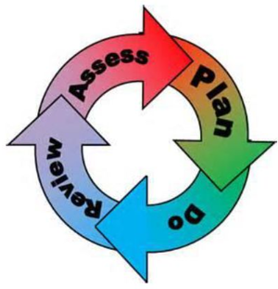
How will the school staff support my child?
The graduated response-Identifying, planning for and supporting pupils with SEND
Where a pupil is identified as having a special educational need, School will follow a graduated approach which takes the form of cycles of ‘Assess, Plan, Do, Review’. ​
• Assess a child’s special educational need. ​
• Plan the provision to meet your child’s aspirations and agreed outcomes. ​
• Do put the provision in place to meet those outcomes. ​
• Review the support and progress.

How does the school know if children need extra help and what do I do if I think my child has special educational needs?

- Assess
Identification – Your child will be identified as having SEN and/or a disability if they have significantly greater difficulty in learning than the majority of children of the same age or if they have a disability preventing or hindering the use of educational facilities provided for children of the same age within the Local Education Authority.
- First steps - if from our rigorous tracking and monitoring of your child’s progress, it becomes apparent that he/she is not making expected progress then you will be invited to a meeting with their teacher and Mrs Hargreaves, Where appropriate your child will be involved in this meeting. At the meeting we will begin to explore the possible barriers to learning and you will be asked how we can best support your child.
- Observations and assessments will then be carried out and, if required, input from specialist services may be sought with your permission.
- Where appropriate your child may be placed on our school’s Targeted Support or SEND Support Register and a plan will be devised by the class teacher that will set achievable targets. These will be reviewed and updated at least half-termly.
- EHCPs (Education, Health and Care Plans) will be sought when a child’s needs are deemed more complex and require the input from a range of outside agencies. This could be in the form of Educational Psychologists, Occupational Therapists or other professionals with an area of expertise, e.g. Autism. An EHCP helps to determine the level of educational, social and health support the child needs.
- If you are concerned about your child’s progress or that your child may have SEN and/or a disability, please contact our SENDCo Mrs Hargreaves

- Plan
Our procedures are in line with the SEND Code of Practice 2014
The first point of contact is the class teacher, who has overall responsibility for the welfare of your child.
Additional provision is planned carefully and overseen by Mrs Hargreaves, the SENDCo (Special Educational Needs and Disabilities Coordinator). It is implemented by a skilled team of teachers and supported by experienced teaching assistants.
SEND Resources
At St. Joseph’s we have an extensive range of different SEND resources and interventions available. These are closely matched to the needs of our children and their progress is monitored by the class teacher, the SENDCo, the deputy head, the headteacher and staff with specific curriculum responsibilities.
Where provision does not result in adequate progress, as outlined in the SEN Code of Practice, the SENDCo (Mrs Hargreaves) should be consulted for advice.
Pupil progress meetings are held three times a year with the Head Teacher, SENCO and class teacher to discuss and plan suitable teaching programmes for each child.

- Do
Our teachers are skilled at adapting teaching and learning to meet the diverse needs in each class. ​
Daily planning considers individual children’s needs and requirements and is annotated and adapted according to need. Explicit reference is made in the teacher’s planning to the needs of those children identified with SEND. ​
Adaptive teaching is approached in a range of ways to support access to the curriculum and ensure that all children can experience success and challenge in their learning. ​
Grouping arrangements consider the different skills and abilities of each child. This ensures that learning is maximised. ​
Additional adults support groups and individual children with the long-term goal of developing independent learning skills. The class teacher monitors this support to avoid students becoming over reliant on this. ​

We fully encourage parental support and offer opportunities for individual meetings with parents/carers to provide clarity and recommendations on how they can support their child at home.

- Review

If despite all steps taken, good progress is still not being made, we will refer back to our graduated approach and increase/change support whilst continuing to monitor and review progress. It may also be necessary, at this stage, to consult with the expertise and specialist services secured by the school. Parents will be consulted before these referrals take place.
Consultation sessions are held in the Autumn and Spring terms where you can meet your child’s teacher to discuss and look at their work in different subject areas.
Parents that have children on the school’s SEND Support Register, are also invited to termly meetings to review their child’s coordinated support plan and targets. If appropriate, your child will be involved in reviewing their targets at appropriate times throughout the term, with the class teacher or teaching assistant, and during the setting of new targets on a termly basis. If, of course, you would like to meet Mrs Hargreaves or your child’s class teacher at any point during the term, this can easily be arranged.
For every child who is in the care of the Local Authority, (a looked after child - LAC), a Personal Education Plan PEP) will be devised. This Plan will establish clear targets and actions to respond effectively to each child’s needs and provide a continuous record of their achievements.
If your child has an EHC Plan, you will be invited to an annual review of this plan.
Homework is given regularly and your child may have the opportunity to access computer programmes to support their learning at home through the school website. You are encouraged to support your child’s learning at home.
Home school diaries are used to support communication between home and school and you are encouraged to use
these frequently.

How will the curriculum at our school be matched to my child’s needs?
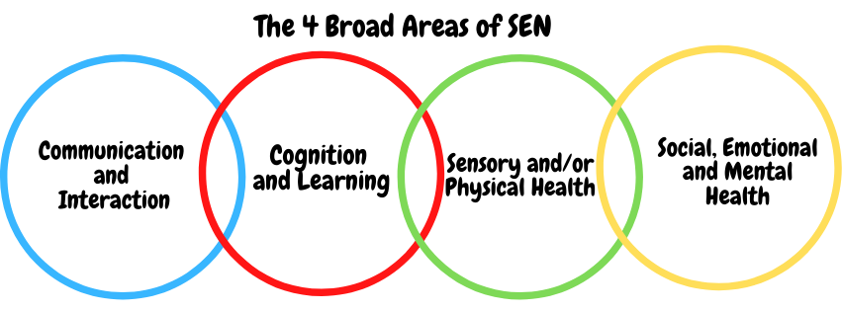SEN needs are classified under four broad areas of need. Below are the strategies, in class support and interventions that school may put in place to support your child.

At St. Joseph’s, we offer many different forms of additional provision, including;
- Additional in and out of class support
- One-to-one support when appropriate
- Flexible groupings (including small group work)
- Access to specific resources and learning programmes
- Counselling
- Access to a wide range of outside agencies
Communication and Interaction
Strategies to support children with these needs include:
- Access to small group and/or individualised interventions to develop skills in communication and interaction with others.
- Visual timetables used in every classroom
- Flexible approaches to timetable when necessary
- Access to additional aids/technology
- Explicit teaching of generalising skills from one context to another
- Careful planning of transitions, e.g. advance notice, familiar resources
- Mentoring and/or buddy systems
Cognition and Learning
Strategies to support children with these needs include:
- Regular, individual or small group focused interventions, e.g. reading (Reading Plus – Y3 - 6), phonics numeracy (Becoming 1st Class Number, 1st Class Number 1 and 2)
- Increased access to small group support in class
- Practical aids for learning, e.g. place value counters, number lines, pictures, photos, coloured overlays, accessible reading material suited to age and individualised success criteria
- Flexible groupings
- Access to technical aids e.g. spell checker, ICT software and/or hardware
- Adaptations to assessments to enable access e.g. readers, scribe, ICT
- Curriculum/delivery adaptations to meet the learning needs of individuals
- Frequent repetition and reinforcement

Sensory/Physical
Strategies to support children with these needs include:
- Occupational Therapy Support sought when necessary and suggestions followed.
- Concrete apparatus available to support learning, e.g. Numicon materials (numeracy)
- Sensory resources available e.g. Chew Buddies, seat wedge, writing wedge, heavy work activities
- Access to support for personal care, e.g. school nurse service
- Adaptations made to the curriculum when needed to avoid sensory overload.

Social, Emotional and Mental Health
Strategies to support children with these needs include:
- Access to time out/individual work area
- Playground Friends
- Access to counselling services, e.g. CAMHS, Alliance,
- A dedicated Family and Inclusion Support Worker (Mrs Willis)
- ELSA (supporting social and emotional learning)
- Bereavement support
- When possible, increased access to additional adults in and out of the classroom
- Supported transition programme with chosen secondary school
- Applications made to SEMH when necessary

What training is provided for staff supporting children with SEND?
The school offers range of training through:
- Staff Meetings
- Trust training
- Online meeting/training
- Local training though external providers

How do we support transition in our school?

Transition within classes/key stages: ​
As a small school the staff know all children very well:
- Prior to transition staff meet to discuss the children and their needs
- Meeting with the SENDCo previous teacher and new class teacher
- Support plans and other documentation are shared
- A transition day takes place in the classroom that the children will use the following year.
- Enhanced or additional transition will be supported as required

Transition to Secondary settings: ​
We work closely with all secondary schools in the area.
- The majority of our children move on to English Martyrs Secondary School.
- • The transition process will begin early, usually in Y5, for some of our more vulnerable children.
- Meetings are held for the transfer of essential information relating to EHCPs, Child and Family Services and pastoral matters.
- Miss Willis, our Parent Support Advisor, works closely with the SENDCo and Y6 class teacher to support children who require additional provision during their transition period.
- We can also support you in organising meetings with secondary school staff if you wish to speak to them personally.
- When reviewing an EHCP for children in Y6, staff from the secondary school will always be invited to review meetings.
- During the last term, staff from English Martyr’s come to meet our Y6 children and in addition to this, our Y6 children attend their chosen secondary school for a period of transition decided by the secondary school

Where can I get further information about services for my child?

The Local Offer
- SEN Code of Practice (graduated response) https://www.gov.uk/government/consultations/revision-of-the-send-code-of-practice-0-to-25- years
- Local Authority’s Local Offer https://www.hartlepoolnow.co.uk/local_offer

What key school documents refer to support and provision for pupils with SEND?

- SEND Policy​
- Admissions Policy​
- Supporting Pupils with Medical Needs Policy​
- Accessibility Plan​

Accessibility​
- St Joseph’s Accessibility Policy https://onedrive.live.com/view.aspx?resid=F1176C625B1BB1!3868&ithint=file%2cdocx&authkey=!AH aPrkENasf8J8k

Activities Outside of School​
St. Joseph’s is an inclusive school and we will put in place appropriate support, whenever possible, to enable your child to be educated alongside their peers. This may include extra staffing and/or equipment.
• Staff who are arranging an offsite trip will discuss with parents and the SENDCo any requirements needed and the suitability of any trip which the school is taking part in.
• We will not stop your child from going on a trip due to their special educational needs and/or disability if the trip is suitable for your child and their safety and the safety of others is not compromised.
• The headteacher oversees all trips to ensure children are safe and included where possible

What to do if you have a complaint, a compliment, or a query.

The school details and relevant contacts
Mrs Hargreaves Headteacher and acting SENDco
St. Joseph’s Catholic Primary School
Musgrove Walk
Hartlepool
TS24 7HT
01429 272747
Admin@stjosephshartlepool.bhcet.org.uk

​
Name of school SEND governor.
Mr J Race
C/O St. Joseph’s Catholic Primary School
Musgrave Walk
Hartlepool
TS24 7HT

Telephone: 01429 272747

