
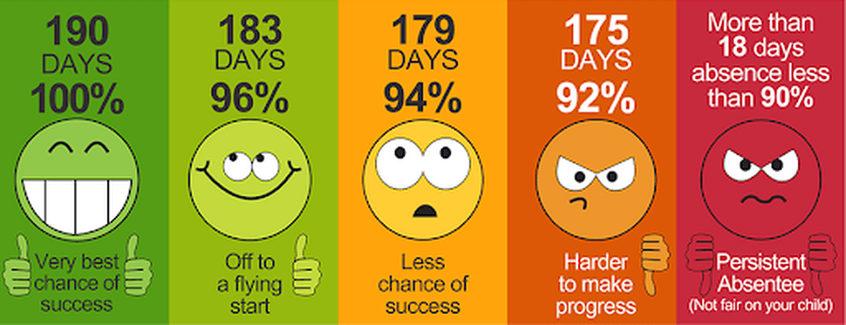
- Lower academic achievement
- Lower graduation rates
- Higher rates of interaction with juvenile justice systems
- Mental and physical health issues
- Lower employment opportunities
- Increased alcohol, tobacco, and substance use in adolescents
It is essential for pupils to get the most out of their school experience, including
their attainment, wellbeing, and wider life chances. The pupils with the highest attainment
at the end of key stage 2 and key stage 4 have higher rates of attendance over the key
stage compared to those with the lowest attainment. At KS2, pupils not meeting the
expected standard in reading, writing and maths had an overall absence rate of 4.7%,
compared to 3.5% among those meeting the expected standard. Moreover, the overall
absence rate of pupils not meeting the expected standard was higher than among those
What we expect
Target attendance 97% or more
If your child is unwell – send them in unless they have been sick with a bug
Call school to inform us why your child is off
Commit to getting them here everyday -no excuses
meeting the higher standard (4.7% compared to 2.7%). At KS4, pupils not achieving grade
9 to 4 in English and maths had an overall absence rate of 8.8%, compared to 5.2%
Working together to improve school attendance August 2024 Department for Education

