Our topic is…
MEALS
Our key questions are…
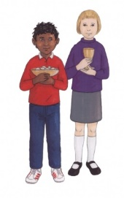
What happens at a meal? What makes some meals special? What happened at a meal Jesus had? How does the Parish family celebrate together?
Our Scripture links are:

Luke 22:19-20
RECD:
Revelation: the main events, characters and places in the life of Jesus: the Last Supper
Celebration: the ‘Church’ as the People of God made one by Jesus, a community which shares love and life; the Church as a ‘house of God’ where God’s People gather with Jesus
The Church: the place and value of celebrations in family, school and parish; the church’s celebration of Sunday as a special day; the story of the Last Supper; the main aspects of the Eucharistic celebration and prayers used at the Eucharist; prayers from Scripture and tradition; Jesus prayer to his Father

Age-related skills:
Knowledge and Understanding | - Recognise religious beliefs  - Describe religious beliefs  - Describe some of the actions and choices of believers that arise because of their belief  - Recognise key people in the local, national and universal Church  - Describe different roles of some people in the local, national and universal Church  - Recognise religious signs and symbols used in worship, including the celebration of the Sacraments  - Describe some religious symbols and the steps involved in religious actions and worship, including the celebration of the Sacraments  - Retell, in any form, a narrative that corresponds to the scripture source used
Engagement and Response | - Talk about their own feelings, experiences and the things that matter to them  - Ask and respond to questions about their own and others’ feelings, experiences and things that matter to them

